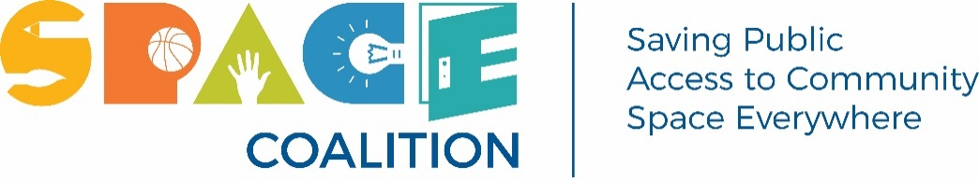

ACHIEVING GREATER VALUE IN COMMUNITY USE OF PUBLIC ASSETS

Community Use of Schools (CUS) is an initiative of the Ontario Ministry of Education that supports access to school space, outside of school hours, for community members to come together, volunteer, build skills, access community programs, become physically active and build strong and healthy communities.

Schools and school facilities are more than just centres of education. These publicly owned assets benefit the community at large and help make Ontario a rewarding place to live, work, and visit. Effective and intelligent investment will benefit Ontarians and support communities for years to come.
The Space Coalition believes it is possible to get greater value from these public assets and we are suggesting a pathway to achieve that goal. For this reason our submission is focused on Community Use of Schools funding.

The SPACE Coalition is requesting the following elements be recognized regarding Community Use of Schools:

- ‘Sweatering’ of CUS Funds is essential to enhance accountability and ensure disbursements benefit the appropriate NFP organizations. To further advance accountability of CUS funds, the Ministry of Education should resume collecting, collating, analyzing and sharing rich data provided by Boards of Education via EFIS.

- Community Use programs and partnerships deliver value by supporting Ontarians’ physical and mental health through physical activity programs, in combating social isolation by bringing people together thereby reducing stress and lowering anxiety which can lead to a decrease in health costs. Student academic achievement and wellbeing can be enhanced through community programs (e.g. music programs), school grounds benefit from community participation (e.g., gardens). Students can gain transferable life and employability skills through volunteering and mentoring (sport programs), leadership (Scouts and Guides).

- Maximize the benefits from Ontarians’ investments in school facilities by
  - ensuring the cost of maintaining facilities is kept at a level that ensures free and low-cost community programming in high-needs neighbourhoods including but not limited to covering costs for free evening, weekend, March Break, and summer permits.
  - reducing weekend costs for nonprofit organizations by allowing school boards to utilize school board staff at straight time rather than double and triple caretaker overtime.

- Explore a means to allow shared funding and collaboration among Ministries which either operate programs or deliver services through schools (Health, Sport, Seniors and Accessibility) to broaden the benefits of CUS and enhance both physical and financial accessibility for participants.

Taking the foregoing into consideration the SPACE Coalition urges the Government of Ontario to immediately invest an additional $19.94 million to capitalize on the existing investment in community use of schools and related programs.

These new funds will be comprised of:

- $3 million increase to the core Community Use of Schools program, approximately 10% of the total allocation, to begin to address cost of living increases since 2018-19.

- $7.04 million to support school board-led community outreach.

- $8.25 million to support free/low-cost permits in high needs neighbourhoods.

- $1.15 million to Focus on Youth program (i.e. restore it to the 2018-19 funding level and add a 10% inflationary increase).

We further recommend that the Government of Ontario take a system-wide approach to addressing community use of schools by:

- Providing school boards with dedicated funding to retrofit aging school facilities to meet current accessibility standards thereby ensuring fair access to all community members.

- Mandating Community Use of Schools Advisory Committees in every school board.

- Expanding the authority of the Provincial Ombudsman to the oversight of the Community Use of Schools Program.

- Establishing a home in government to efficiently work with the over 58,000 nonprofits, charities and grassroots groups in Ontario.

In Summary
The SPACE Coalition advocates for affordable, accessible and equitable access to public space that is welcoming to all residents. We believe that access to public space, including schools and municipal facilities, is the cornerstone of healthy, vibrant neighbourhoods. Our membership includes numerous community service and not for profit organizations offering programming, many of which are run by volunteers.

School Boards recognize that programs provided by local and community based not for profit organizations include ongoing learning opportunities for children, youth and seniors; recreation opportunities to support mental and physical well-being; job and mentoring situations providing life skills and transferable employment skills for local youth.

SPACE believes that education is a life long activity. Supporting community programming beyond the school day ensures that people are able to continue to grow and develop as contributing members of society.

Simply put, effectively funding Community Use of Schools underpins a holistic approach to well constructed and progressive growth in communities across Ontario.

Respectfully Submitted
SPACE Coalition
Saving Public Access to Community Space Everywhere
c/o 1720-2 Carlton Street, Toronto, ON M5B 1J3

Visit our website | Follow us on X | SpaceCoalitionON@gmail.com

