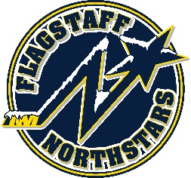
Flagstaff Youth Hockey Association
BOARD OF DIRECTOR’S MONTHLY MEETING AGENDA
March 23, 2022

Topic: FYHA General Board Meeting
Time: March 23, 2022 at 6pm
Location: 215 E Birch Ave or via teams: https://tinyurl.com/FYHA-General-Board-Meeting

Approval of Minutes:
Reports:
- President’s Report- Travis Joralmon:
- AAHA Hockey Director- Travis Joralmon:
- ADM Coordinator: Kris Walsh:
- Coaching Coordinator- Travis Johanson:
- Equipment Manager- Greg McLaughlin:
- Fundraising Coordinator-Kyle Palmer:
- Ice Scheduler-Brad Mihalik:
- COVID Updates and Protocols- Brad Mihalik:
- Registrar-Judy Smith:
- Treasurer-Lauryn Sandoval: Switching Banks
- Webmaster-Courtney Matthews:
- Managers-Courtney Matthews:
- Sponsorship- Stephanie Babbitt:

UPCOMING EVENTS:
- RMHS 6/20/22-6/24/22
- Dark Sky 7/22/22-7/24/22
- 8U tournament 4/2/22-4/3/22
- Robby Glantz- Easter Weekend
- Travel tryouts- 10U 6/7 & 6/14; 12U/14U 6/9 & 6/16

OLD BUSINESS:
- Elections
- President’s banquet

NEW BUSINESS:
- Tryout fee
- Budget Review
- Avalanche

