Great Drills For the Year

(WITHOUT GOALIES)

3v3 3-Pass to Coach (W/O a Goalie)

Object: Coach dumps a puck into the zone. Three Xs compete against three Os. To win the game, all three players on a team (X, in this example) must complete at least one pass to each other (each X needs to catch at least one pass) and then finish the game with a single successful pass to the “roaming coach” (C2). All passes must be made successfully and all three players must control the puck upon receipt of a pass. More than three passes are allowed among the teammates, e.g., back and forth to X1 and X3, but before the pass to C2 is made, all three players (X1, X2, X3) must control the puck and be in on the play.
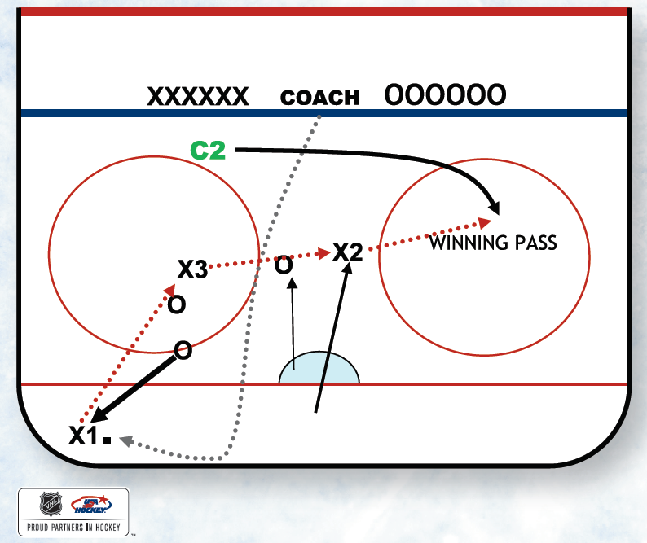

Emphasize getting to the puck first at the start of the drill and winning that puck battle. Offensively, emphasize puck support and short passes rather than long, spread-out passes that are easy to read or intercept. Puck carrier should rarely try to beat an opponent 1v1. Instead, this drill should emphasize quick, smart puck movement, players moving without the puck, getting open, playing with their stick on the ice (give a good target) and using verbal communication to call for the puck.
Defensively, coaches should emphasize good body position (take good angles, force offensive players to the outside, clog passing lanes), playing with head on swivel, sticks on ice and anticipating when to pressure the puck.
Also, for both teams, emphasize quick transition to defense or offense when possession changes.
C2 must have the ability to roam and anticipate when the offensive team makes their second successful pass to get open to finish the game.

Cross Fire Passing Lax (W/O a Goalie)
Players compete 2v2 within the box & outside of the box. The players have teammates on opposite sides of the box. The X players can only pass to Xs and O players can only pass to Os. Teams get a point when they complete passes from one side of the box to the other, but they must complete at least one pass to a player within the box first. Two points are attained if both players in the box touch the puck before getting it to the other side.
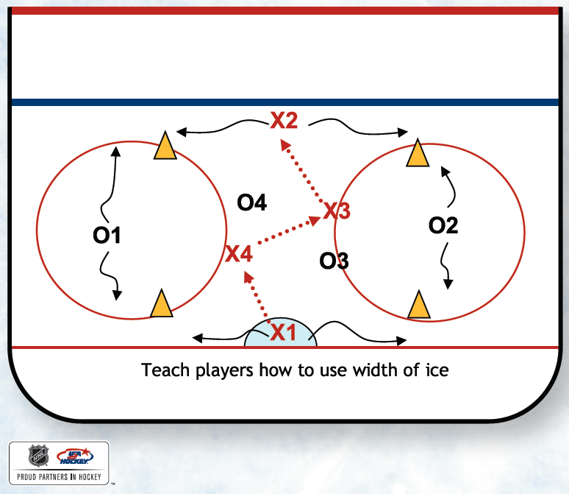
Teach passers to give “false information” or no-look passes. Teach players away from the puck to get open and use the width of their given space. Teach rapid puck movement. Teach defensive stick skills. This drill works on passing, O-zone play, D-zone play, power play, penalty kill and team play.

Warm-Up Full Ice Keep Away -

Warmup Full Ice Keep-Away Players pair up. On whistle, play 1v1 keep-away for 30 seconds. Players must stay in a small area and try to beat each other 1v1. Don’t let them skate all over the ice to maintain possession; work on deception and hand skills.

Have players stationary pass during rest periods. Stay 15 to 20 feet apart to increase reps. Pass hard on forehand, backhand, onetouch & saucer pass, catch pull pass, etc.

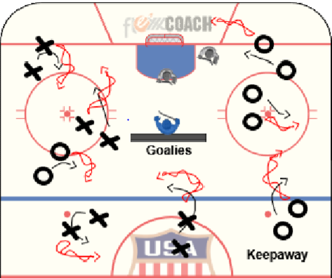

Simultaneous Regroup (Passing Warmup with no Goalies):

Drill Structure: Structure the drill cross-ice. Use cones, tires, dividers, etc., as obstacles on the playing surface. With an ice marker, draw two lines from the blue line to the corners to give defensemen space to operate in front of the boards. There are two live pucks in this drill (represented by the green and red dotted lines in this example). Two X players control the red puck and the two O players control the green puck. Have both groups (Xs and Os) simultaneously regroup the puck with the opposite D pairings. Once the regroup is over, the offensive pair travels to opposite side and regroups with the other D pair. In this example, X regroups with D1 first. Then they move to the opposite side of the ice to regroup with D2. O regroups with D2 first. Now they move to the opposite side of the ice to regroup with D1.
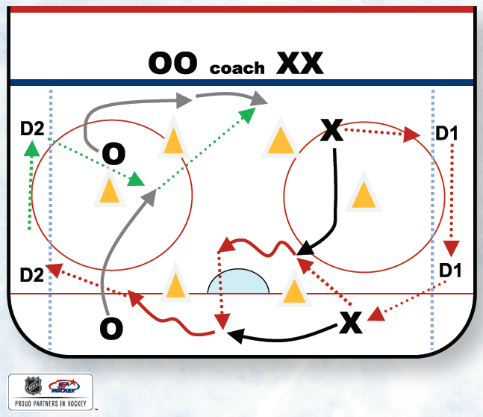
Comments: Offensive players must keep their heads up to avoid collisions. The real coaching is in the form of teaching puck support and gauging speed for the drills to work (sometimes they’ll need to accelerate; sometimes they’ll need to decelerate, just like during a game situation). Also, the offensive players will need to use their eyes to see if the next D pair is ready to receive the puck or if they are still transitioning the previous group. Allow offensive players to slow down, make an extra pass or perhaps a new regroup with the same set of D. As for the D pair, emphasize hard, flat passes, keeping the puck off the wall and moving the puck efficiently to keep the drill moving.

Progression: Add a pass. Have the forward who receives the pass from D one-touch it back to the D for another regroup or option.

Comments: Emphasize two-way play. Teach effort on both sides of the puck.

1v1 To Center Ice:
1v1. Goal is to skate the puck back to your half of the face-off circle via 1v1 battles. Stress that the puck carrier does everything he/she can to maintain possession of the puck. It does not have to be a straight line back to home base. Creativity, puck protection, bounce off the boards around defenders, spin moves, etc..

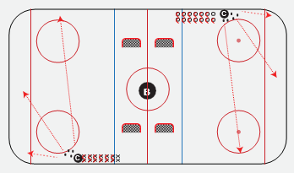

Full Ice Warm-Up: Stick Handling Meyham/Puck Protection/4v4/4Game – Triple Crown Drill
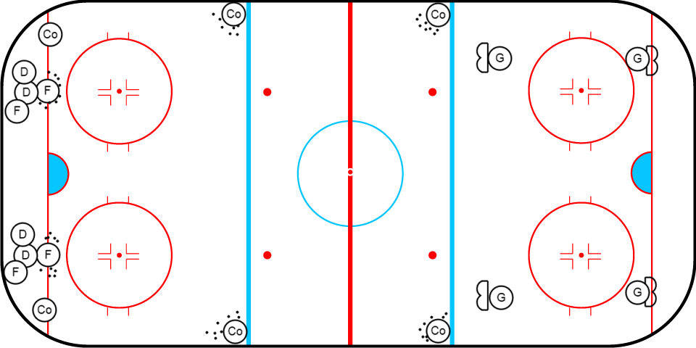

4 Skaters with pucks on each side start. Dark Jerseys on one side and White Jerseys on the other.
Sticking Meyham in the face-off circle. 30seconds then whistle.
Original 4 Skaters enter the neutral zone and play keep away with 1 puck (Coaches on both side spot a puck). 4 new Skaters enter the face-off circle – sticking handle meyham. 30seconds then Whistle.
Original 4 skaters play 4v4 in the far Zone. Players can score on any net. Coaches to spot pucks and be sure to angel the Goals towards the center of the zone. 30seconds then whistle
1/6 ICE SET UP

Diagonal Divider Pass (W/O a Goalie)
Coaching Points: Start drill with a RIGHT-shot player and LEFT-shot player facing each other behind two dividers. Players should work together and move in opposite direction of each other. In this example, Player O has the puck and moves to his/her left (their forehand side). Player X moves to his/her left (their backhand side). Player X gives Player O a good target. Player O passes the puck to Player X. Player X corrals puck on backhand, and in one motion, moves to the right while moving the puck across his/her body. Drill continues as player X reports to the right side of his/her divider to deliver a forehand pass to Player O on his/her backhand at the right side of his/her divider. Repeat as many times as desired.
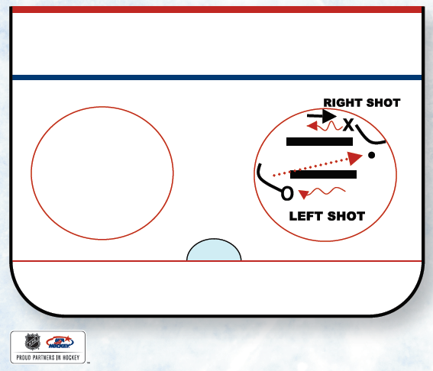
Comments: Encourage players to work together, match their timing and verbally communicate. Encourage players to keep head and eyes up. Encourage players to move hands across body quickly. Set up more than one station to keep all kids active during this drill.
Progression: Mix the hand of the passers to encourage backhand passes.

Figure 8 Passing:
Players are in groups of 3 as the figure 8 diagrammed. X1 passed to O who passes back to X1 and skates the figure 8 pattern as shown. X1 passed to X2 who passes to O, repeat and continuous. 15sec., then interchange players.
- Players 15 feet apart – catch & pass.
- Players 15 feet apart one-touch

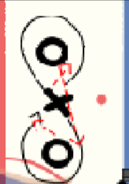
Power Play 4v2 Four Square (Two Goalies)
Purpose: To encourage quick puck movement, spreading out (proper spacing) and goal-scoring. This drill teaches players how to play with a man-advantage and maintain a numerical advantage with puck possession and passing. It also emphasizes transition from offense to defense on one-sixth of the ice. The drill starts with players playing 2v2. Once puck possession is won (F1 in this example), the game turns into a 4v2. F2 players must stay inside their square. F1 players must move or spread out in order to create passing lanes for their teammates in the squares. When X1 steals the puck, the play transitions to the opposite end for a new 4v2.
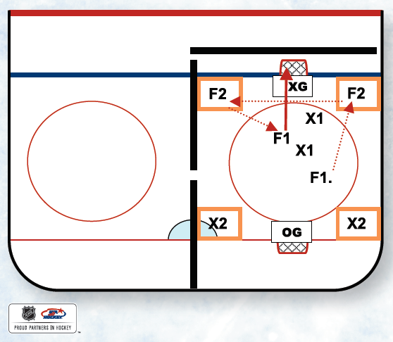
Drill Progression:
- Allow players inside the squares only 3 seconds with the puck. This adds pace to the game and decision-making.
- Allow players inside the squares the ability to shoot.
- Defenders cannot defend the F2 square players, they must defend the active 2v2 players.
Player Rotation:
On Deck > Squares > 2v2 Action
Comments: This is a great drill to create hockey sense and encourage playmaking. Watch the players without the puck to ensure that they are getting open and creating good passing lanes for the players in the square. You can also watch the defensive side of the puck and coach good stick habits and penalty-kill skills.

Oulu Slingshot (1 goalie)
Purpose: To have continuous flow among players while executing passing, receiving and shooting skills.

Drill Structure: Start in a corner, using a sixth of the ice. Have two groups of players ready with pucks. Place a cone on the dot in the center of the circle. Drill starts with X1 passing to oncoming F1. F1 then touch-passes back to X1. Once X1 receives this pass, he/she is activated and directly attacks the net 2v0 with F1. F1 skates around the cone and gets in position to receive pass or attack rebound from X1. After a play on goal is made, X1 repeats the drill by circling back around the cone and receiving a pass from X2. F1 moves out of the drill.

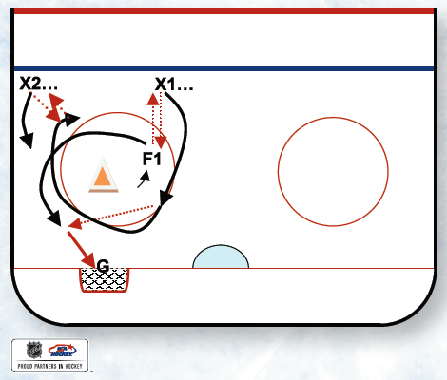
Coaching Points: Let the drill unfold. There should be great tempo. Teach players to position themselves to receive passes either off the rush or when regrouping with the next person in line. Teach "presentation" (the ability to demand the puck with physical readiness and stick on the ice providing a good target).
1v 1 Angling (No Goalie)
Purpose: This drill works on basic breakout and regroup patterns, passing and receiving skills as well as angling, body contact and body-checking skills.

Drill Structure: X1 passes to X2 and then pivots low for a return breakout pass. X1 then passes to X3 and pivots high for a return regroup pass. X2, upon passing back to X1, skates around the tire and then tries to angle and play off X1 before he or she can attack the net.
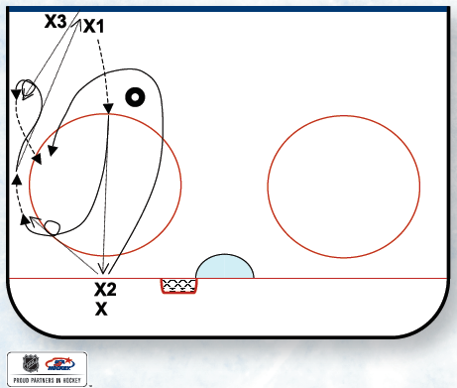
Coaching Points: The main focus of this drill is to work on X2's angling, body and stick positioning as he or she defends against X1. The stick should be down and played stick-on-puck as X2 closes. X2 must establish body position that eliminates the opponent's ability to cut inside to middle ice. X2 needs to close on X1 and separate X1 from the puck.

Comments: X2 is provided with a favorable starting angle on X1 to increase the chances of successfully defending. The live-action play will allow X2 players to develop and refine the timing skills needed for angling and playing a 1v1 from the middle of the ice.

Grillo Gap Drill (1/6ice & 1 Goalie)
Purpose: To reinforce aggressive skating to close gaps while taking time and space away from the offensive player.

Coaching Points: F1 starts on the top of the circle. D1 starts on the bottom of the circle. This drill requires 1/6 of the ice. F1 starts the drill by sprinting down to the dot. F1 must stop on the dot. Once F1 comes to a complete stop, D1 is activated. F1 now sprints to one of the two puck piles (F1’s choice). D1 sprints behind F1 to close the gap. F1 has an option once he or she gathers a puck. F1 can break right or left (in this example, F1 breaks right). Now, F1 challenges D1 in a 1v1 battle. D1 does not stand still or skate backward. Instead, D1 closes the gap and leads with stick and puts body between F1 and the defensive net. NOTE: D1 should not follow F1 down the boards. D1 should cut the player down with good body position and stick-on-stick defense. Once the 1v1 thrust is over, coach blows whistle and F1 sprints and gathers puck from opposite pile and drill repeats.

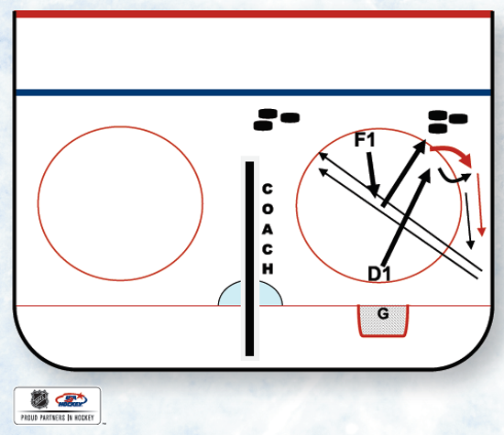
Progression:
- Draw a line under the top of the circle. Have players shoot from above this line and follow shot to net.
- Add coach as an outlet to the offensive player high in the zone. If F1 has no room because of a tight gap, he or she should dish across the slot to the coach. Teach F1 to go to the net after passing to coach. If D1 has a poor gap, teach F1 not to pass, but exploit the poor gap instead.

MLADA Flow Drill
Procedure: Start with X1 in front of the net. On the whistle, X1 skates away from the corner, tracing the outside edge of the circle. At the same time, X2 skates up the wall with the puck and passes laterally across the circle to X1. After X2 passes puck to X1, X2 continues up ice and gets to a support position outside of the blue line. Once X1 receives the pass, X1 skates out of zone, and well before exiting, makes a pass to D1. D1 one-touches the puck to D2. D2 one-touches the puck to X2, who is posted on the wall, outside the blue line.
X1 must time his or her loop outside the zone to stay on-side and receive a pass from X2. X1 then attacks the net. X2 follows X1 to net and repeats the drill.
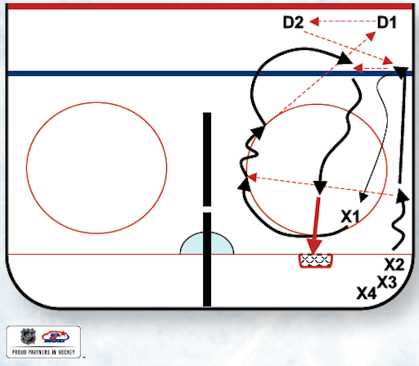
Coaching Points: Quality passes will make this drill much easier, so emphasize concentration and making a good pass. Timing and execution go hand in hand. This is an introduction drill for flow and continuous timing drills.

Comments: This is also a scoring drill. Have the shooter stop at the net front and add a screen element. Progression can also be a 2-on-1. Have X2 join the rush to create a 2v1 against X3 who gaps up. X3 then repeats the drill after his or her rush defense.

2v1 With Backcheck
D breaks out to F1 & F2. F1 & F2 then pass to X1 and tag up onside for a return pass from X1. As soon as the puck re-enters the zone, X1 is activated as a backchecker. The D must follow the play and gap up for the 2v1 back. Play until the whistle.
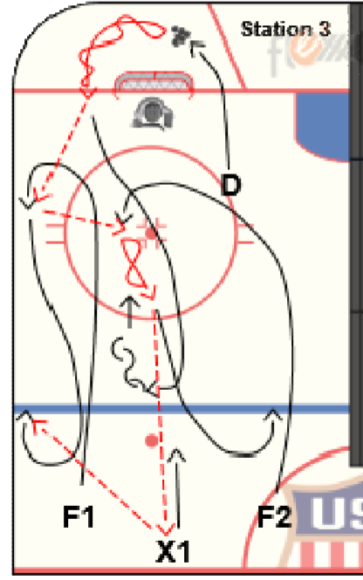
CROSS ICE SET (TWO Goalies)

3 v 3 Wrap-Around (with Two Goalies)
Purpose: To create a small-game environment that emphasizes working on wrap-arounds and wall play in a tight space.

Drill Structure: Use the dots down as the competition area. The space for this drill should be tight. Turn the nets around and have them facing the side walls (goalies should have their backs to the play). Play 3v3.

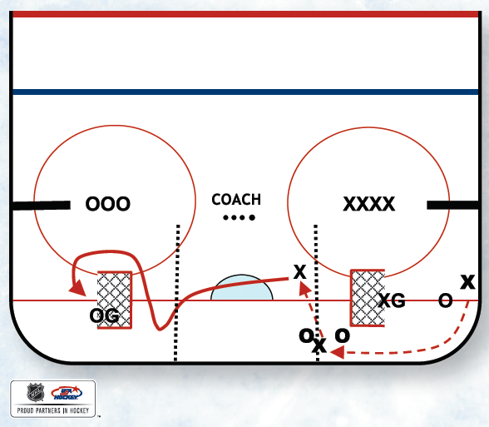
Coaching Points: Play competitive 3 vs. 3 in this confined playing surface. Have players attack opposing nets from behind. They should be creative and try to deke goalies from behind the net. Physical play will also be important in this game. Once a wrap-around is missed, play should continue on the wall in front of goalies. Strong wall play and puck-possession battles will occur here. Encourage offensive players to win these battles and attack the net off the wall.

Progression: Draw two lines behind each net. Teams must head-man pass the puck over the line before an attack on the net.

Comments: Emphasize strong creative attacks on the net and strong wall play.

Backward net 3v2 with Hanger (Two Goalies):
Purpose: This is a small-area game that involves a transition pass, wraparound look and increased wall play for body contact. This game also works on a man-advantage situation.
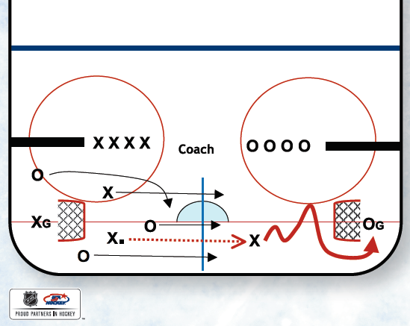
Coaching Points: Use dividers at the hash marks to keep the puck in play. Play 3v3 below the hashes, however, one player on the defending team (X, in this example) must always hang back on the offensive side of the mid line (in this example, the solid blue line drawn with an ice marker).
This creates a numerical advantage for the attacking team, 3v2. Once the defending team gains control of the puck (X in this example), they must head-man the puck over the solid blue line to create transition going the opposite direction. Players can wrap the puck.
Comments: This drill is good when introducing body-contact concepts. Once the goalie makes a save on the wrap-around, the play should naturally head to the wall. Emphasize winning battles and making plays off the wall. Good puck-protection skills will be needed during this drill. Also, work on power-play concepts for the three attacking players.

F1 Forecheck Game (Two Goalies)
Purpose: To teach the finer techniques of your forecheck scheme, especially the role and techniques of the F1. This game helps coaches teach how to apply offensive-zone pressure, steal/regain the puck and create more offense.

Drill Structure: Play 3v3 cross-ice with two nets. Divide the zone in half with a center line made by a marker from the end boards to the blue line. There are two simple rules for the game:
- Once the defensive team gains possession of the puck in their defensive zone, they must skate the puck behind their net before breaking out and attacking the offensive zone.
- Once the offensive team loses possession of the puck in the attacking zone, they must send at least one player (F1) hard on the puck (this is the aggressive F1 forecheck component).
NOTE: If a forechecking team is successful in regaining the puck before the breakout team reaches the center line, i.e., the forechecking team successfully steals the puck in the attacking zone, reward the forechecking team by allowing it to attack the net immediately. If an attacking team retrieves a puck in the attacking zone, that team does not have to regroup and skate behind their net. Teach players to attack off turnovers.
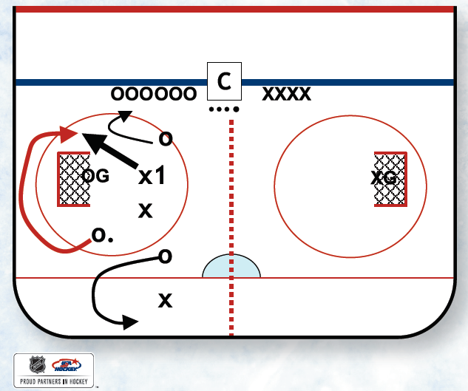
Coaching Points: This game helps teach the finer points of the F1 forecheck role and should be tailored to fit coaches’ preferred forecheck style. Most coaches like pressure on the puck, so in this game, F1 can be instructed to pressure hard on the puck (but don’t chase O1 behind the net if there’s no chance to get a good angle). This drill creates many live situations for your players to apply attacking-zone pressure on the puck. You can teach F1 proper angles, proper stick position, proper speed and closing techniques. You can also progress and add F2, teaching the anticipation or read-and-react part of your forecheck system to regain the puck.

Concepts Taught: Forecheck, angling, stealing the puck, read and react, breakouts, puck support and goal scoring.

Attack and Backcheck Drill
Purpose: To create high tempo in attacking the offensive net, then transition from offense (attack) to defense (backcheck) in a high-tempo situation.

Drill Structure: Four lines of players in two groups of Os and two groups of Xs. Have pucks in designated lines only (one O line and one X line). On whistle, two Os attack the opposing goal 2v0. After this attack is over, e.g., goal is scored, goalie freezes the puck or rebound is to be played, coach blows whistle (coach’s option). On this
whistle, two things happen:
- Two Os stop at the goalie and backcheck through the mid-lane of the ice.
- At the same time, two Xs attack the opposing goal with speed, trying to beat the two O backcheckers up the ice. After the X attack, then Xs become backcheckers against the new O attackers.
Drill Rotation = Attack > Backcheck > Done
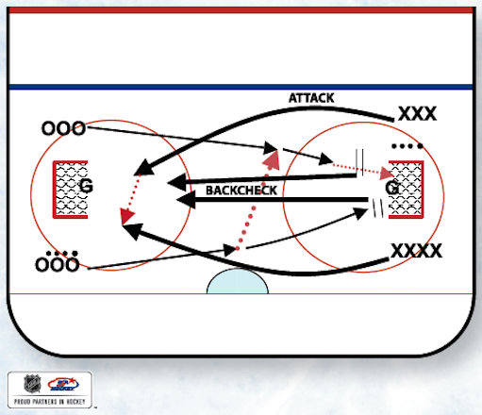
Coaching Points: Both players in line must be ready (one player with puck) to explode on offense. A head-man pass works well. Offensive attackers must read the pressure. If there is no pass option, encourage player to shoot to score or shoot off the goalie’s pad for a rebound. Offensive players must stop on the net (players cannot “fly by” the net because they’ll lose the backcheck opportunity). Encourage backcheckers to fill the mid-lane and get sticks on the ice. Backcheckers will break up many lazy passes in this drill, which should transition quickly. Encourage second chances and brief net-front battles if there are rebounds on the initial shot.

Comments: Emphasize two-way play. Teach and encourage effort on both sides of the puck.

Join, Read & React Drill
Purpose: To create an environment where players are forced to join an active live play while thinking and reading the play. This drill develops instincts and hockey sense. It also allows the coach to see which players quickly read the action and assume the correct supporting role (either offense or defense).

Drill Structure: Set up two nets cross-ice. Use black foam dividers to create a lane from the center red line to the blue line. Drill begins with live 1v1. Once play is established, coach taps stick to signal two additional players. On the coach’s stick tap, they jump the barrier, tag the blue line, sprint to the center red line, then sprint into the zone. When these players enter the zone, they must read the play and assume the correct roles.
Encourage verbal communication. Once 2v2 is established, coach taps stick again to signal X3 and O3 to join the drill.
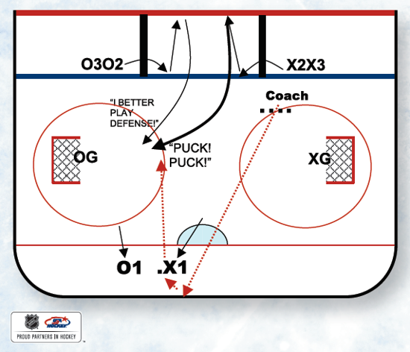

Coaching Points: Purely role recognition. Players must understand that help, either offensively or defensively, will be on the way. Players need to recognize situations and ultimately help or use teammates wisely. Teach the puck carrier to attack or wait for offensive help. Teach incoming defensive player(s) where the highest-threat areas are on the ice and how they can effectively enter the zone to add an additional layer to the defense.

Teach players that the sooner they support the puck, the better chance their team has to win the offensive or defensive situation. This drill is great to teach roles away from the puck. Watch your players to see how fast they can change roles between offensive and defensive responsibilities.

Big Box 3v3 – Outside Lane Drive (Two Goalies)
Purpose: The big box acts as a barrier that offensive and defensive players must negotiate with skating and puck-support skills. The idea is to encourage 3v3 play, pace and transition. More importantly, this game will force the offensive players away from the puck to skate hard, or move fast to join the rush on the opposite side of the box. The nice thing about this drill is that it reinforces good offensive habits. If the players don’t skate hard to support the puck, they will not be in the offensive rush. They will literally be stuck behind the box, out of the play.

Coaching Points: Play 3v3 in one half of the ice (from the center red line). The drill can be played side-to-side or lengthwise. Waiting players are located inside the box (constructed of foam dividers). Put an emphasis on coaching the players who don’t have the puck and make sure these support players are anticipating offense and moving assertively to join the offensive action at the opposite side of the ice.

Also, when a defensive player gains control of the puck, teach that puck carrier to attack the open lane instantly. Encourage them to avoid bringing the puck back toward the defensive net. At times, all three defenders may be on the opposite side of the ice, which will allow the puck carrier an open lane to the offensive net. Instruct them to take it.
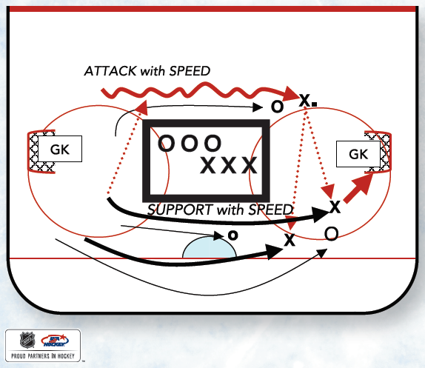
Comments: This drill will identify players who are slow to react or just plain slow away from the puck. Encourage anticipation to offense and racing up the ice to the opponents’ net. Use short shifts. Have players jump over dividers to start and end shifts.
FLANK Game
Purpose: Puck Support, Power Play, Penalty Kill & Transition
Drill Mechanics: The game begins 2 vs. 2 with teams also having two support flank players on both sides in the offensive zone. The flank players can only skate up and down their flank and not into the play. The players with the puck can use their flank players to set up a 4 vs. 2, simulating a power play situation. The flank players can pass or shoot when they receive the puck. On the whistle for a change, the flank players stay and go into the play, 2 vs. 2, and four new players (two on each team) now become the flank players.

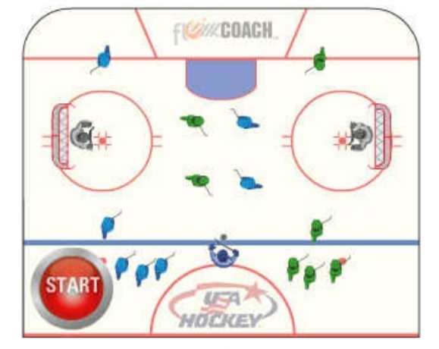
Coaching Points: The team that can take advantage of quick transition will have the advantage during this game.
Offense take advantage of numbers, lots of scoring chances. Defense sticks in lanes, body in shooting lane, read the body language and positioning of attackers.

Comments: Transition happens fast in this game. Take advantage of your numbers and strike quickly.
2v2 Plus Scissor Activation

Purpose: To compete 2v2 and compete defensively to steal pucks, defend and make good outlet passes. This drill does a great job of changing the “hockey role” of the players, since they must act and think quickly as they change roles from offense to defense. This drill also activates the offensive mind and feet with a quick scissor play behind the net.

Drill Structure: To start the drill, coach designates the offensive team (both Red1 players in this example) and that team begins with the puck. Two Gold1 players are on defense. If Red scores, Red gets the puck back and can attack again, make-it-take-it style. If Gold1 steals or gains possession of the puck, they must pass it back to Gold2 players. Both Gold1 players are then done with the drill and return to their line. Immediately, the Gold2 players perform a scissor (interchange) behind the net and attack Red1 players who are now defending. Drill repeats. Now Red1 players attempt to gain puck possession and activate Red2 players.

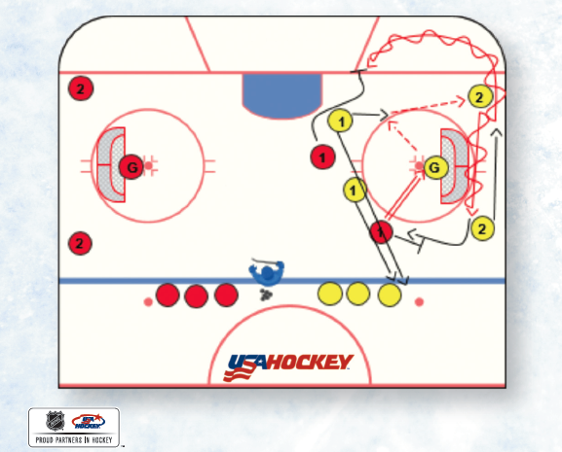
Rotation: Offense, Defense, Out. Players in line start behind the net.

Skidmore 2v2 Wrap Around Drill – Coach Spot Puck to a specific team (Two Goalies/Cross-Ice) (10mins)

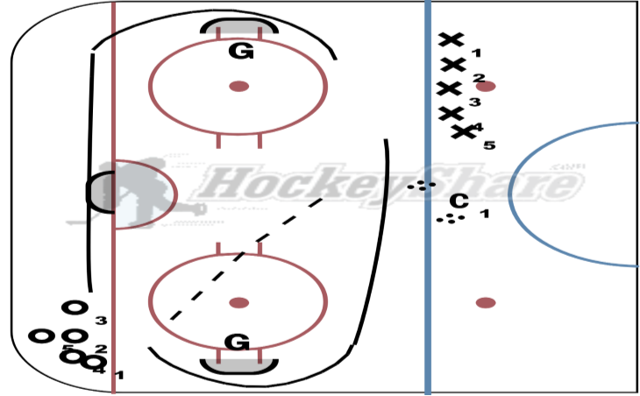

2 v 0 Drill going both directions. (8mins)
Purpose: 2v0 passing/shooting execution drill.

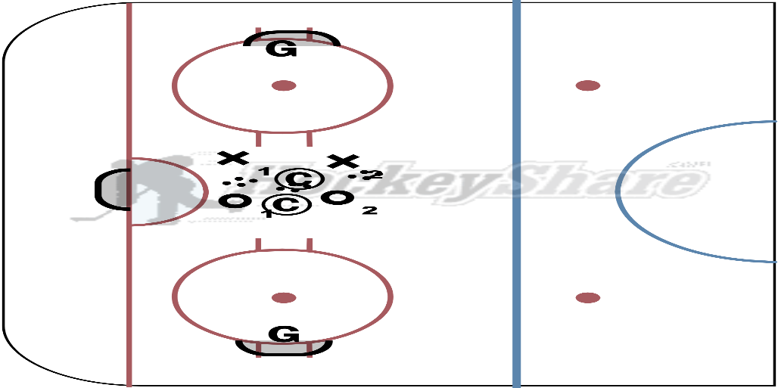
All skaters start 2v0 on the goalie. Crisp passing & shooting (5mins)
All skaters start 2v0 but now the coach now applies light pressure. (5mins)

Purpose: We are looking for players to develop better timing while do 2v0. Correct timing of passes, correct body position while shooting, strong shots on net and strong rebounds.

4v2 Transition Cross-Ice Game (8-10mins)

Purpose: 4v2 transition to goal cross ice, defensive pair wins the pack and passes across the midline to two teammates and join the attack against two back checkers from the initial attacking team. If you score, you get a 2nd puck. 45sec shifts.

Offense take advantage of numbers, lots of scoring chances. Defense sticks in lanes, body in shooting lane, read the body language and positioning of attackers.

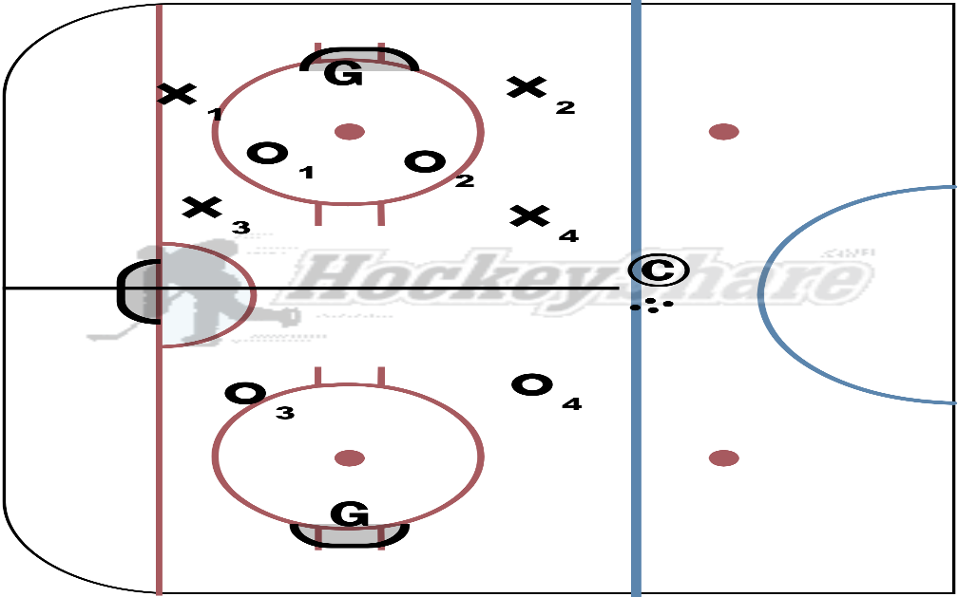
Offensively: Can the defense activate and join/help the attack? Can the use their numbers to their advantage? Are they using deception? Can the execute on their scoring chances?

Defensively: Can they backcheck to break up the play? Are they covering defensively inside out? Can they take away passing lanes with their sticks? Can they use their body to take away shooting lanes?

Questions from the players?

Shooter on the Dot Game:
Purpose: Puck Support, Power Play, Penalty Kill & Transition
Drill Mechanics: The game is played 3 vs 3 with two nets and a goalie on both sides. One player on each team stands on his/her offensive zone face-off dot and is the designated shooter. The other two must pass to the designated shooter who is the only one who can shoot. The defensive team cannot defend the designated shooter. After a turnover, the play moves to the other side, with the defensive team going on offense and the offensive team going on defense. Change every 45 seconds.
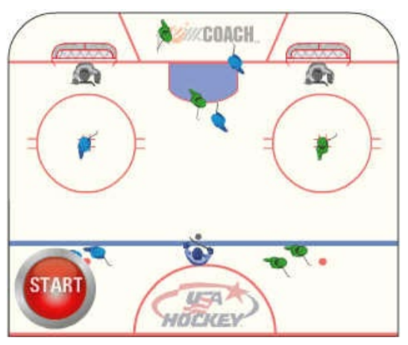
Coaching Points: The team that can take advantage of quick transition will have the advantage. Make sure the opposing teams to not defend the designated shooter. Shooters must get the shoot off quickly.

Offense take advantage of numbers, move the create space & time. Shooter must always be ready be in a shooting position.

Defense, transition quick to take advantage of your numbers.

Comments: Puck Support, offense zone play, defensive zone play, power play and transition
Team Canada Women’s 1v1/2v2 drill – 10mins
Play the 1-1, then join the other side for the 2-2 then play a second 2-2 then exit. Coaches are spotting pucks

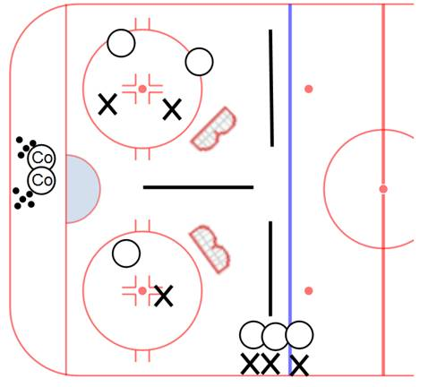

Minuteman Double Battle Drill with Two Nets - 10mins

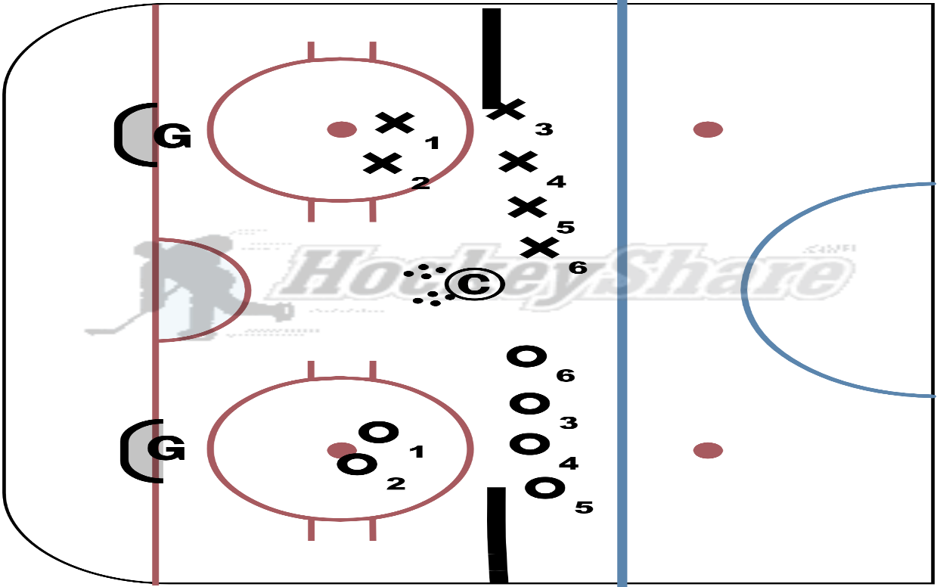
Dark v White: There are 2 separate 1-1 battles going on at once. Both goalies need to be aware and always be looking. Players can score in any net. Play it out until a goal or puck goes out of the zone. As players exit, send 2 new 1-1 players to opposite side. Players from the top of the circles down.

SINGLE GOALIE ZONE SET UP

Ducks Scissors Drill
Purpose: Introduce offensive zone play and teach players to move without the puck to create proper puck support in the offensive zone. The drill creates 2v1 attack situations out of the corner, teaching both the attacking role and understanding of 2v1 defense in front of the net.

Drill Execution: Have lines of players in both corners with pucks. Begin drill with X-scissors player in the slot without puck and a defender in front of the net. Drill starts when X-scissors player skates up and around cone toward X1. Scissor player should stay to the outside or near the wall. X1 skates toward X-scissor on the inside and creates an exchange or drop pass, then loops around cone. X1 and X-scissor then attack the defender 2v1. Once the offensive thrust is over, X1 becomes the scissor and the drill repeats on the other side of the ice. Scissor then becomes defender. Previous defender joins a line in the corner. This is a continuous drill.
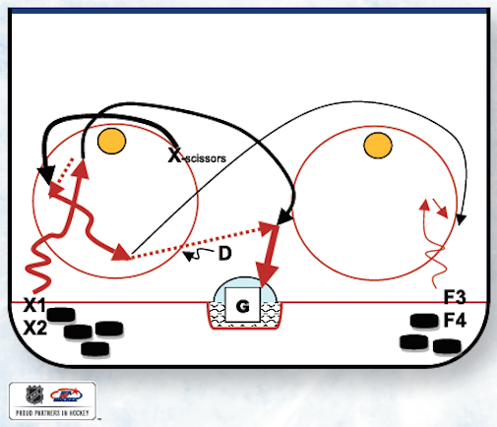
Player Rotation: X1 line > X-scissor > Defense > Out

Coaching Points: Emphasize speed of attack and a quality exchange. Try to exchange the puck toward the safety of the wall instead of open ice in the middle. Emphasize strong, decisive attacks 2v1 to the net. NOTE: This drill can be performed in a smaller space as well.

Comments: This is a great introductory drill to teach the concept of puck support. This drill forces the player away from the puck to move toward his or her teammate and support in the offensive zone.

Puck Control – Stickhandle and Shoot
Player starts in circle with 1 puck
Stickhandle in random pattern, on whistle – shoot
Coach then adds 2 pucks, stickhandle both and shoot both.
Coach then adds 3 pucks, stickhandle all 3 and shoot all three
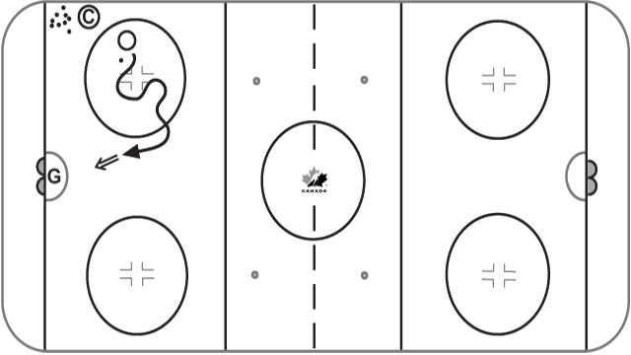
Key Teaching points
Quick hands
Shoot to score
When using 2 or 3 pucks, place them in position to shoot quickly

Skating – Defense Agility Transition
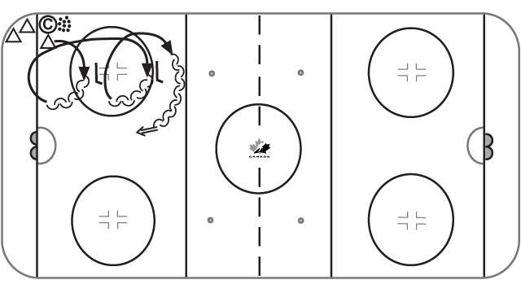
Agility “slide stops” from forward to backward and backward to forward
Keep toes up ice and pivot in front of each stick
Good shooting principles on blue line

Key teaching points
Keep your speed
Keep shoulders square and toes up ice
Get the puck on your forehand as soon as possible
Work on quick feet

Video Link: https://www.hockeycanada.ca/en-ca/hockey-programs/drill-hub/3847141223001/skating--defence-agility-transition
5 Puck Agility Drill

Place 5 pucks in circle as shown. Player must skate around each of the outside pucks, and always come back to the middle before skating around one of the outside pucks again. Toes always pointing forward during transitions.
Add puck for progression

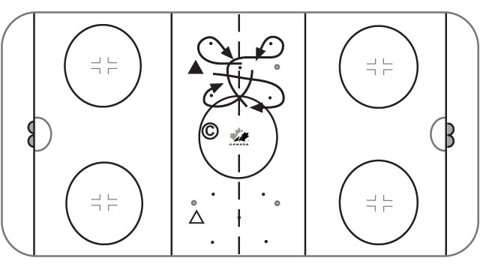

Key Teaching Points
Quick feet, stay low for balance
Efficient movements! Try to do only 1 crossover to get back to middle

2v2 Outlet Game with 4 active Outlet passers

Drill Execution: Dark v White: 2v2 skaters in the zone. Each team will have an offensive and defensive outlet they can pass to. Each team must make at least one pass to either outlet before they can transition from defense to offense. Outlet players can pass to each other. Rotate the goalies every 2 shifts.
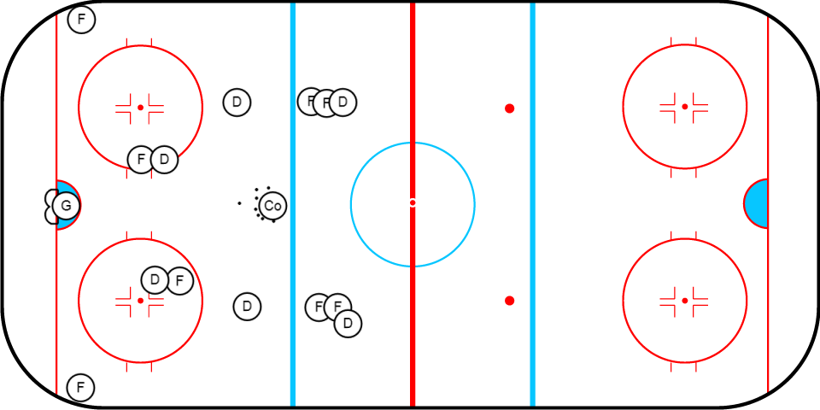
Purpose: Great drill and it really gets the kids moving/thinking. 8players engaged during each session. The 2v2 skaters exit the zone after each whistle, the active passers become the skaters, the 4 skaters not in the drill become the passes.

RICE Levels Game: 10mins
Coach fires puck in the zone, play 2v2 or 3v3 for 30/45 secs with dual coach support along the side.

The game is played 2v2 or 3v3 with coaches on both sides of the boards for support. The coaches can skate up and down the boards to get open, but they can’t enter the play. Players must pass to a coach to be able to go on offense. Players from either team can pass to either coach throughout the game and they can score on either net to foster creativity and deception.
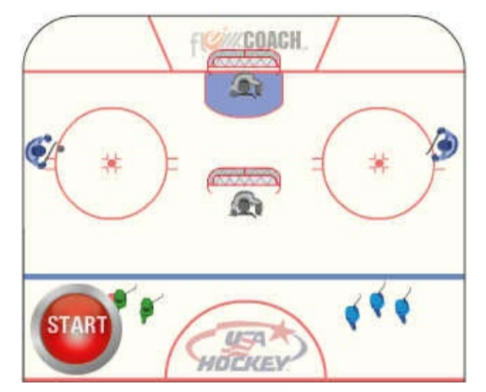

3v2 in the BOX (1 Goalie)
Shrink the space in front of the goalie. Two coaches to line up at the gaps in the dividers. Once coach fires the puck into the space and runs the drill. 3v2 in front of the net. Forwards are trying to score as many times as they can. Defenders are trying to control the puck and skate to the gaps in the dividers or the have to make a clean pass to the coaches through the gap in the dividers. 30second shifts
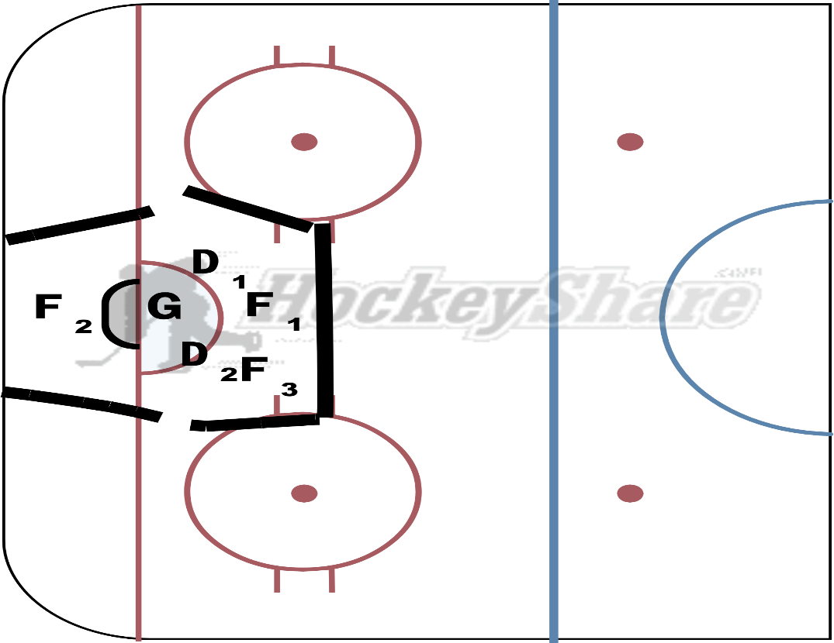
Forwards: Stress constant movement and quick feet in the area. Heads up and quick passes.
Defenders: Quick feet and head on a swivel in the area. Use their sticks to take away passing lanes and force the forwards to the outside.
Goalies: Communicate with your defenders and cover every puck that they can.
I expect hard fought battles and bodies to be flying in this drill.
3v3 All-Out Forecheck Drill (8mins)

Object: Coach creates three “scoring boxes” in front of the net. Coach dumps a puck into the zone. Three Xs compete against three Os. To win the game, the teams must complete one pass to a teammate and you can only shoot from inside the scoring boxes. When the opposing teams has the puck, all three skaters must FORECHECK on the puck. Keep score and roll for about 30-40secs.
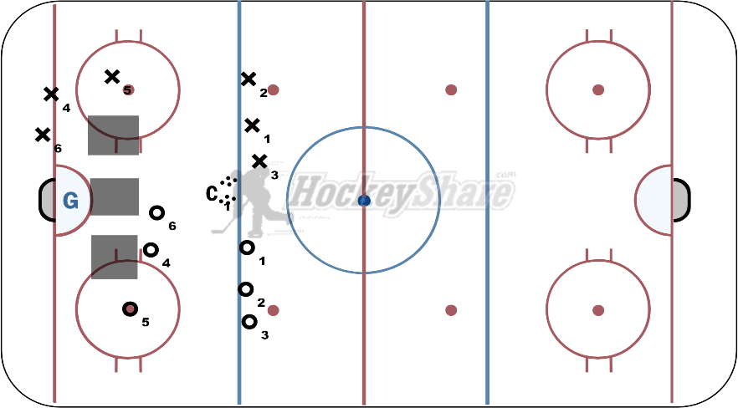
Coaching Points: Emphasize getting to the puck first at the start of the drill and winning that puck battle. Offensively, emphasize puck support and movement and quick passing in the zone. The drill should emphasize quick, smart puck movement, players moving without the puck, getting to the scoring boxes, playing with their stick on the ice (give a good target) and using verbal communication to call for the puck. Players will need to quickly shot once inside the scoring boxes.
Defensively, coaches should emphasize an all-out attack on the opposing teams puck carrier (take good angles, force offensive players to the outside, clog passing lanes), sticks on ice and constant pressure the puck.
Also, for both teams, emphasize quick transition to defense or offense when possession changes.

Breakout/Forecheck Game to the Goalie: (10mins)
Coach dumps a puck into the zone. Three Xs compete against three Os. X’s are forechecking and trying to score. O’s are defending and trying to skate the puck out of the zone and make a clean pass to the coach or goalie.
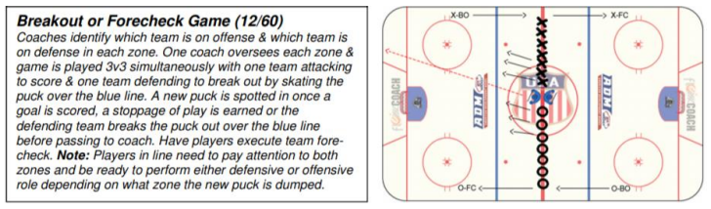

The defensive players must pass it to the Goalie!
3v0 Offensive Attack Drill (10mins)

Purpose: To teach to attackers to enter the offensive zone with Width & Depth.
Drill: Coaches identify the three (3) skater (#1, #2, #3). The Coach to fire a puck to the far side of the ice.
Skater #1 skates full speed to pick up the puck and enter the zone. #1 continues into the zone down the far side with speed, makes a move around the circles (mohawk, head dodge, etc..), then does an escape turn towards the boards and finishes with a pass to Skater #2 in the middle of the ice.
Skater #2 skates to the far set of cones and goes around. #2 adjusts their speed and enters the zone to receive a strong pass from Skater #1. #2 receives the pass, makes a quick dodge and then passes to Skater #3.
Skater #3 skates to the near set of cones and goes around. #3 adjusts their speed in order to time the pass from Skater #2 near the net.
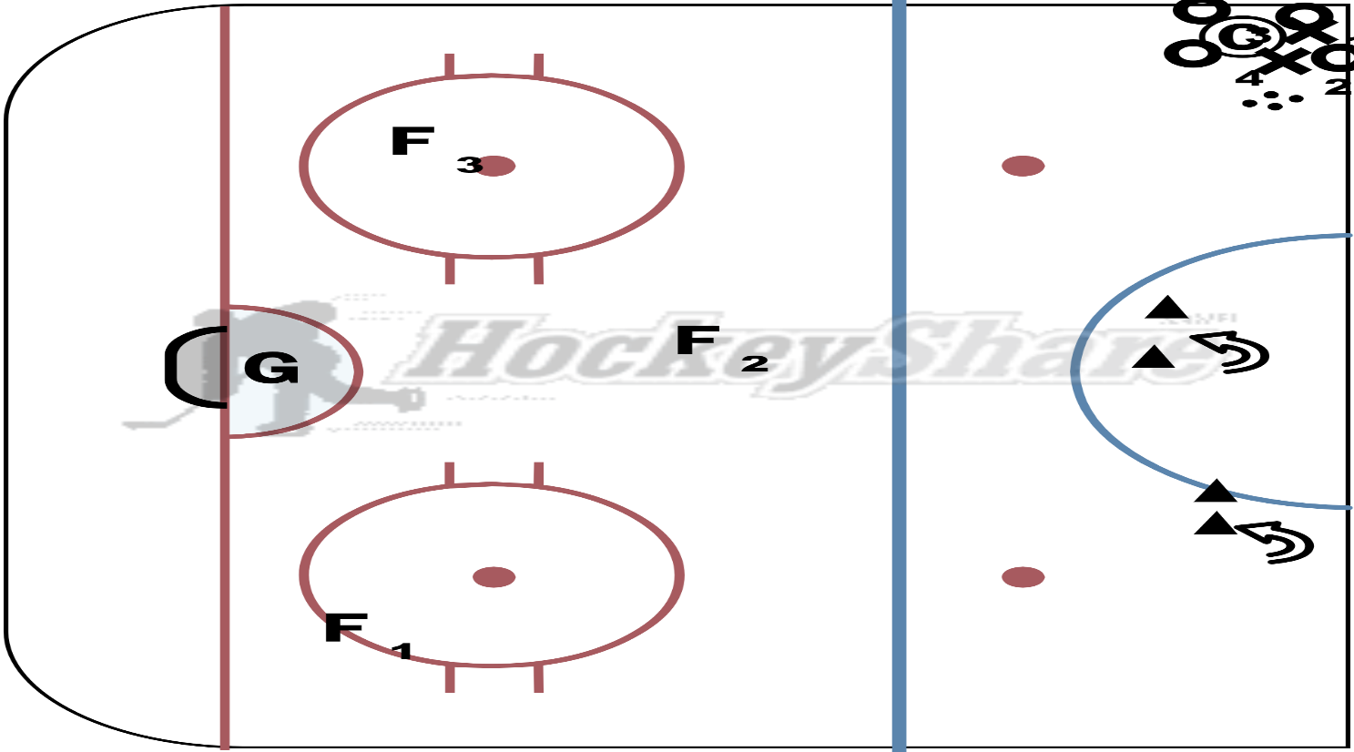

This is flow drill order to teach the attackers timing, patience and how to enter the zone with speed, depth & width. Goalies to rotate every 2 groups.
Faceoff Intensity Game
Purpose: To create a super competitive environment that encourages good faceoff technique and winning faceoffs as a team instead of expecting the centers to win draws by themselves. This game teaches a line-of-scrimmage mentality.

Structure: The game begins with six players lined up as shown in the illustration. Play starts when the coach drops a puck between the X1 and F1 centers. This game creates an opportunity for coaches to teach good faceoff techniques, both in terms of centers winning the draw and also wingers crashing to help.

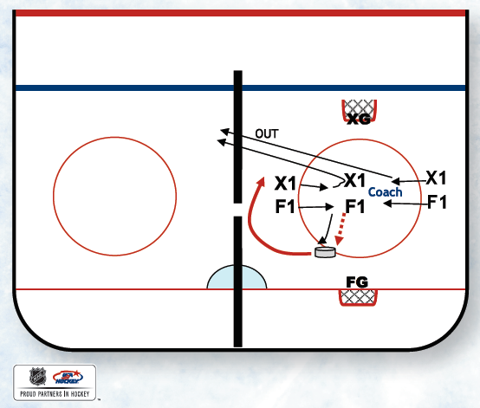

Object: The object of the game is for all players to win/battle for puck possession. Coaches should encourage the players outside the circles on the hash marks to be in a ready position and anticipate the puck drop. Once the puck is dropped, outside players must aggressively crash the dot and battle for a loose puck.

When possession is secured (Team F in this example), both the losing- team wingers (Team X in this example) must immediately leave the game by sprinting out of the playing area (however, the X center stays in the game). This creates a 3v1 for the faceoff-winning team. The winning team is rewarded with the opportunity to go on the offensive and quickly attack the opposing net 3v1. This should happen very quickly, and after a goal or save on either net, players should return to the faceoff circle and line up quickly for another faceoff to get as many reps as possible. Rotate players as you see fit.

12U-18U: D-Zone Build-Up
Purpose: To introduce defensive-zone concepts through a small game. This drill is great for teaching defensive details while providing players many repetitions and a progression up to your five-player defensive-zone coverage.
Coaching Points: Start with one offensive player (without puck) in each corner (X1 & X2). These players should be facing the coach, who stands just inside the blue line between the circles. Defensive players (D1, D2 & F1) should start in front of the net. Coach begins drill by passing a puck to either offensive player (in this illustration, coach passes to X2 initially). NOTE: Coach should not make a direct pass to the offensive player. Coach should bounce the puck off the wall so X2 does not get a clean pick-up. Defending players must then react to the situation. Here is where the coaching begins. Teach D2 how you want to close on the puck (e.g., stick-on-stick, up the wall, stick first-body second, etc.). Teach F1 how to back up the puck and D1 how to play net-front. The object is to force a loose puck, have F1 secure the loose puck and break it out to the coach. Once this happens, defending players should return to the net-front and reorganize themselves and then attack X1 as coach fires the puck into the alternating corner. Have X2 return to his or her original corner and wait for another repetition.
This is a great drill for easily teaching the finer points of defensive-zone play. If you’re teaching layers, zone or man-on-man, you can instruct players on these concepts with this drill.
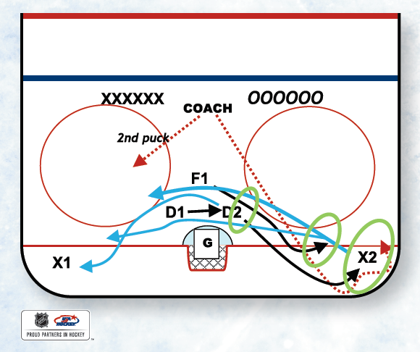
Equipment: One net, one puck.
Progression: Add a second player in each corner; add defensive wingers to teach positional play and defending versus high rolls.

FULL ICE DRILLS

¾ Ice Zone Entry
1side and then the other. 1skater makes the pass to the far side. The Passer walks the line and provides him an outlet pass. Skater takes it the net. The Passer becomes the skater.

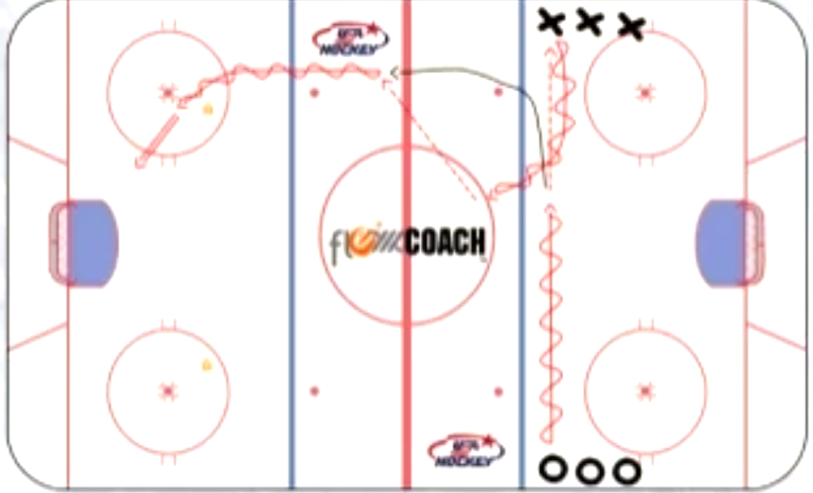

¾ Ice Zone Entry
The two forwards scissor at the blue and then attack the far net. Coach will be there to provide light d pressure.

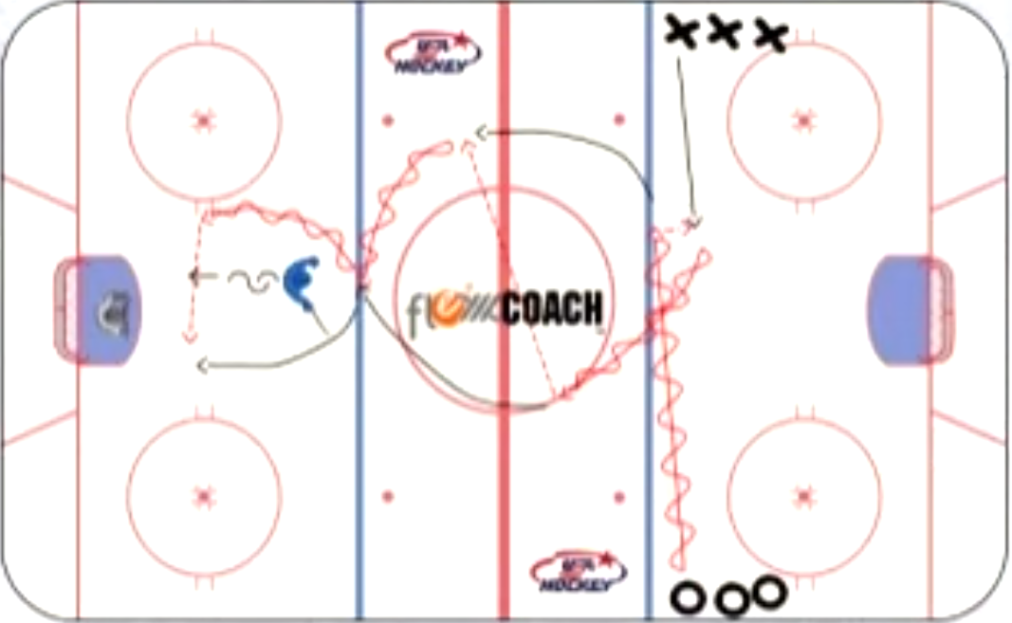

5v3 Neutral Zone Regroup
Set one net facing center ice above the tops of the circles but below the blue line in the middle of the ice. Also, draw or explain to players a dotted goal line from board to board at the net. If the puck crosses this line, the puck is dead and the coach passes another puck in to resume play. Play 3v3 with two defensemen below the opposite blue line from the goalie. These defensemen will regroup both teams.

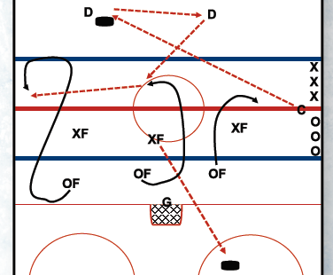
Object: Play 3v3 in the neutral zone. Team that possesses puck must regroup with the two defensemen. The offensive team must move to support the D and accept pass on the defensive side of the red line. You can add an offside rule at the red line if desired. If the defending team steals the puck, they automatically regroup with the D and the drill repeats itself. If Team X shoots the puck wide or the goalies freezes the puck, coach passes another puck to the D which now regroups with Team O for offense (see example).

Coaching Points: Work with your defenders on proper puck movement in the NZ, using the D-to-D pass or the quick option of an immediate head-man pass. Remind your D to not stand still while making passes in open ice; keep moving. This drill requires the D to pay attention to the play and know what team is on offense after turnovers. Quick transitions lead to good scoring chances. Also, work with your offensive forwards to hustle back on the defensive side of the red line and get open for a short puck support pass.

USA Activation Drill (Two Goalies):

Purpose: Create a live-action situation for your team. This drill encourages players to battle for loose pucks and activate the defense to create a 4v2. It also works on power-play and puck-possession skills, and eventually, zone entry concepts.

Drill Structure: Put both nets between the tops of the circles and blue lines. Drill starts when the coach shoots puck across the ice. First two players in each line sprint to puck and battle to gain possession. The third and fourth players in each line skate behind nets and become defensive players, ready to receive a pass from O1. Once possession is gained (O1), offensive players (O1, O2) can either attack the opposing net or kick the puck back to their two players behind their net (OD1, OD2). If OD1 receives the puck, he or she can immediately attack open ice or pass D-to-D. Both ODs activate regardless and the four offensive players then attack 4v2 vs. the two Xs. Puck possession is important. Once the puck is shot wide, or if the goalie freezes the puck or the defending Xs intercept the puck, then the two ODs return back behind their defending net and the Xs activate and attack.
Drill should run in 30-second shifts. Four new players activate from each line on each whistle. Be sure to create a puck race to begin the drill.
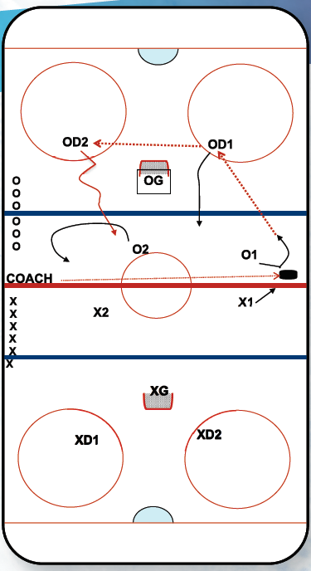

Coaching Points: This is live action. Teach puck-battle skills and prompt the offensive player to survey the opportunity to score or activate the players behind the net. Encourage behind-the-net players to head-man the puck appropriately, but also to attack the open ice with their feet and puck. This will influence the two defenders and open passing lanes for the other offensive options.

Progression: Behind-the-net players must pass D-to-D. They retrieve all wide shots and attack the game with speed. O teammates should regroup low (possibly even behind the net) while X1 and X2 must stay in the neutral zone.

