Passing: NEVER USE THE TOE!
Warm up
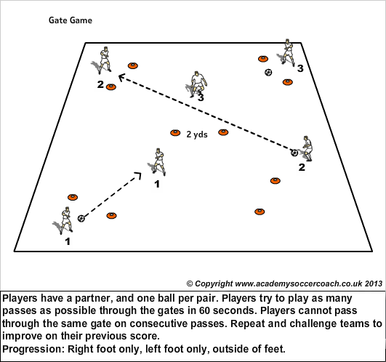
To improve technique, in pairs pass the ball using inside of the foot.
Coaching points: Use inside of the foot (arch or where the logo is on the shoe) and following through. Hit the middle of the ball. Non kicking foot should be next to ball.
Make it a game. How many passes can you do in 30 seconds.
Receiving the ball: Heel down, toe up.
Do the above game again to see if they have improved.

Activity 1: Groups of 4, in an area 20x20. Get the players moving around with one ball passing it between them. Try and get the players to take 2 touches. If they are really good they may want to try one touch.
Coaching points: Be in front of the player when receiving the ball. Get the player who wants to receive the ball to call the name of the person who has the ball.
Activity 2: Keep ball. Groups of 5. 4v1. 1 minutes games. How many times can the defender get the ball. Each player has a turn at being a defender.
In your area can you set up boxes. 3v1/4v1. Kids arrive at different times so this will allow them to be doing something constructive. 10 mins: To warm up. Groups are to do the number 1-5 for their warm up. Dynamic stretching.
Activity 1- 8 mins: Players can dribble around the areas using what move/number they want. Add in defender(s). You may want to restrict tackling, depending on level of players. Coaching points: head up/space awareness/ ball close to feet, keeping knees over the ball.

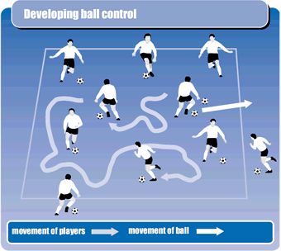
Activity 2- 10 mins: Making it 1v1 but defender is not allowed to tackle, they just have to jockey partner. Other pairs will be going at the same time so will also have to be aware of space. Coaching points: attack space and standing leg.

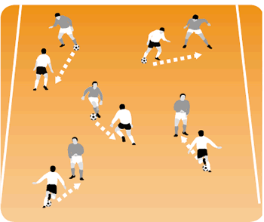
Activity 3- 10min. Only have two zones because of space. Some groups will be jockeying, others will be able to tackle depending on ability. We want the kids to be successful. Points are awarded for how many zones they get through. Example: They beat first defender they get 1 point and so on.
Coaching points: Keep ball controlled/Head up to see where the space is for next move.
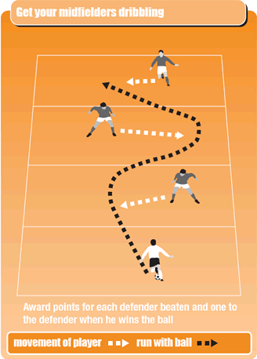
Game situation: 2v1

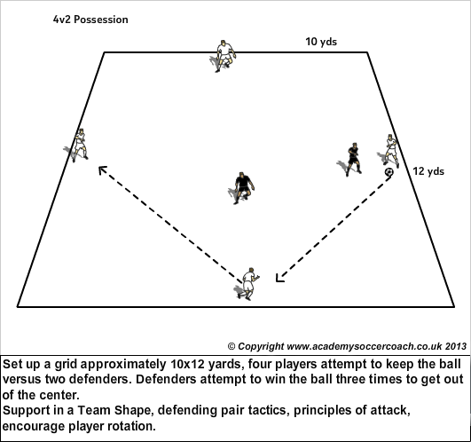
Coaching points: Try and do 2 touch. Receive with one, pass with the other. Players must be able to see the ball otherwise the player on the ball cannot see them. Defenders work together and close down the ball.
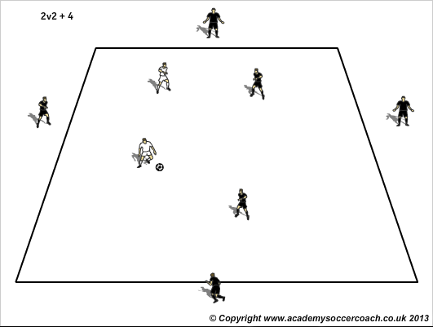
Players on the outside are allowed to pass to each other. Coaching points: Working on first touch. Always moving to the ball. Angles.
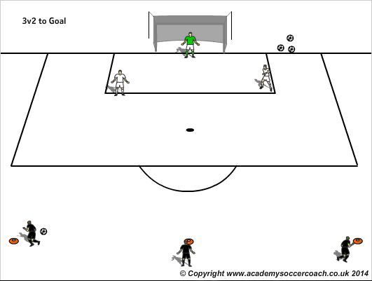

Coaching points: Attackers keep spread out. Encourage to shoot if defenders don’t shut down.

