SLPYHA Board Meeting Agenda
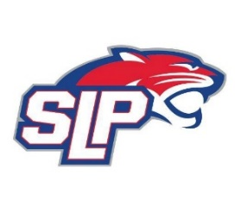
Date: 8/9/21
Roadside
7:00pm

Attendees: Scott Lichter, John Pitzl, Corey Piekarski, Mike Mliner, Jason Shipman, Adam Kiedrowski, Mike Fitzpatrick, Kevin Mitties, Bob Roloff, Jeremy Flaten
Guests: Sarah Clark

- President Report: Scott Lichter
- Call to order: 7:00pm
- Approve agenda
- Approve minutes from 7/19/2021 meeting, motion: Lichter, move: Mliner
- Latest D10 updates
- Golf tournament -$ Report
- Tryouts – schedule, judges, etc…
- 9th grade non-SLP school
- Equipment – tryout, practice and goalie gear
- Vice President Report: Michelle Rice/John Pitzl
- Treasurer Report/Gambling Report: Mike Mliner
  - Motion from Pitzl to transfer $15,000 from gambling account to hockey account, Moved by Lichter
- Secretary Report: Corey Piekarski
- Traveling Director Report: Jason Shipman/Adam Kiedrowski
  - Tryout scrimmages
- Girls Traveling Director Report: Kevin Mitties
- Mite Director Report: Mike Fitzpatrick
- Coaching Director Report: Jeremy Flaten/Bob Roloff
  - USA Hockey #’s
- New/ongoing Business:
- Motion to dismiss: 8:56pm, motion: Piekarski move: Lichter

