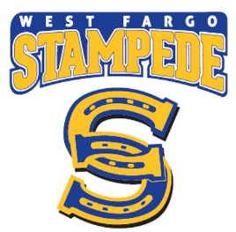  You and your opponents want the same thing. The only thing that matters is who works the hardest for it.  Good Luck PeeWee Blue!  Brock |  | You and your opponents want the same thing. The only thing that matters is who works the hardest for it.  Good Luck PeeWee Blue!!  Ben
You and your opponents want the same thing. The only thing that matters is who works the hardest for it.  Good Luck PeeWee Blue!  Jaydan |  | You and your opponents want the same thing. The only thing that matters is who works the hardest for it.  Good Luck PeeWee Blue!!  Kyan
You and your opponents want the same thing. The only thing that matters is who works the hardest for it.  Good Luck PeeWee Blue!  Xander |  | You and your opponents want the same thing. The only thing that matters is who works the hardest for it.  Good Luck PeeWee Blue!!  Logan
You and your opponents want the same thing. The only thing that matters is who works the hardest for it.  Good Luck PeeWee Blue!!  Kaiden |  | You and your opponents want the same thing. The only thing that matters is who works the hardest for it.  Good Luck PeeWee Blue!!  Jack
You and your opponents want the same thing. The only thing that matters is who works the hardest for it.  Good Luck PeeWee Blue!!  Jack |  | You and your opponents want the same thing. The only thing that matters is who works the hardest for it.  Good Luck PeeWee Blue!!  Kyler
You and your opponents want the same thing. The only thing that matters is who works the hardest for it.  Good Luck PeeWee Blue!!  alec |  | You and your opponents want the same thing. The only thing that matters is who works the hardest for it.  Good Luck PeeWee Blue!!  Dustyn
You and your opponents want the same thing. The only thing that matters is who works the hardest for it.  Good Luck PeeWee Blue!!  Matt |  | You and your opponents want the same thing. The only thing that matters is who works the hardest for it.  Good Luck PeeWee Blue!!  carter

