2026 U9 & U10 TOURNAMENT RULES

Middleton Baseball and Softball Commission and any tournament sponsors are not liable for injuries occurring during the tournament.

SOME RULES MAY VARY BASED UPON SPECIFIC AGE LEVEL TOURNAMENTS. RULE ALTERATIONS WILL BE STATED IN WRITING AT REGISTRATION OR PRIOR TO START OF TOURNAMENT.

Game Preliminaries

1. Eligibility:
All players must meet the April 30th age level cut off. Teams must provide birth certificates to the tournament director upon request. Failure to do so will result in disqualification with no refund.

Team Rosters are limited to 15 players.

Players are allowed to play on only one team per division; players are not to be shared. A team must have 9 players to start a game and 7 players to finish once the game has started. No new players may be added during a game.

2. Equipment:
- 9u-10u: USSSA, USA, or BBCOR Bats are permissible as long USSSA Bats are 1.15 stamped, 2 3/4in barrel, no drop rule
- Cleats: Rubber Cleats only
- Baseballs: A standard Little League baseball will be used.
3. Field Size:
- 9-10U: 46/60ft
4. Umpires

Umpires are to be treated with respect always. Umpire abuse will not be tolerated. Ejection from the game or team disqualification from the tournament may result. Managers are responsible for themselves, their coaches, players, and fans.

If there is reasonable doubt that any umpire’s decision may conflict with the rules, the head coach may appeal the decision and ask that a correct ruling be made. Such appeal shall be made only to the umpire who made the protested decision.
- Any umpire’s decision which involves judgment, such as, but not limited to whether a batted ball is fair or foul, whether a pitch is a strike or a ball, or whether a runner is safe or out, is final. No player, manager, coach, or substitute shall object to any such judgment decisions.

There are no protests and the decision of the field umpires is final. The only exception to this if there
is a misapplication of any of the tournament/age level rules stated in the document below. In this case, the head coach should approach the umpire upon the ball being declared dead and ask for clarification with consultation of the Tournament Director or Designee.

Ejections (No Exceptions)
- If a COACH is ejected he/she will be suspended for the next game and asked to leave the entire complex.
- If a PLAYER is ejected he/she will be suspended for the next game and can stay in the complex but needs to be removed from the dugout.
- If a PARENT is ejected he/she will be suspended for the next game and asked to
leave the entire complex.
- ALL ejections are subject to further suspension upon a review from the umpire and
tournament director.

5. Tie Breakers
- Seeds will be determined by overall points in pool play.
- 2 points for a win, 1 for a tie, 0 for a loss.
- Head to head – If more than 2 teams are tied this criteria will be skipped.
- Runs allowed
- Run differential – Maximum of 8 runs per game.
- Coin flip.
- Please note that if there is a 3-way tie in head to head, then it automatically goes to the next tie breaker on the list (runs allowed).

6. Pitching Limits
- 9U-10: A player may pitch 2 innings per game but not more than 6 innings in the tournament. Throwing one pitch in an inning constitutes an inning pitched. A pitcher may not return once removed from a game.

While we use Innings Pitched instead of Pitch Count during tournament play, we strongly believe in coaches prioritizing a player’s arm health. We strongly advise consulting USA Baseball’s Pitch Smart recommendations when making pitching decisions.

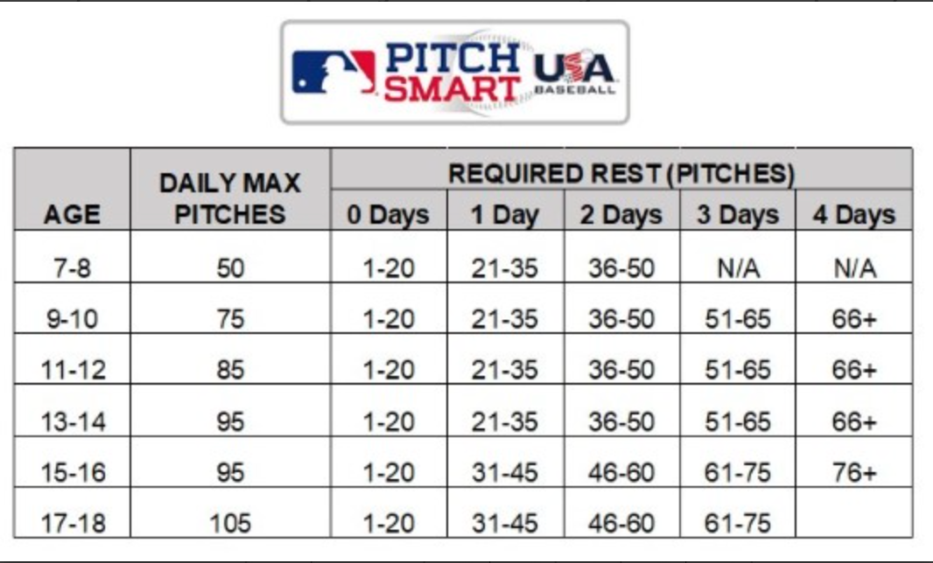

7. Time Limits/Innings (subject to change)
Time starts at the conclusion of the home plate meeting:
Ages 9-10U: 6 innings or 1:30 time limit.
- No time limit for Championship game - run rules still apply; coin flip for home team.

8. Coin Flip:
- A coin flip will determine home team through pool play. The team that traveled the furthest gets to call the coin toss. Home team is official scorekeeper and visitors will operate the scoreboard.
- Bracket/Seeded Games: Higher Seed is Home Team.
- Championship Game: Home Team is determined by coin flip unless an overall tournament seeding is utilized.

9. Extra Innings:
- California Rule after time limit or inning limit – 0-0 count, 1 out, last batted out on
2nd base (Applicable only if Bracket Play is utilized, excludes Championship game).
- No extra innings or Cali Rule in pool play; just bracket/seeded play.

10. Run Rule:
- Ages 9-10U = 15 after 3 innings = 10 after 4 innings.

11. Coaching
- 9U-10U: Only 4 coaches/adults are allowed in the dugout at once; the scorekeeper counts as a coach.

Game Play Rules
NFHS Rules Apply (Unless Noted Below).

Batters and Runners

- On-Deck Hitter
- 9u-10u: On-deck batter can warm up in the on-deck circle on side of hitter .

- Batting Lineup
- 9u-10u: Teams must bat the entire line up.

If an injury occurs and the injured player is unable to return for his next at-bat, the player will sit out for the rest of the game unless the opposing coach agrees to nullify the rule. No out for injured player.

- Basepaths
- 9U-10U: Stealing is allowed once the ball crosses home plate. No leadoffs.
- 9U: Home is Closed.
- 9U-10U: Infield Fly Rule is in effect.
- Batter is out on dropped 3rd Strike.

- Bunting
- 9U-10U: A Batter may not bunt. If a bunt is attempted, a strike will be called and all runners must return to the previous bases they occupied prior to the pitch.

Pitching

See Game Preliminaries (above) for tournament pitching limits.
- 9U- 10U: Once a pitcher has been removed, he may not pitch again in that game.
- 9U-10U: 1 free visit per inning; the pitcher is removed upon the second visit.
- 9U-10U: No Balks

Intentional walk
- 9U-10U: Coaches can request the batter be intentionally walked, no pitches need to be thrown.
Courtesy Runners
- 9U-10U: Are required for catchers with 2 outs, last batter out.

Defense
- 9U: 10 players on defense, must have 4 outfielders

9U-10U General Rules

Pre-game Preparation
- No pre-game infield. Warm up in the outfield ONLY.
- Batting Cages are available on first come basis. Please limit hitting time so other teams have a fair opportunity. There will be no monitoring of the cages. Team’s use of batting cage at their own risk and are liable for any injury or loss of property.
  - You are allowed to hit wiffle balls or no flight balls in foul territory.
  - DO NOT hit against the fence or backstop.
- Games can possibly start 15 minutes ahead of schedule; if BOTH coaches agree, games can start more than 15 minutes ahead of schedule.

Weather Delay Policy:

If one field goes under weather delay, ALL fields go under weather delay.
- Automatic 20 minute delay for lightning. No delay for thunder.
- Tournament Director will send email and text.
- In the event of rain, our fields hold water very well; if the rain becomes dangerous,
we will pull all the players from the fields and resume when it is safe to play again.
- In the event of lightning, we will pull all the players from the fields and go under a 20
minute delay; every spotting of lightning by an umpire or tournament director will
start the time over; we keep a close eye on the weather with lightning and rain; we
don’t go under a delay with thunder.
- If weather is going to significantly alter the start time of game times, a text and email
will be sent to coaches as well as an announcement at the complex.

Shortened Game due to Weather
- A game shortened by rain is a complete game if 4 complete innings have been played, 3 ½ innings if the home team is ahead. A game called prior to this point will be a suspended game and will continue from the point the game was suspended when play can resume.
- The score of a game called after 4 complete innings will be the score at the time the game is called if the home team is ahead or the score at the end of the last complete inning if the away team is leading at the time the game is called.
- In the event a game is called due to rain after 4 complete innings and there is a tie at the time the game is called, the game will be complete for pool play. See #5 above for the official score of the game. A suspended seeded game will continue from the point that play was suspended when and if play can resume.

Additional Rules/Procedures:
- No carry-ins; each team is allowed ONE cooler of water or Gatorade to be brought in by a coach.
- TEAM CHECK-IN: A team representative will turn in a roster and a copy of team insurance.
- The scores and standings will be updated and posted in the area near the concession stand under the overhang.

Tournament Refund Policy/Pull Out of Tournament Fees
30 days Prior to Tournament - Refund Less $75 Deposit Fee
Less than 30 days to Tournament - Forfeit Full Tournament Registration
Host Tournament Cancellation - Full Refund

Weather Policy
- A game started is a game played.
- 0 games started- full entry refund
- 1 game started- full refund minus $75.00.
- 2 or more games started-no credit will be awarded.

