Attendees: Michelle T, Liz Young, Shaun Hallman, Lauren Wellbank, Byron Masi, Bryon Cramsey, Michael Stanley, Hassan McCoy, Kenny Wellbank, Adam Segall, Annie Greaves [six volunteers from NHS were also there to provide childcare, however I misplaced that sign in sheet].

- Call to Order: Bryon called meeting to order at 7:10om
- Motion to Approve Minutes: Lauren W motioned to approve March 2025 minutes, Shaun seconded, nobody objected.
- Monthly Wins Recognition: Jamie Painter made two more new scoreboards for Laubach baseball fields! Liz’s wrestling season made 4K surplus! Two Wins!
- Old Business:
    - Community Day Planning Committee: Still working out a couple of details, Coca-Cola will donate 5 cases water, 5 cases soda. Guest Hassan M. recommended Woodys for the pizzas, we could get them for $7/pie rather than $10/pie from Penn Pizza. Iron Pigs are coming too to run a table. Flyers – paper flyers can go out next week and Brittney will get them.
    - LOGO Update: Alix Martinez is the designer, she is still working on it.
    - Update on Gym mats – Brittney sent the money for the SES gym mats, SYA’s contribution to this matter is over.
    - Update on the Garage Space – no electricity still, we should arrange a date to all go and work on cleaning it up. Bryon will ask Tammie about the electricity. [Addendum: we found out from Frank that PPL needs to connect electricity from the pole to the building. Once they do that, we can get the overhead garage door opener and light switches can be mounted]
    - Porta-Potties: needed at Laubach and the Elementary school, discussion about where to put a second one in Laubach. There will be one by the concession’s stand. There are two at Franko currently (one behind the shed). Lauren W says maybe we should take out the one at Dodson because nobody is using it.
- Quote of the Month – “Be Decisive, we cannot wait to get complete consensus on all issues/actions”. A brief discussion ensued about this good advice. The Decide part is the most challenging, especially when trying to accomplish things quickly or move quickly during meetings. We need to understand what decisions need consensus while going fast. Decisions need to be made in the best interest of the youth. Once we make a decision, we need to be able to explain the why, all the things that support our decision making.
- Directors Updates:
    - Fundraising: looked into Shake Shack for dine and donate, waiting to hear about that.
    - Concessions: The stand is open, all inspected. Treasurer paid Kissler.
    - In-house Baseball: Seasons off to a start. Uniforms had some issues. The weather has not been great, fields are a mess, Kenny reports being a bit burned out. Opening Day is Saturday (4/26) but unlikely due to weather. [Addendum: Opening day ceremony ended up being on 5/3] Three raffle prizes will be raffled off at the opening ceremony, the money will go to the concession stand for free hotdogs for the kids. Reminder that there is no port a potty at SES yet. Whatever SYA members can do to support the in house program is encouraged, any help would be welcome. SYA players were invited to the SHS Varsity teams senior night at Limeport Stadium for the National Anthem. Kenny plans to buy a sliding mat instead of using cardboard to learn to slide.
    - Travel Baseball: no updates, season started and going well.
    - Softball: The 10u and 12u season is off to a great start. There are 14 girls registered on the 12u team and 16 on the 10u team. Tiffany and Michele have been able to work around the April weather with the use of the middle school and high school gyms. The girls just received their uniforms and are anxious to have their first games next week. Working on an ice bucket challenge fundraiser. Softball director and assistant will work on budget.
    - Soccer: The season has gotten off to a late start due to the weather and the holiday, and now the first round of games are scheduled for this weekend [April 26-27]. This was already going to a short season but now it’s just 6/7 games for the season. Lauren is looking for a different league, they will consider several, trying to get out of current league due to its poor management.
    - Football: Season is going well, first games on Sunday night (4/27). Games are at 5-6-7 PM at the HS. Byron says to make sure there is plenty of water. They are still awaiting Insurance pricing update.
    - Cheer: No major updates at this time, except that the bathroom situation at Laubach is not ideal and the Squad Easter egg hunts were fun. The girls all enjoyed the little holiday celebration. The girls are excited to cheer for football again; All squads received their team shirts, bows and Poms this week; 3 squads going out this Spring- Rookies (18 girls), JV (18 girls), Varsity (13 girls); All squads will go down to one day a week practices now that games are beginning. 5/6U and 8/10U will be Mondays 5:30-7:30 and 12U will be Thursdays 6-8. SYA Community Day: As Rebecca works closely with Eastern Fire Dept, she has made sure ESFD and possibly Officer Watson and Echo will be at Community Day. Two Cheer coaches will be running the cheer table, Jess Bogan & Rachel Tierno. Information handouts will be available. Raffle basket is made and will be ready. [Annie will pick it up] All 3 squads will take about 10-15 to perform some cheers/dances or simple stunting. A couple of outdoor tumble mats will be brought down for safety/use. Cheer will not be bringing the indoor mats! SYA Iron Pigs Night forms were handed out to all cheerleaders and are being collected. Hoping for a great turnout and team bonding experience.
    - Basketball: I won’t be at the meeting - coaching baseball. Not much interest from kids to play in summer basketball. Jesse Stout is fielding a ⅞ boys team in a league in Whitehall. There were a few single kids that were willing to play on other teams. But no teams had open roster spots. Michele says there are 7/8 girls who are interested and SYA also always used to play in a summer league.
    - Wrestling: The end of season party went great. The final budget/tally is in. Liz sent it to the board in an excel sheet. The wrestling program’s income was over budget by about $4,000 because of the amazing job fundraising and keeping costs low for the banquet and other supplies. This could be made available to the SYA general fund. Mike Dredge did the accounting.
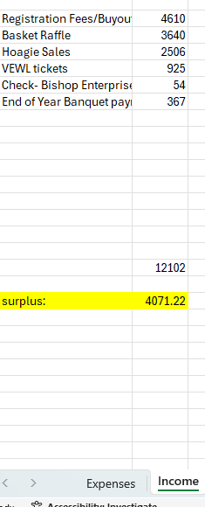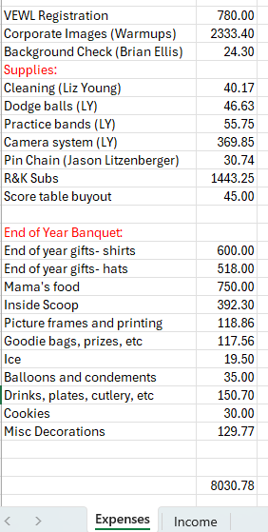
- Team break out session deferred.
- Officers Reports:
    - Secretary:
    - Treasurer:
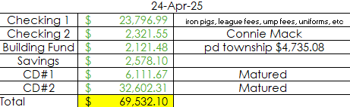
Connie Mack registrations were paid (using the general fund money) and Brittney needs to move the money from CM account into the general fund as a result, to make up for that payment. Dan Soria has no interest in the heading up SYA’s participation in the Legion and neither does SYA, so likely the Legion program will not be running much longer. The donated money can go to Franko field to put in a mound so Connie Mack games can be played at Franko. We have to figure out if/how long Connie Mack will keep playing and how long is SYA supposed to cover fees with the donation money.
    - President: I have not seen any additional Coach’s clearances (other than Kenny and LW’s). Still looking for prelim-budgets (only got In-House & Soccer). Iron Pigs game is May 9th. 96 tickets already sold for Iron Pigs game, out of the 600 SYA already committed to per a contract, which ends in 2027. [ALL AGREED TO SELL IRON PIGS TICKETS AT COMMUNITY DAY – we just need names and email addresses to send the tickets to]. We’ve gotten no answer yet on using Lindberg / Field Permits – Kenny has been surreptitiously telling people (coaches) to use Lindburg if its empty. Jeremy Bachtrum says the Hamilton baseball Program might be dying and SYA can absorb some of those players.
    - Vice President:
    - Chief Admin: Byron’s “ChiefAdmin” email needs to be fixed. The GOC license – Byron will work on this ASAP. Porta Potties – 3 more will be ordered.
    - Communications Officer: Everyone needs to go into their SYA/Gmail accounts and check settings to make sure there is nobody getting their emails forwarded to someone else.
- New Business:
    - Revised Section V of the SYA bylaws were read aloud – Discussion ensued about bylaws ensued – some changes made – discussion about whether each program should have a treasurer.
    - Mike Stanley wants to start promoting the parent child dance for next year…maybe he can have lottery baskets and get more traction at the event. He might make a flyer to put up at Community Day. A brief discussion ensued about doing the dance at a different time…Not the Spring because it’s too busy, not December because it’s too busy, February seems to be the best time. Maybe it could be in the Fall, but that’s when SYA does the homecoming parade and used to do a Phantoms game.

- Motion to Adjourn: Liz made a motion to adjourn at 9:13pm, everyone else seconded.

The next SYA meeting will be 5/15 at 7:00pm, in the SES Library, with childcare offered in the gym for kids who are potty trained.

For Next time: LW has a question about the $25 fee which comes out of registration.

