2022/2023
Annual Report
Pirate Youth Athletic Association, Inc.

Sports Director: Hank Rollinger

About
The Pirate Youth Athletic Association is a registered 501(c)3 non-profit organization that provides youth athletic opportunities for children in grades Pre-K through 8th in the Cochrane Fountain City School District. Athletic programs include Girls Volleyball, Football, Girls Basketball, and Boys Basketball. The association is made up of an all-volunteer board, paid employees, volunteer coaches, community volunteers, and the many children in the community that participate is our athletic programs.

Vision, Mission, and Values

Vision
The Pirate Youth Athletic Association aspires to be a true community asset that provides children in the Cochrane-Fountain City School District opportunities to participate in youth athletics that promote general health & fitness, fun, and teaches participants fundamental skills and important life lessons through sports.

Mission
Our mission is to provide high quality, well-organized, and affordable athletic programs for children in the Cochrane Fountain City School District. The goal is to create a community-based association that is sustainable and can be passed on for generations to come.

Values
- Transparency
- Sustainability
- Accountability
- Community
- Volunteerism
- Fun
- Family Oriented
- Integrity
- Teamwork
- Respect

Donations to the Community
Throughout the years PYAA has donated to Cochrane Fountain City School District for various projects that support athletic programs. The following are some of the items PYAA has donated in past years.
- 2014 $4,476.89 for Boys State Basketball Trip
- 2015 $4,000.00 for Volleyball Nets
- 2016 $1,819.50 for Middle School Gym Pad
- 2016 $1,000.00 for Wrestling Mats
- 2018 $6000.00 for Basketball Hoop Replacement Project
- 2020 $750.00 for Basketball Hoop Replacement Project at Fountain City Auditorium
- 2022 $2,000 for Score Board at High School
- 2023 $3000 for Score Board at High School
- 2023 $2700 for Cochrane Field Improvements

2022/2023 Season Highlights

Football: No report given

Basketball: No Report Given

Volleyball: We were able to offer a normal version of volleyball which included practices and competitive play through the Wisconsin Independent Volleyball League. COVID protocols were followed in order to provide this opportunity for the participants. For volleyball grades 3rd-8th we had XX participants.

Community Ball: As of March 2021 the PYAA has provided youth with various playing opportunities at an affordable price while being able to utilize field space in a number of communities.

Sponsors
We would like to thank our generous sponsors that financially supported the Pirate Youth Athletic Association over the last year. Without their contributions, we wouldn’t be able to sustain the affordable athletic programs we offer.
Sponsors
Alliance Bank | LaCrosse Milling
B&S Express | Mann Insurance
Baures Excavating | Midtown Foods
Brones Bike Shop/ World Cup Coffee | Minn City Detail
CD Terminal | Minnesota City Custom - MCC
C-FC Booster Club | Minnesota State College Southeast
C-FC PTO | Monarch Public House
Cochrane Cooperative Telephone | NorthEnd Pub & Grill
Cyrus Lawn & Landscaping | Pirate Booster Club
Edina Realty - David Taylor | Roadhouse Bar & Grill
Edina Realty - Neil Isakson | Schaffner Tax Solutions LLC
Engel Law Office | Suncrest Gardens
First Class Foundations | Supreme Graphics
First Class Fabrication | The Grove
Fastenal Manufacturing | Universal Truck Equipment
Fountain City Ford | Vision Design Group
Graphic Image | Waumandee State Bank
Great Northern Corporation | Waste Management
HighTine Addiction, LLC | Weldfabulous
Itechra, Inc. | Wnuk Trucking
J&D Special T’s LLC | Jeff’s Carpentry

Municipality Support
We would like to thank the local municipalities that support our programs through financial assistance, facility use, and community support. Without their support, we wouldn’t be able to offer the programs we do.
Municipality Support
City of Buffalo City | Cochrane Fountain City School District
City of Fountain City | Village of Cochrane

Board, Staff, and Volunteers
PYAA Board Members |  |  | Active PYAA Members
President | Ben Adank |  | Football Lead | Joe Holzer
Vice President | Hank Rollinger |  | Volleyball Lead | Kristy Baures
Secretary | Michelle Davis |  | Member | Tina Leverance
Treasurer | Nikki Adank |  | Member | Debbie Meng
Director | Heather Secrist |  | Member | Angie Bambenek
Director | Kristy Baures |  | Member | Collen Bedtka
Director | Tina Leverance
Director | Denise Yapp
Director | Becky Holzer
Staff
Sports Director | Lance Litschfield

Coaches |  |  | Coaches
3rd Girls Basketball | Kevin Halgren |  | T-ball Black | David Timmons
4th Girls Basketball | Annie Lisowski
5th Girls Basketball | Annie Lisowski |  | T-Ball Red | Chris Todd
6th Girls Basketball | Tom Gotzninger |  | T-Ball Red | Jenna Todd
7th Girls Basketball | Ben Holien |  | 8U Baseball | Matt Prieur
8th Girls Basketball | Craig Wolfe |  | 8U Baseball | Adam Pronschinske
3rd & 4th Boys Basketball | Dylan Adank |  | 10U Baseball | Jay Baures
5th & 6th Boys Basketball | Ben Adank |  | 12U Baseball | Quint Yapp
JR High Basketball | Mark Brone |  | 12U Baseball | Joe Holzer
 |  |  | 14U Baseball | Matt Bambenek
 |  |  | 14U Baseball | Rick Kujak
3rd Volleyball | Erin Tullius |  | 14U Baseball | Landon Stoppelmoore
4th Volleyball | Erin Tullius |  | Minor Softball | Denise Yapp
5th Volleyball | Annie Lisowski |  | Minor Softball | Nikki Schiller
6th Volleyball | Annie Lisowski |  | Major Softball | Brian Aspenson
7th Volleyball | Nicole Hunger |  | Major Softball | Brad Schmitt
8th Volleyball | Kristy Baures |  | Seniors Softball | Aubrey
 |  |  | Seniors Softball | Kevin
 |  |  | Football | Joe Holzer
 |  |  | Football | Troy Arneson

Balance Sheet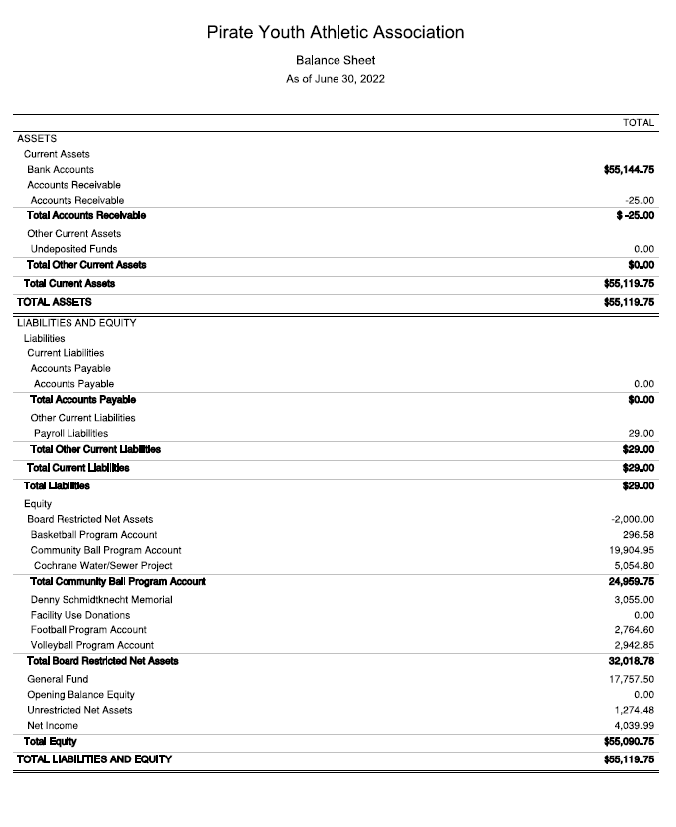

Profit and Loss Statements

