GIRLS HOCKEY
“SNAP SHOTS”
Welcome back to the 2017-18 school year. The hockey season is a short two months away from starting. Hopefully everyone is fully charged and ready to go for the season. A couple of things to put on the calendar is the Fall Clinic that the MGHCA is holding in conjunction with the Minnesota Hockey Coaches Association, the MN Wild and Minnesota Hockey. The “State of Hockey High Performance Coaching Summit” clinic will be held at the River Center in St Paul on September 22nd & 23rd. The registration link is below. The fee includes a lunch during the General Membership meeting on Saturday from 11:00am to 1:00pm. The full clinic schedule and updates can be found on the MGHCA website or the MHCA website.
Registration link for Fall Clinic
https://mnhockeycoach.sportngin.com/register/form/232312792
Another event to add your calendar is the Senior Classic and U18 Festival to be held at the Schwan’s Super Rink in Blaine, MN on March 2-4, 2018. The Senior Classic is an all-star event showcasing the top 136 senior female players from around the state. Teams are formed through their respective A/AA sections which then compete against the other section teams. This year will mark the 20th anniversary of the event which started in 1999 with 40 players competing on two teams. There is no entry fee for the Senior Classic and the U18 Festival. As part of this competition, 20 seniors and 20 U18’s are selected to represent Minnesota at the High School National Invitational Tournament that takes place in April in conjunction with the HP 16/17 Final 54’s and the HP 15 Spring Festival. This event will also take place at the Schwan Super Rink in Blaine. Information on these events can be found at www.mghca.com and www.minnesotahockey.org under the HP tab.
On September 9, the Minnesota Girl’s Hockey Coaches Association will kick off the 2017 Premier Prep League at the Schwan Super Rink in Blaine. 160 high school players, representing 73 different high school programs, will compete for seven consecutive weekends at various rinks across the metro area. Premier Prep hosts eight teams and will also welcome Wisconsin (two teams), North Dakota and others for games throughout the schedule. This year, we are very excited to be sending our league champion on to the USA Hockey Tier II National Championships in Massachusetts! Over 250 girls have participated in Premier Prep and gone on to play NCAA Division I or III college hockey. We are very proud of the level of play in our program and the exposure opportunities that we provide for these players.
If you are interested in more information and/or getting on our mailing list, please follow @PremierPrepHock on Twitter or email jesschristopherson@gmail.com.

Photo: Team Gray won the 2016 Championship at the Xcel Energy Center!
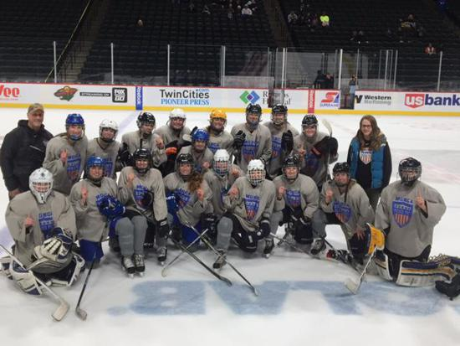
For information on these events or any other activities and awards provided by the MGHCA, go to www.mghca.com. Information regarding all programs can be found there or by emailing any of the Section Reps or Executive Council staff.

