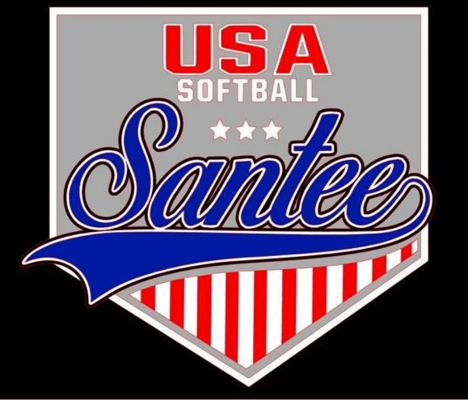
MINUTES TO BE APPROVED AT THE NEXT BOARD MEETING. THESE MINUTES ARE NOT CURRENTLY POSTED AND SHOULD NOT BE DISTRIBUTED UNTIL APPROVED BY USASSCS BOARD.
Board Meeting Minutes August 14, 2023
Location: Santee City Hall
Attendees Shown with Marked Box
President | Jay Strandberg | X | Field Prep | Kevin Hopkins
1st VP/ Field Prep | Erik Ruiz | x | Field Prep | Trevor Henton | x
2nd VP | Kelli Timanus | x | Field Prep | James Timanus | x
Treasurer | Tiffany Lynch | x | Field Prep | Nate Anderson
Secretary/Safety Coordinator/Head Scorekeeper | Bryan Scholar | x | Field Prep | Brad Allen | x
Tax Advisor | Lori Britt |  | Field Prep | Shane Frary | x
Player Agent | Lance Craw | x | Equipment Coordinator | Ryan Zuckerman
UIC/Parlimentarian | Felicia Leca | x | Head Team Parent Coordinator | Dana Hisaw | x
Field Scheduler/Fall Ball Coordinator | Chris Klima | x | Uniform Coordinator | Jamie DeChant | x
Webmaster/Social Media/All-Star Coordinator | Alexis Ruiz |  | Picnic Coordinator/Pictures | n/a
BOTH Tournament Coordinator | n/a |  | Snackbar #1 | Amy Ramirez | x
Sponsorships | Kylee Scholar | x | Snackbar #2
Awards | Janis Aiello | x | Snackbar#3

Guests: N/A
Meeting called to order: 7:06PM
Meeting Minutes
Brad Allen motioned to approve minutes from 7/10/23. Erik Ruiz seconded the motion.
Meeting rule – One Topic at a Time
Financial Update (Tiffany L)
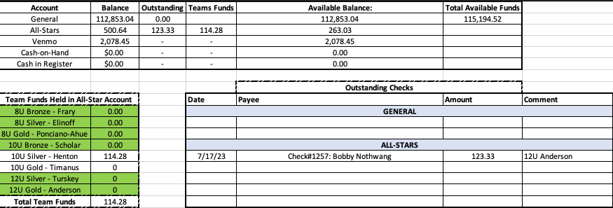

Snack Bar
Upcoming cleaning of the snack bar coming up
Fall Ball
Teams being divided up, and pool players added to teams
Need 2 8u managers to take teams – meeting will be held to get 8u teams established

Fields/Equipment
Field 4 has been laser leveled – new home plate and pitching rubber
Field 2 has a new home plate
All fall ball teams received equipment for 9 games
Put together a committee for marketing/advertising/social media
Dana Hisaw will chair it
Alexis Ruiz and Janis, Kelly Timanus on the committee
Other people interested are Sophia Vigil and Shahday Galloway
- Banners for spring need to go up at the schools the week before thanksgiving
- Open registration Monday of Thanksgiving and close registration January 5
- Evaluations the weekend before the select tournament
Safety – Bryan/Felicia – Zoom on Aug 27 @ 6:30 pm
Meeting Adjourned: 8:41 pm
Next Meeting: September 11 @ 7pm

