Senior  Moments 50’s Volleyball 2024    When  April 13-14  9am-5pm  Where  The rMac - 4895 Ward Rd.  Wheat Ridge, CO 80033  Hosted by:  The Colorado Volleyball Connection “Life’s too short not to play!”  www.coloradovolleyballconnection.com  Providing quality volleyball leagues, tournaments, drop-ins & clinics in the denver metro area since 2002  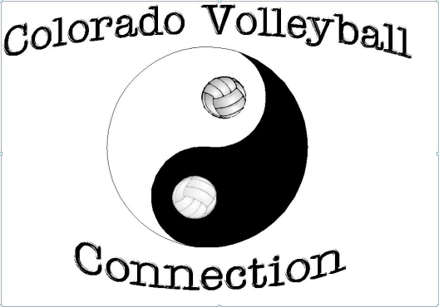 | What is this?  Senior 6x6 all day tournaments play for ages 50+ (as of 12/31/2024)  Formats Offered  *Saturday, Women 50+  *Saturday, Men 50+  *Sunday, Coed 50+ Girl Rule  Included:  Aside from a professionally organized event, each player will receive a Senior Moments Souvenir, & there will be plenty of great raffle prizes, & surprises along the way.  Registration  All formats - $45 per player  singles & teams welcome!  H Ave something to Donate for a raffle Prize? Maybe a business promotion or new gear? Please let us know.  If you want to see more events like this, let us know. If you will play, we will make it happen!

