How to qualify for the Northland Youth Wrestling Association (NYWA) State Tournament

 1. NYWA Membership
Before anything else, your child must have a valid NYWA membership for the season. This costs about $30 and is required to compete in district, regional, and state events.

 2. Compete at a District Qualifier
- Kids in Pre-K through 8th grade must first wrestle in an NYWA district tournament.
- District tournaments are generally scratch weight rounds (no pre-selected weight class).
- Wrestlers can attend multiple districts if they want, but once they qualify for a region, they must wrestle in that region.
 Typically, the top 2 finishers in each weight class at a district qualify for the Regional tournament.
Here are Region 3’s District Tournaments:
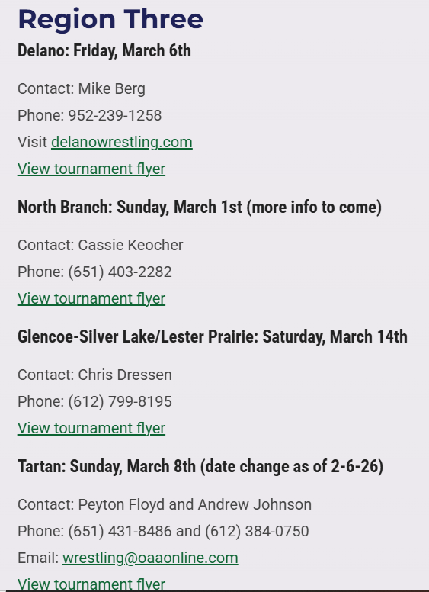

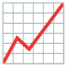 3. Advance Through Regionals
After qualifying at districts:
- Your wrestler goes to the Regional Qualifier assigned to that district.
- In regionals, wrestlers register at a specific weight class (they select and must make that weight).
- At regionals, the top 3 finishers in each individual weight class (in most regions) advance to the State Tournament.
  - A rotating “wild card” region sometimes advances the top 4. This is Region 4 this year.
- 4th-6th place finishers can optionally enter the NYWA Invite Tournament (a separate event).
- Region 3 has one Regional:
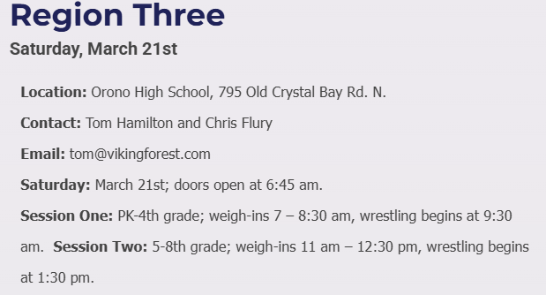

 4. State Tournament
Once your child qualifies through regionals:
- They compete at the NYWA State Tournament, held in Rochester, MN the weekend of March 26-29.
- Wrestlers must make the weight class they registered at regionals — no changes from region to state.
- At state, wrestlers generally receive a 1-pound weight allowance.

 Extra Notes
- Girls also have a Girls State event. This one doesn’t require district/regional qualification — it’s open for registration with a valid NYWA membership.
- Districts are not open events for advancing — kids must follow the district → region → state path (except for the girls state).

 NYWA State Qualification Checklist

February- March: District Tournament
☐ Register your child with your local NYWA-affiliated wrestling club
☐ Purchase NYWA membership (required for districts/regionals/state)
☐ Register before the deadline
☐ Bring:
- USA/NYWA card confirmation
- Headgear, singlet, mouthguard (if needed)
- Healthy snacks & water
 Goal: Place top 2 in your weight group to advance to Regionals

 Mid-March: Regional Tournament
☐ Register for the correct regional (based on your qualifying district)
☐ Choose and confirm your weight class (must make this weight at State)
☐ Double-check weigh-in times
Goal: Place top 3 (sometimes top 4 depending on region) to qualify for State

Late March: NYWA State Tournament
☐ Confirm state registration (don’t miss deadline!)
☐ Book hotel (Use our Room Block for discounted rates)
☐ Make weight (usually 1-lb allowance from region weight)
Compete at State — big atmosphere, long days, great experience.

