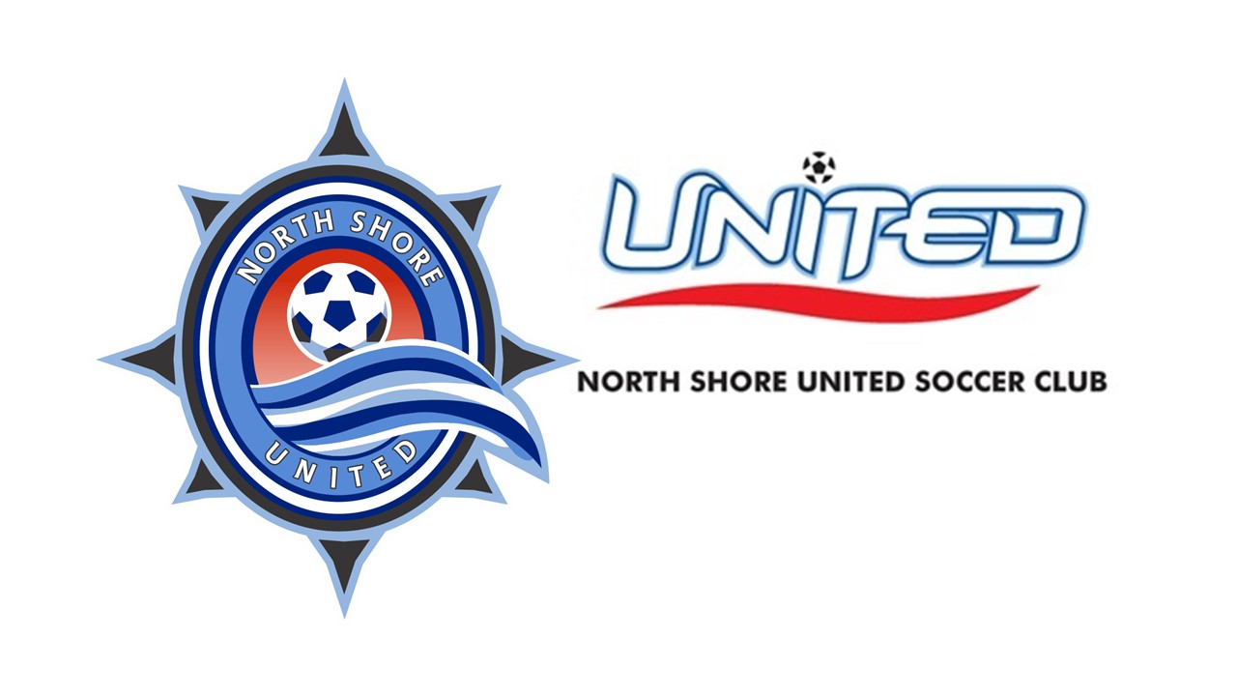
We are reaching out to you on behalf of the North Shore United Soccer Club with a request for sponsorship. As a passionate member of our community, we believe that your support can make a significant difference in the lives of our young athletes.

The North Shore United Soccer Club has been a pillar of our community since 1978, providing a safe and nurturing environment for children from all walks of life to engage in the beautiful game of soccer. Our club aims to instill not only a love for sport but also important values such as teamwork, discipline and respect.

However, running a successful soccer club requires substantial financial resources. We rely on the generosity of sponsors like you to assist us in covering various operating and capital expenses, including coaching salaries, facilities and equipment. By becoming a sponsor of our club, you will directly contribute to the development and growth of these young athletes, allowing them to reach their fullest potential on and off the field.

In return for your sponsorship, we offer numerous opportunities for exposure and recognition. We have over 1500 players in our club across our various programs and while most of our families live in Mequon, Cedarburg, Grafton and Port Washington, we have players that live in Milwaukee County, Sheboygan County, Washington County, Waukesha County, Racine County and beyond. In addition, our teams play in a variety of local, state, Midwest and national leagues. As a result, over 25,000 players and spectators from around Wisconsin, Kansas, Illinois, Indiana, Iowa, Michigan, Minnesota, Missouri, Nebraska, South Dakota and other states throughout the U.S. visit our facilities each year. With our sponsorship, you have an opportunity for your company logo to be prominently displayed at our fields, on our club website and other promotional materials. Additionally, we actively promote our sponsors through social media campaigns, local advertisements, and community events. This partnership will not only have a positive impact on our club but also provide your business with increased visibility among families and soccer enthusiasts from near and far.

With your support, we can continue to inspire and empower young athletes, fostering their growth as individuals and athletes, and positively impacting our community.

Thank you for considering our sponsorship proposal. Together, we can make a difference in the lives of these aspiring soccer players and create a legacy for the North Shore United Soccer Club. We eagerly look forward to the opportunity to work with you and appreciate your kind consideration.

Thank You,
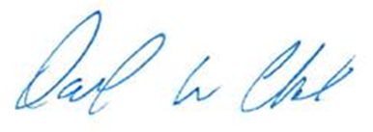
David W. Clark
President
North Shore United Soccer Club
Annual Sponsorship Opportunities

Platinum $1,500
Components include:
- Field Banner with your company name and logo to be displayed in both the spring and fall seasons of 2026 on the main field.
- Optional: An opportunity to host a game day promotion/giveaway each year.
- Company name and logo to be displayed in both the spring and fall season of 2026 by concession stand.
- A link with your logo on the front page of our website.

Gold $800
Components include:
- Company name and logo to be displayed in both the spring and fall season of 2026 by concession stand.
- A link with your logo on the front page of our website.
- Optional: An opportunity to participate in our annual social event.

Silver $500
Components include:
- A link with your logo on the front page of our website.

Thank you for your consideration!

North Shore United Soccer Club

Sponsorship Form

Sponsor Information:
Company Name:
Mailing Address:
City: State: Zip:
Phone: E-Mail:
Sponsorship Contact Name:
Sponsorship Phone Number:

Select Sponsorship Package:
Platinum $1,500 | Gold $800 | Silver $500

Please Make Checks Payable To: North Shore United Soccer Club
Mail To: P.O. Box 815, Cedarburg, WI 53012

Online Payment Option Available: https://www.northshoreunited.org

Email Company Logo: to Melissa Kunz melissak@northshoreunited.org

Thank you for your sponsorship!

North Shore United Soccer Club

