SLPYHA Board Meeting Agenda
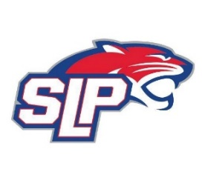
Date: 3/31/21
Zoom
7:00pm

Attendees: Bob Roloff, Corey Piekarski, Scott Lichter, Michelle Rice, Mike Mliner, Jeremy Flaten, Jason Shipman, John Pitzl
Guests:

- President Report: Bob Roloff
- Call to order: 7:00pm
- Approve agenda
- Approve minutes from 3/10/2021 meeting, motion: Roloff move: Mliner
- Latest D10 updates
- Vice President Report: Michelle Rice/Scott Lichter
  - Golf Tournament update (August 7th @ Majestic Oaks)
  - Hockey Lab Training
  - FHIT/MAP Training
  - Golf tournament update (August 7th @ Majestic Oaks)
- Treasurer Report/Gambling Report: Mike Mliner
  - Credits/Overages
  - Gambling funds to date
- Secretary Report: Corey Piekarski
- Traveling Director Report: Jason Shipman/Chris Mueller
- Girls Traveling Director Report: Kevin Mitties
- Mite Director Report: John Pitzl
  - Board positions for next year
  - Up north annual meeting
- Coaching Director Report: Jeremy Flaten
- New/ongoing Business:
- Motion to dismiss: 8:30pm, motion: Shipman, move: Roloff

