Equipment Handout Steps
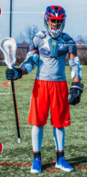

- Bag
- Gloves
- Elbow Pads
- Chest Protector
- 6U & 8U: numbered jersey
- 10U & older: practice pinnie
- Helmet
- Stick
- Complete paperwork and provide check for deposit

*Additional equipment not provided:
- Mouthguard: required and enforced in games- must be a visible color (not clear or white)
- Protective cup
- Cleats (optional, recommended for 10U and older)
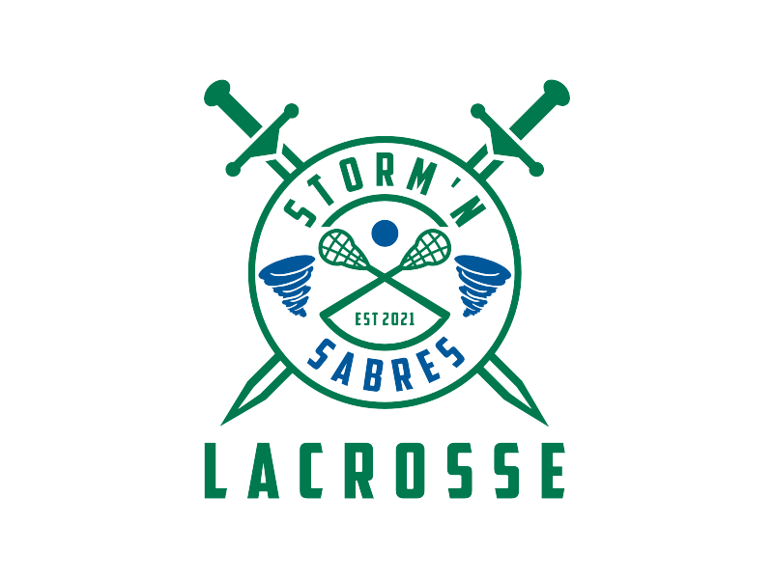

Helmets:

- All can be adjusted tighter or looser in the back

- Smallest size has Velcro on the back

- Chin straps adjusted with side straps

- Should fit snug

Paperwork:

- Complete paperwork

- Provide deposit check made out to: SSRLAX
  - 6U & 8U: $50 deposit; will be refunded once clean
equipment is turned back in
  - 10U & Older: $100 non-refundable rental fee

- Add child’s name to the memo

6U & 8U Jersey’s

10U & Older Practice Pinnies

