1421 SW Pembroke Lane dunsheeelizabeth@haydencatholic.net
Topeka, Kansas 66604 785-640-5583

Elizabeth Dunshee
Class of 2022
Hayden Catholic High School
Topeka, Kansas
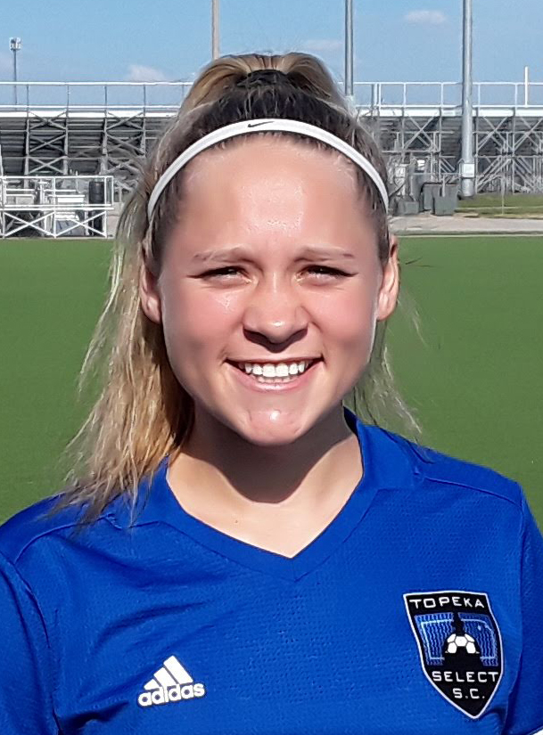
Personal Info
Height: 5’3” Weight: 125 Right-footed
DOB: 09/10/2003
Parents: Carlyle Dunshee: cdunshee@gmail.com
Kathleen Dunshee: kdunshee1@gmail.com

Academics
GPA: 4.2 ACT: TBA

Soccer Experience
Hayden Catholic High School: 2019-Present; Jersey #1
- Forward, Wing, Midfielder
- 2019: Varsity starter for every game as a freshman
- 2019: Honorable Mention All City
- Leading Varsity scorer as a freshman: most assists/tied most goals
- Hayden Catholic High School Co-offensive Player of the Year as a freshman
- Class 4A Regional Champions 2019
- Class 4A State 3rd Place 2019
- Coached by Klaus Kreutzer: kreutzerk@haydencatholic.net

Topeka Select Pre-Academy: 2018; Jersey #5
- Captain

Topeka Select Elite: 2018; Jersey #5
- Guest played as an 8th grader in the U19 Kansas City Showcase Tournament

Topeka Select Blaze: 2015-2018
- Center Midfielder
- Team Captain
- Heartland Division Champions
- Coached by Brian Cole: briancole@snco.us
Comments: “Elizabeth is an outstanding player. Elizabeth has exceptional skill in winning the ball, 1 v 1 skills, and seeing the field for passing. Elizabeth is not afraid to take on the opponent and is tenacious in the midfield.”

Extracurricular Activities
- TopSoccer volunteer: mentors physically and mentally handicapped children on and off the soccer field
- Student Ambassador: student leader who mentors potential students and helps at school functions in various capacities
- Debate: placed in competitive high school tournaments
- Varsity Cross Country as a freshman
- SADD: member of Students Against Destructive Decisions

References
- Brian Cole: Head Coach Topeka Select Elite; 785-640-3934; briancole@snco.us
- Klaus Kreutzer: Head Coach Hayden Catholic High School; kreutzerk@haydencatholic.net

