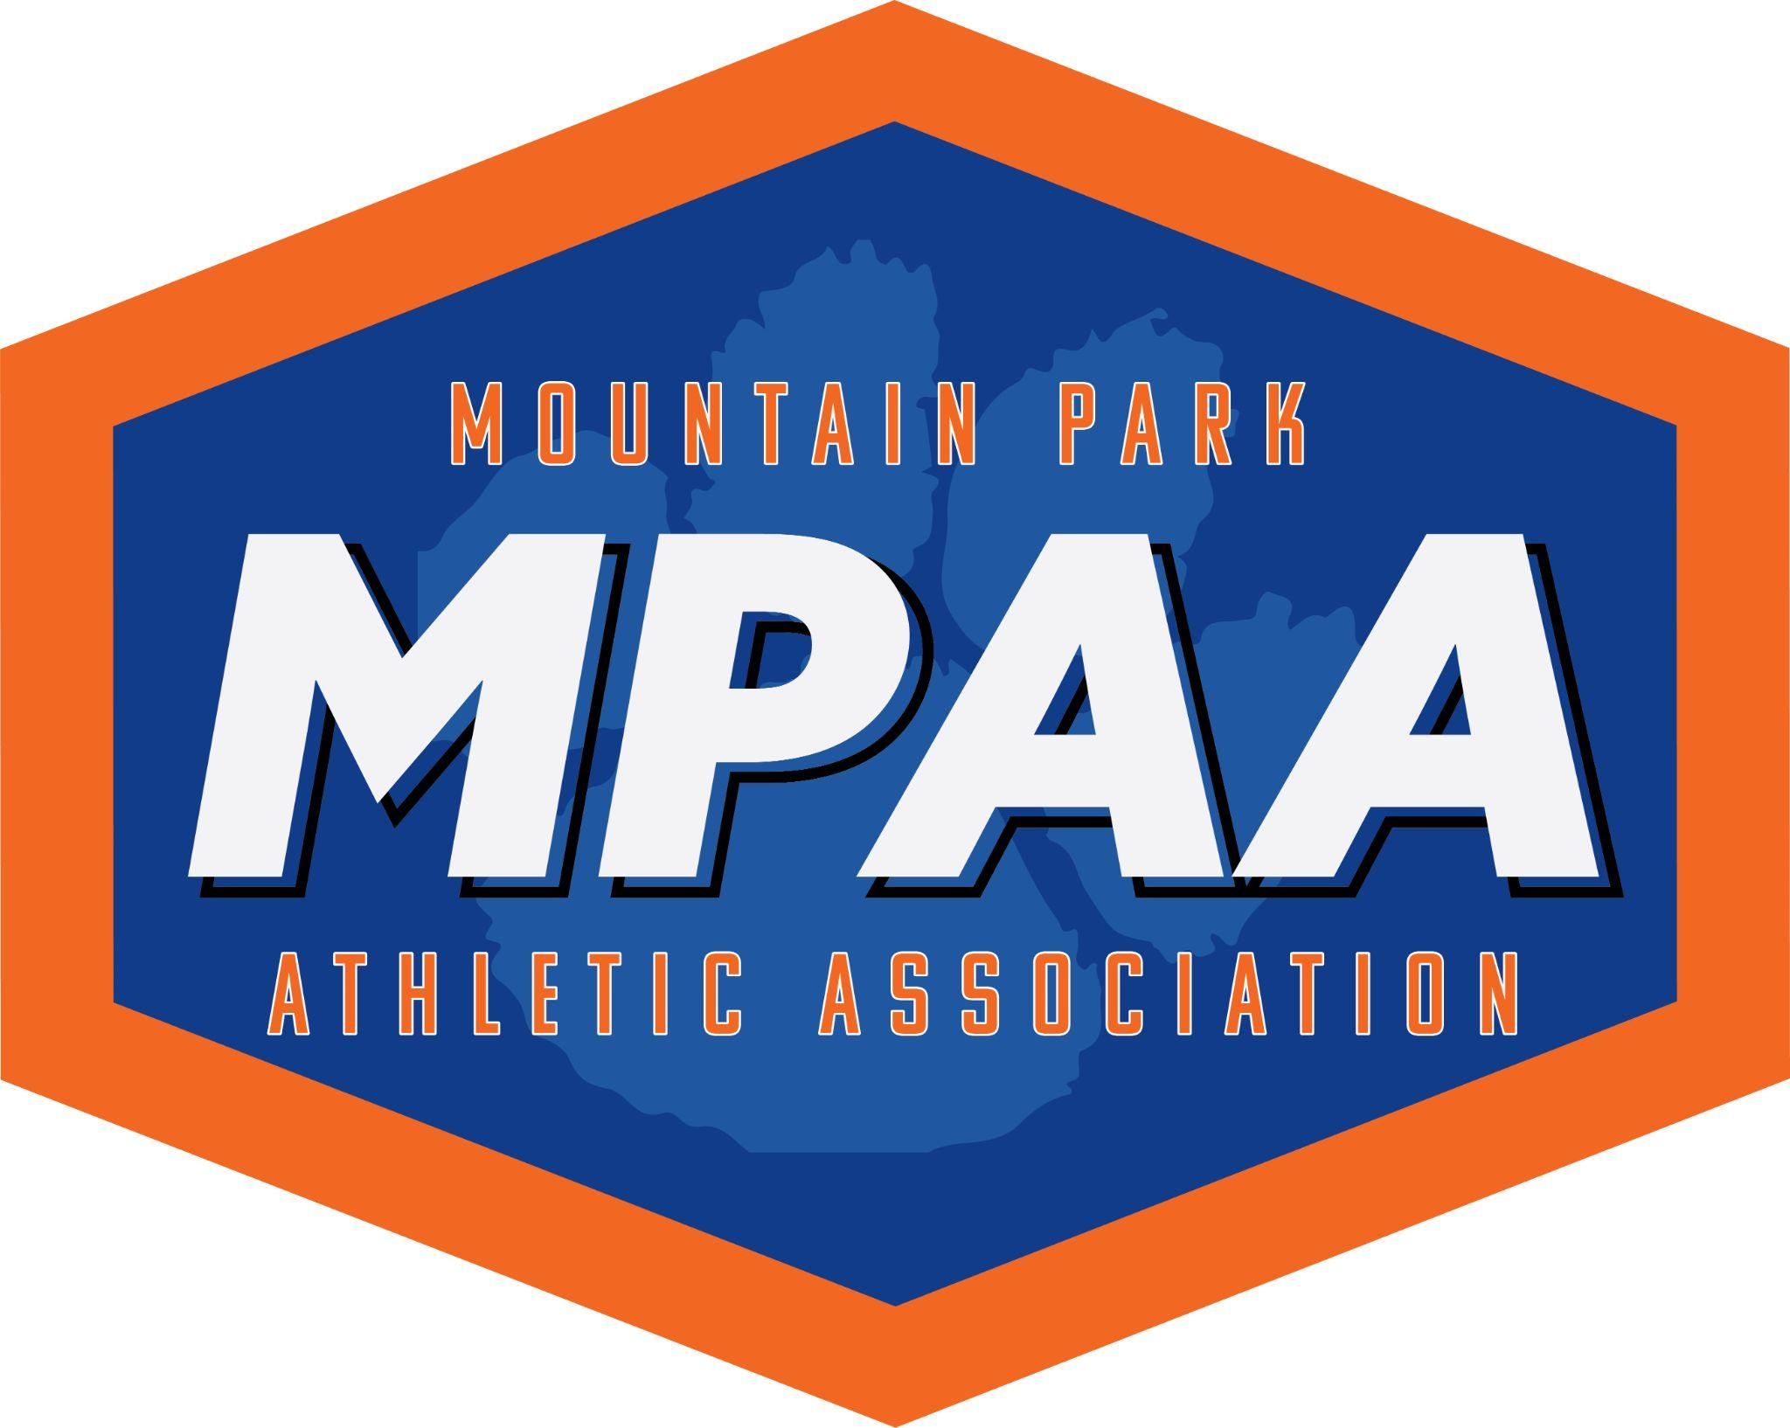

MPAA Baseball Team Mom Helpful Hints
Fall 2023

Team Mom Role
As a Team Mom, you are the link between the coach(es), the players, and their parents. You help communicate information from the team to the players’ parent(s).

Responsibilities
As a team mom you will be responsible for communicating important dates, collecting team dues, preparing and distributing snack schedules, organizing the dugout, distributing the uniforms, ordering the team banner/pennants (optional) and t-shirts (optional), ordering trophies (optional), and coaches gifts (optional).

Team Communication
- MPAA uses the Sports Engine APP for means of communication. That is where you will have any notifications sent directly from MPAA. Coaches and Team Moms can also use this APP to send messages to their own team, add practice schedules and game schedules. A team roster can be added and parents can upload pictures from the games as well.

Team Dues
- Gather and manage funds for the team banner or pennants (optional), buckets (great for 4u-8u), gifts for the coaches, team party, and trophies (4u trophies are supplied by MP, all other leagues purchase their own). In our experience, $30-50 is the most you would ask of each family.
- Set a budget early! If you plan on collecting team money, request and collect before the first game of the season.
- Try to encourage parents to find sponsors for the team dues.

Uniform Distribution
- All uniforms will have players’ numbers on the back of the jersey.
- Coaches place uniform orders according to the sizes picked at registration by the players’ parents.
- The team mom is responsible for picking up the uniforms once you have been notified when and where to get them.
- The team mom will inventory your bag, and distribute it to your team.
- THERE WILL NOT BE AN EXCHANGE DAY
- For uniform concerns contact the Baseball Uniform Coordinator – Tanya Griffith tanyamgriffith@gmail.com
- DO NOT email Tanya regarding when uniforms will be ready for pick-up. The Team Mom Coordinator will send out an email once they are available. They are usually ready a couple days before the games begin. Thank you!!

Snack Schedule (Optional)
- Most Team Moms create a snack schedule that includes a snack and drink for each player after the game. Some teams divide drinks and snacks among 2 families, some leave the duty to one family at a time.
- Concession Stand Team Snack Purchase: Please let your parents know that they can order team snacks from the concession stand for $2.00 per player.
  - The Concession Stand needs at least a 10 minute notice. The snack will include a small slushy and a bag of chips or cookies. This comes in handy when a parent forgets to bring snacks on their assigned day.

Dugout Organization (Optional)
- Dugout tags are used to assist with team line-ups. Can be laminated, foam, etc. Use shower hooks or ‘S’ hooks to connect to the fence. Dollar Tree or Dollar General is a great resource to find these.
- Dugout buckets or baskets are used to keep helmets, gloves, and water bottles. Again, great for 4u -8u leagues.

Team Banner/ Pennants (Optional)
- Many teams purchase or make a team banner to hang on the dugout during games.
- Can be handmade or professionally made.
- Cost for the banner can range from $90 to $150 and can be divided evenly among all the players’ parents.
- Banners Usually Include:
  - Team Name
  - Coach (es) Name (s)
  - Player’s First Name (Last Name Optional)
  - Player’s Number
  - Team Sponsor (If you have one) – Include logo if possible
- Vendor Options:
  - Sign Systems (makers of Pennant Style Banner) – Terri Pagani – (770)277-9380 – terri@signsystemsga.com

Team Shirts (Optional)
- The Team Mom, or designated person, is responsible for working directly with a vendor on tee design, art approval, pick-up, payment collection, and distribution.
- The park is not involved at all.
- Vendor Options:
  - Tanya Griffith- thevinylboutiqueatl@gmail.com
  - Patricia’s Spiritwear – info@pswear.com

Trophies/End of season Gift (Optional)
- Check with your coach on end of season gifts and Trophies first. Some teams may wish to forgo trophies. However, check with your parents first.
- You are responsible for ordering & collecting funds for trophies for your team.
- Here are a few vendors that we have used in the past, you are not limited to these vendors:
  - Pinehill Discount Trophies (Lilburn) – (770) 564-1126
  - TrophyDepot.com
  - CrownAwards.com

Coaches Gifts (Optional)
- Team Moms handle Coaches gifts and typically solicit funds from the parents to purchase gifts.
- Gifts typically range from gift cards to team pictures matted and signed by the players. (We are working on getting rights to team pictures for Team Moms to use as team coaches’ gifts and possible plaques for sponsors).

Going Above and Beyond
- Have a Dugout Mom! You can bounce ideas off of one another and share the work.
- Send out snack duty reminders!!! We have busy parents that may forget.
- Encourage the parent’s to wear team colors to encourage the kids.
- Bring extra water bottles for kids who forget to bring their own.
- Bring a small first aid kit just in case.
  - Concession Stand has bags of ice ready to go in case of injury. Do not wait in line – go around to the side entrance and ask one of the workers for a bag of ice for an injured player.
  - An AED is also located in the Concession Stand if ever needed.

Baseball Director & Team Mom Coordinator:
Ashley Hill
laurenahill27@gmail.com

MPAA Baseball Moms Email
mpaabaseballmoms@gmail.com

