The 2025 Porter Parent Football Association (PPFA) Newsletter – Playoff2
The LTHS Porter Parent Football Association (PPFA) is a volunteer group dedicated to enhancing the football experience for players. Our goal is to foster a positive, memorable environment for each player, achieved through support for both the players and coaches. The PPFA funds its efforts through various fundraising initiatives, including spirit wear, player sponsorships, and volunteering.
- Twitter @LockportFootba1 - Facebook @ LTHSFootballBoosters  - Lockportfootball.com
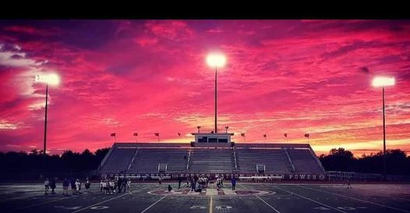Every Week
Varsity Players Pasta Dinner – Every Thursday @ Cooms Corner, but breakfast will be served this week (see below).
Playoff-2 Breakfast (Cooms Corner): Sat 11/8 @ 9:30am **Parent Volunteer and/or Drink Donation**
** Ask-a-Porter ** - 10Q with Rayden Cherco
Game Schedule/Results
Varsity: Porters vs Homewood-Flossmoor: Sat 11/8 @ 6:00pm Game Preview Concession Volunteer
Porters over Sandburg on 11/1 (21-14) Game Recap Game Photos (TKMEDIA09) Game Photos (ZL VISUALS)
Game Photos (RJ.Prodz) Game Photos (Flicz.By.J)
News and Notes
PPFA Board Meeting: 11/18 (Tuesday) @ 7:00pm – LTHS (Room 107A)
Save-the-Date: 11/8 – State Playoffs (2nd round)
11/15 – State Playoffs (3rd round)
12/8 – Varsity Banquet @ Crystal Grand Banquets (details to follow)
**Lost and Found** Missing a PPFA 2025 Newsletter? Click HERE

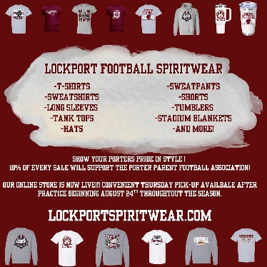
Order your 2025 Lockport Football Spirit wear HERE
Helpful Links
Spirit Wear Game Digital Tickets IHSA Football Info 8to18

