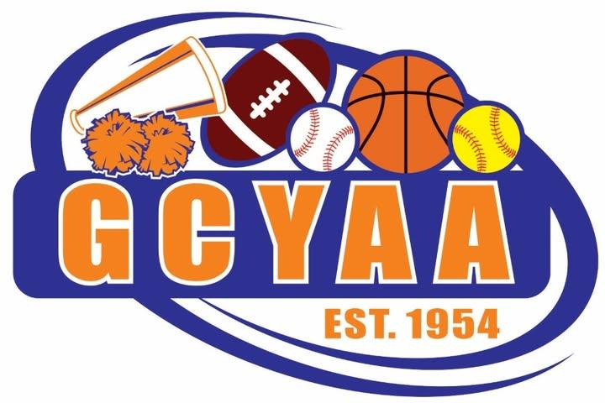
Basketball Draft Process

Divisions
3–4 grade
5–6 grade
7–8 grade

Draft Format
GCYAA Basketball will use a snake draft format within each division.
In a snake draft:
- The draft order reverses each round
- If a team picks first in one round, that team picks last in the next round
- This process continues until all eligible evaluated players have been selected
The goal of this format is to support a fair and balanced team building process across each division.

1. Player Evaluation and Tier Placement
All players who attend evaluations will receive scores based on the approved GCYAA Basketball Evaluation Process.
Players are evaluated in the following measurable categories:
- Layup
- Shooting
- Ball Control + Passing
- Speed
- Size / Physicality
Each player receives a composite score based on evaluator scoring. That composite score is then used to assign the player to a draft tier.

Player Tiers
Players will be grouped into the following tiers:
- A Tier
- B Tier
- C Tier
There will be no tier lower than C in the evaluation process.
The commissioner and evaluators will not release individual evaluation scores to coaches, parents, players, or anyone else. Coaches will only receive each player’s assigned tier for draft purposes.

2. Tier Draft Rules
The draft must follow the player tier order exactly.

Required Tier Order
- All A Tier players must be drafted before any B Tier player is drafted
- All B Tier players must be drafted before any C Tier player is drafted
Teams may not skip ahead to a lower tier while players remain available in a higher tier.
This rule applies to every team in the draft and is intended to maintain fairness and roster balance within each division.

Kept Players Within a Tier
If a coach’s child or approved ride along player is kept in a tier, that player will take that team’s next available pick in that tier.
If multiple kept players fall in the same tier for the same team, they will be placed using the next available picks in that tier.

Example
If a team has:
- one kept player in A Tier, that player takes that team’s first available A Tier pick
- two kept players in A Tier, those players take that team’s first two available A Tier picks
This means the team does not receive additional open selections ahead of other teams in that same tier.

3. Coach’s Child and Approved Ride Along Rule
A coach’s child or approved ride along player is considered a kept player and does not enter the open portion of the draft.
The kept player will be placed into the appropriate draft slot in the tier in which that player was ranked.

Examples
- If a coach’s child is evaluated and placed in A Tier, that player becomes that coach’s team’s first available A Tier selection
- If a coach’s child is evaluated and placed in B Tier, that player becomes that coach’s team’s first available B Tier selection
- If an approved ride along player is evaluated and placed in C Tier, that player becomes that team’s first available C Tier selection
To be eligible as a ride along, the children must have the same mailing address or provide proof of guardianship.
A ride along player must still go through evaluations if they are able to attend. That player will still receive a composite score and tier placement. Once tiered, the player is assigned to the approved team in that player’s tier.
The draft board should reflect all kept players before the live draft begins so all coaches clearly understand the available player pool and tier by tier draft order.

4. Players Who Do Not Attend Evaluations
Any player who does not attend evaluations will not be placed into A, B, or C Tier through the standard composite scoring process.
These players will be handled as hat picks after the tiered draft is completed.

Hat Pick Process
- Each non evaluated player’s name will be written on paper
- Names will be placed into a hat or similar container
- At the end of the evaluated player draft, teams will randomly draw from the hat live
- Hat picks will continue until all non evaluated players have been assigned
This process keeps unevaluated players separate from the tiered draft and ensures those selections are handled randomly and transparently.

5. Draft Preparation
Before the draft begins, the following should be completed:
- Evaluation composite scores finalized
- All players assigned to A, B, or C Tier
- All kept players identified and applied to their appropriate team and tier
- All non evaluated players listed separately for the hat pick process
- Final draft order confirmed for each division
Coaches will receive player tiers for draft purposes. Individual evaluation scores and composite score details will not be shared.
This should be shared with coaches before or at the start of the draft so expectations are clear.

6. Draft Day Process
Each division draft should follow this order:

Step 1
Confirm draft order for the division

Step 2
Place all kept players on the board in the appropriate available draft slots within their assigned tier

Step 3
Draft all remaining A Tier players in snake draft order

Step 4
Once A Tier is exhausted, draft all remaining B Tier players in snake draft order

Step 5
Once B Tier is exhausted, draft all remaining C Tier players in snake draft order

Step 6
After all evaluated and tiered players have been drafted, complete the hat pick process for all players who did not attend evaluations

Step 7
After the hat pick process is completed, all coaches will have the opportunity to make trades.
All trades must be:
- agreed upon by the coaches involved
- completed during the draft session
- made between players in the same tier
No cross tier trades will be allowed.

7. Key Principles
- Player tiers are based on evaluation composite scores
- The draft is conducted in snake draft format
- Teams must draft all players in a higher tier before moving to the next tier
- Coach’s children and approved ride alongs count as kept players
- Kept players take the next available pick in their assigned tier
- If multiple kept players fall in the same tier for one team, they take the next available picks in that tier
- Players who do not attend evaluations are assigned through a live hat pick after the tiered draft is complete
- Trades are only allowed after the hat pick process is complete and must be between players in the same tier
- Individual evaluation scores will not be released
- Coaches will only receive player tiers
- The process should remain simple, transparent, and consistent across all divisions

