Kern Center Clock Instructions:

Scoreboard Controls:
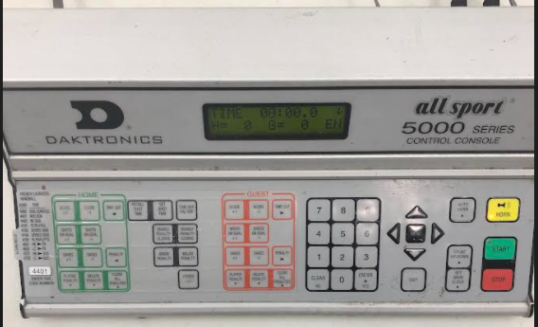

PRE-GAME AND BETWEEN PERIOD TIMING INSTRUCTIONS:
VARSITY (Referee has final say on all timing issues, including pre-game):
- Arrive 35 minutes before game
- Pre-game/pre-Zamboni: Set clock to 12-minutes for warmup period.
  - If rink is empty, start the 12-minute clock 28-30 minutes before game time regardless of whether both teams are on the ice.
  - If a prior game ends late, start the 12-minute clock when both Varsity teams get on ice or when ref tells you to start it.
- Players should go to locker room 15-17 minutes before start of game
- When players return to ice, they’ll skate for about a minute and then line-up along the goal line
- Once players are lined-up, begin pre-game introductions. Default is Music volunteer does introductions, but any booth volunteer can do it by agreement
- Set Period for 17 minutes
- Set Period to 1
- Between periods: Set clock to 12 minutes (immediately after players leave ice) The ref will let you know if they want to start the game early.

JUNIOR VARSITY (Referee has final say on all timing issues, including pre-game):
- Ice will be cleaned before game. Warmup time will vary, but game should start on-time.
- Set warmup for 5 minutes when both teams get on ice.
- Set Period for 15 minutes
- Set 3-minutes between 1st and 2nd Period. Ice is not cleaned.
- Set 12-minutes between 2nd and 3rd Period. Ice will be cleaned.

GENERAL SCOREBOARD OPERATING INSTRUCTIONS
Set the Main Clock:
- Press “SET MAIN CLOCK”
- Enter time using numbers
- Press “ENTER”
- (NOTE: YOU CAN RESET TIME ANYTIME BY DOING STEPS 1-3)
Set 2-Minute Penalty:
- Press “PLAYER PENALTY”
- Enter Player #
- Press “ENTER”
- Press “ENTER/YES” again (to set 2 minutes)
Set 5-Minute Penalty:
- Follow first 3 steps above
- Enter “0500”
- Press “ENTER/YES”
Delete a Penalty (when there are multiple)
- Select (on Home or Guest) “DELETE PENALTY”
- Use the Up/Down arrows to find the penalty on the screen to delete
- Press “ENTER”
Run Clock between Periods while Keeping Penalty Time
- Press “DISABLE PENALTY CLOCKS”
- Set Timeclock
- Press “ENABLE PENALTY CLOCKS” when you are ready to have the penalty time run with the timeclock
Run a 1-minute Timeout while Keeping Game Clock Time
- Press “TIME OUT ON / OFF”
- This will run a 1-minute timeout automatically
- Game-clock should re-appear after timeout expires (you can also press “TIME OUT ON / OFF” again to stop timeout early

Running Clock Rule:
If at any time, starting in the second period, when a team is leading by six goals, the clock shall run continuously except for:
NOTE: Don’t start a running clock until the ref tells you to.
(1) When a goal is scored.
(2) When a penalty is assessed.
(3) An injury.
(4) A timeout.
(5) Any other emergency situation or unusual stoppage.

Overtime Rule:
Overtime procedures for Varsity regular season games are as follows:
(1) A three-minute rest period.
(2) An eight-minute five (5) on five (5) overtime sudden victory period.
(3) If still tied, a three-minute rest period, followed by a five-minute three (3) on three (3) sudden victory period.
(4) If still tied, the contest ends in a tie and is to be listed as a tie on a team’s season record.
(5) An alternate tie-breaking procedure may be determined in addition to the procedures identified above by the host school. However, any hockey game where an alternate tie-breaking procedure is used (not including a sudden-victory during an eight-minute overtime period or a sudden-victory during a five-minute three (3) on three (3) period) is to be listed as a tie on a team’s season record.

