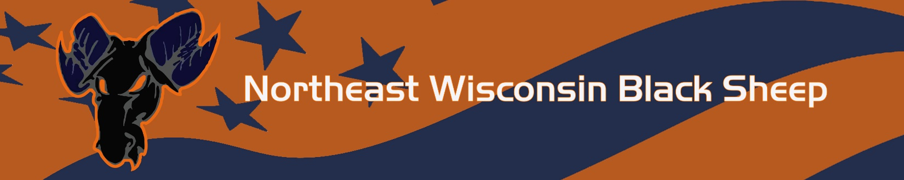

Parent Code of Conduct

Northeast Wisconsin Black Sheep seeks to instill positive character-building traits in our communities’ youth through the demonstration of good sportsmanship, respect, responsibility, integrity, personal courage and excellence in all we do. We ask that parents and their guests attending Northeast Wisconsin Black Sheep sponsored events help us by reflecting these character traits at games.

When attending Northeast Wisconsin Black Sheep sponsored events, I therefore agree:

- I will never be under the influence or under the possession drugs, alcohol or weapons of any kind at practices, games, trips or other events.
- I and my guests will be a positive role model for my child and encourage sportsmanship by showing respect and courtesy, and by demonstrating positive support for all players, coaches, officials and spectators at every game, practice or other sporting event.
- I and my guests will not engage in any kind of unsportsmanlike conduct with any official, coach, player, or parent such as booing, taunting or using profane language or gestures, I will maintain self-control at games, practices and other events.
- I will not encourage any behaviors or practices that would endanger the health and wellbeing of the athletes.
- I will teach my child to play by the spirit of the rules and to resolve conflicts without resorting to hostility or violence.
- I will demand that my child treat other players, coaches, officials and spectators with respect regardless of race, sex, creed or ability.
- I will never ridicule or yell at my child or other participant for making a mistake or losing a competition.
- I will respect the officials and their authority during games and will never question, discuss, or confront coaches or referees at the game field, and will take time to speak with coaches at an agreed upon time and place.
- I will refrain from coaching my child or other players during games and practices, unless I am one of the official coaches of the team.
- I will inform the coach of any physical disability or ailment that may affect the safety of my child or the safety of others.
- I will respect my child’s coach and do my best to have my child at all practices and games on time.
- I will recognize the importance of volunteer coaches.
- I realize coaches are important to the development of my child and the program.
- I will communicate with coaches and support their decisions

I also agree that if I fail to abide by the aforementioned rules and guidelines, I will be subject to disciplinary action that could include, but is not limited to the following:

- Verbal warning by official, head coach, and/or member of league organization
- Written warning
- Parental game suspension with written documentation of incident kept on file by Northeast Wisconsin Black Sheep Board
- Parental season suspension
- Parental Suspension from all future Northeast Wisconsin Black Sheep games (Home or Away), Practices and Events

By signing below, the Parent/Guardian agrees to abide by and be subject to this Code of Conduct.
Parent/Guardian Name (printed): ______________________________________________
Parent/Guardian Signature: ___________________________________________________
Date: _________________________

