
SPRING CREEK ASSOCIATION
FEE INCOME ALLOCATIONS
and
EXPENSE CORRELATIONS

PURPOSE: The following information outlines the fee income and expenses associated with the facilities and amenities as it relates to expenditures for maintaining a stable, efficient, and transparent environment.
Based on the primary objectives, this document will show the commitment to accomplishing the strategic goals.
It is essential the Association maintain fiscal stability to be able to deliver high quality services. This requires an effective and transparent financial system, accurate and reliable forecasting of revenues, and control of expenses. (Goal Four: Financial Stability)
Primary Objective: Maintaining a stable, efficient, and transparent financial environment.
Homeowner Assessments and Comparisons
The Declaration of Reservations (DORs) allows for assessments to be charged to maintain certain designated parcels, amenities, and access roads. The DORs allow for a periodically increase of the assessments at the same proportionate rate as the cost-of-living index of the U.S. Department of Labor as fixed on the first day of June 1971. If assessments had increased with the cost-of-living index, they would be approximately $77.50 per month today or $930.00 annually. Currently, SCA homeowner assessments are only $64 per month or $768 annually for 2021. This is the same rate as 2020. Rates did not go up in 2021.
Comparisons
Annual HOA # of Lots
Community Services/Amenities Assessments Assessed
Spring Creek Association Equine facilities (barn, trails indoor arena rings, $768 5,379
Pastures), 18-hole golf course, Clubhouse, Marina $ 64 p/m
Parks, sports fields; baseball, soccer, football, rifle
range, trap & skeet, campground, 150 miles of roads.
1 acre parcels minimum.

Elko Summit Estates 10-acre parcels minimum. Contract out Road $2,500 75
Maintenance. No other amenities. $ 208 p/m

Bear Valley Springs Equine facilities (6 arenas, barn pastures, trails), $1,420 3,582
9-hole golf course, Clubhouse, campgrounds, athletic $ 118 p/m
fields, dog park, shooting range, tennis courts, (2016 rates)
2 lakes, gated (separate district for roads & utilities

TOTAL SCA INCOME AND EXPENSES (2020 IS UNDER AUDIT)
2018 TOTAL INCOME: $4,862,487 2018 TOTAL EXPENSES: $4,453,544
2019 TOTAL INCOME: $4,996,214 2019 TOTAL EXPENSES: $4,783.636
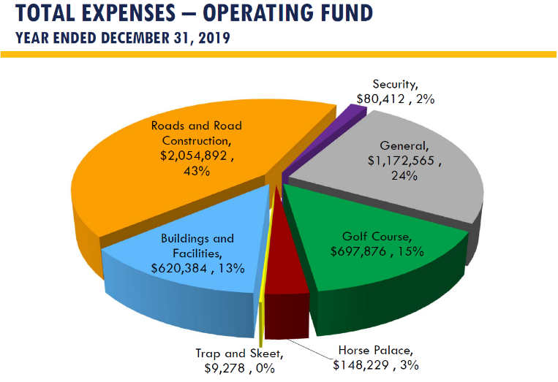
ALLOCATIONS

This document complies with the overall strategic plan for the Spring Creek Association. The Association is committed to working with organizations to make a full range of program and recreation opportunities available so our residents can enjoy them. (Goal Two: Programs & Recreation; SCA Strategic Plan).
Primary Objective: Update facilities and amenities to meet the community’s changing needs and demands.
The field and player fees do not cover the costs for maintaining, upgrades or production of new fields.
SPORT FIELDS NEW AND UPGRADES
Football Fields: Revenue Generated: $ 2,850 2019
$ 0 2020 Covid-19
Costs/Expenses:
Football Field Construction/Irrigation: $146,266
Goal Posts/Bleachers/Scoreboards $ 50,000 (BOD Additional Allocation)
Engineering $ 4,985
$201,251

Labor Costs: 2019 $ 37,622
2020 $ 8,247
$ 45,869

TOTAL COSTS: $247,120
Percent of Revenue Collected: 1.15%

Schuckmann’s Baseball/Softball: Revenue Generated: $ 7,515 2018
$ 6,330 2019
$ 0 2020 Covid-19
COSTS TO UPGRADE FIELDS:
Funds Spent Allocated for 2021
Septic System $ 27,595
Site Survey Master Plan $ 10,600
Baseball Field Improvements $ 37,253 $ 87,748
Concessions _______ $ 92,000
$ 75,448 $179,748
COSTS TO MAINTAIN SOCCER & BASEBALL FIELDS:
Maintenance Labor Costs: 2018 $ 38,796
2019 $ 39,834
2020 $ 41,236

Irrigation Repairs/Fertilizer (All Parks) 2018 $ 9,300
2019 $ 13,500
2020 $ 19,300

Water Amount Gallons
All of Schuckmann’s: 2018 $49,417 9,273,000
2019 $57,211 10,929,120
2020 $83,740 16,328,120

Firehouse Field 2018 $ 5,511 1,184,840
2019 $ 4,223 894,030
2020 $ 8,190 1,884,130
Additional Costs:
Sanitation: $ 3,800
Landscape Supply (Trees, etc.) $ 8,100
Property Insurance: $ 7,200
Health & Safety $ 4,800
Gas/Diesel $12,400
Power $ 3,200
Additional Costs Total: $39,500

OVERVIEW: Revenue vs Maintenance Expenses & Water Only:

2018 2019 2020
Revenue/Income: $ 7,515 $ 6,330 $ 0
Expenses:* $93,724 $101,268 $133,166
Percent of Revenue Collected 8% 6% 0%

*Expense Totals Only include Maintenance Labor and Water: Sports Complex and Fire House Field.
Other expenses include all parks, not just sports complex and Fire House fields.

COSTS TO MAINTAIN, OPERATE, AND UPGRADE FACILITIES ARE GREATER THAN REVENUES COLLECTED FOR FIELD AND PLAYER FEES. ASSESSMENT FEES HELP OFFSET THOSE COSTS.

