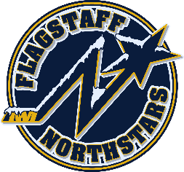
Flagstaff Youth Hockey Association
BOARD OF DIRECTOR’S MONTHLY MEETING AGENDA
January 17, 2024

Topic: FYHA General Board Meeting
Time: January 17 @ 6pm
Location: 214 E Birch Ave or via teams: https://tinyurl.com/FYHANorthstars

Approval of Minutes of November and December
Reports:
- President’s Report- Travis Joralmon: No update
- VP Report- Brad Mihalik: No update
- AAHA Hockey Director- Travis Joralmon: No update
- ADM Coordinator: Kris Walsh: Congratulations to our teams MLK weekend success. 14U Silver at Great Park Ice, 12U Gold at Great Park Ice and 8U Gold at Inland Empire MLK. Working on Little Howlers and another free day.
- Coaching Coordinator- Travis Johanson: No update
- Equipment Manager- Chris Whitney: No update
- Fundraising Coordinator-Paul Barton: No update
- Ice Scheduler-Brad Mihalik: No update

- Registrar-Charlie Knotts: No update
- Treasurer-Gina Nabours: - No updates
- Webmaster-Kristi Kolek: Home games though January have been added to calendar on home page. Will get February added.
- Manager Coordinator-Molly Joralmon: No update
UPCOMING EVENTS:
- Club pictures 1/29 for 10/12/14U
- Club pictures 1/30 for 6/8U
- Robbie Glantz Skating Clinic 4/13 and 4/14
- Rockey Mountain Hockey School 6/17-6/21

OLD BUSINESS:
- Scholarship Application

NEW BUSINESS:
- Change to by-laws regarding cancellation of meetings

EXECUTIVE SESSION:
- Scholarship hours

