

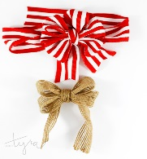

SVYH Holiday Wreath Program

If you sell $500 or more in wreaths and goods, you will receive a SVYH hat.
If you sell $1500 or more in wreaths and goods, you will receive $200 off tuition.
If you sell $2500 or more in wreaths and goods, you will receive $300 off tuition.
If you sell $5000 or more in wreaths and goods, you will receive tuition kickback (see chart below).
The top seller over $5000 in wreaths and goods will receive tuition kickback (see chart below) plus $200.

If you choose to sell NO wreaths, please consider writing a check to SVYH for $300.

The total amount of refund for each player will be applied to your method of payment for the 2024-25 season. Thank you for participating in this program.

CHART FOR SELLERS OVER $5,000:
6U: $650
8U: $650
10U: $1100
12U-19U: $1250

