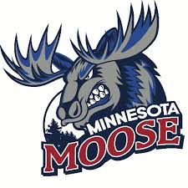
Social Media Content Intern

The Minnesota Moose Hockey Club, located in Blaine, Minnesota, is looking for a creative and savvy social media intern to join the team for the 2025-2026 season. This internship will provide hands-on experience in social media management and content creation, with a focus on engaging the team’s online audience across platforms such as Instagram, Facebook, and TikTok. The intern will assist in developing, curating, and posting engaging content to help promote the team and keep fans informed and entertained.
Key Responsibilities:
- Assist with creating and scheduling daily posts on the team’s social media platforms.
- Help design and produce visually engaging content, including graphics, videos, and stories for social media channels.
- Monitor social media trends and assist in creating relevant content for the team.
- Engage with fans on social media by responding to comments, direct messages, and mentions.
- Assist with live updates during home games, including posting game results, highlights, and fan interactions in real-time.
Required Qualifications:
- Strong passion for hockey, social media, and digital content creation.
- Experience with social media platforms and basic content creation tools.
- Excellent written communication skills with the ability to create fan-focused content.
- Creative thinker with an eye for engaging visuals and videos.
- Availability to work evenings, weekends, and some holidays (game days).
Compensation and Benefits:
- Must be a technical, undergraduate, or graduate student enrolled in a college credit internship program, preferably pursuing a degree in Marketing, Communications, Digital Media, or a related major.
- Valuable hands-on experience working with a Junior hockey team’s social media strategy.
- Networking opportunities within the sports, entertainment, and digital media industries.
- Team merchandise and tickets to games.
How to Apply:
To apply, please send your resume, examples of your social media work (posts, videos, graphics, etc.), and a brief cover letter explaining why you're interested in the Social Media Content Internship with the Minnesota Moose to [email address].

