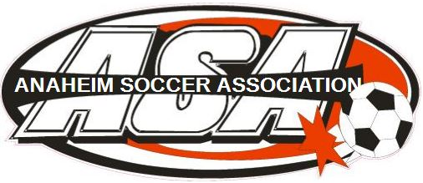

Hi soccer family,
Welcome to Anaheim Soccer Association. We are excited that your child will be joining us for the 2019 Spring soccer season. Anaheim Soccer Association’s objective is to provide your child with a wholesome atmosphere in which to engage in healthy athletic competition. Our goal is for the kids to have fun and learn a little soccer along the way.
Practice: Practices can be up 2x/week for U6 – U8 with practice times varying will be determined by coach and usually can last up to 1hr. U10-U19 practice days are usually 2x/week however scrimmages can be scheduled as a 3rd practice as well and usually can run up to 1.5 – 2hrs (for olders). Practice should begin on or around February 1st. Fields: Maxwell Park, Twila Reid, and John Marshal.
Friday Night Training Sessions: This is open to all levels Recreational, Signature and Club players looking for additional training from ASA Coaches. Friday Night Training is $5.00 per session. Times and date TBD
Games: Normally games begin the first weekend in March. Game schedules should be posted the end of February your coach and/or team parent will hand a copy out.
Referee fees: 2019 Recreational programs Ref fees are included. Signature and Club programs Ref fees will be collected by Team Manager/Admin.
Equipment: All players must have the following equipment which shall be provided by parent/guardian; shin guards, soccer cleats, ball (U6-U8 size 3, U9-U12 size 4 and U13+ size 5) and water jug. Even as the weather changes dry clothes is recommended for after practice ie. Sweatshirt.
Social Media:

Upcoming Dates:

Website: www.anaheimsoccer.org

Thank you,
Tina Gollette ASA President
Go ASA!

