Vulnerable Sector Screening Check, and Criminal Record Check
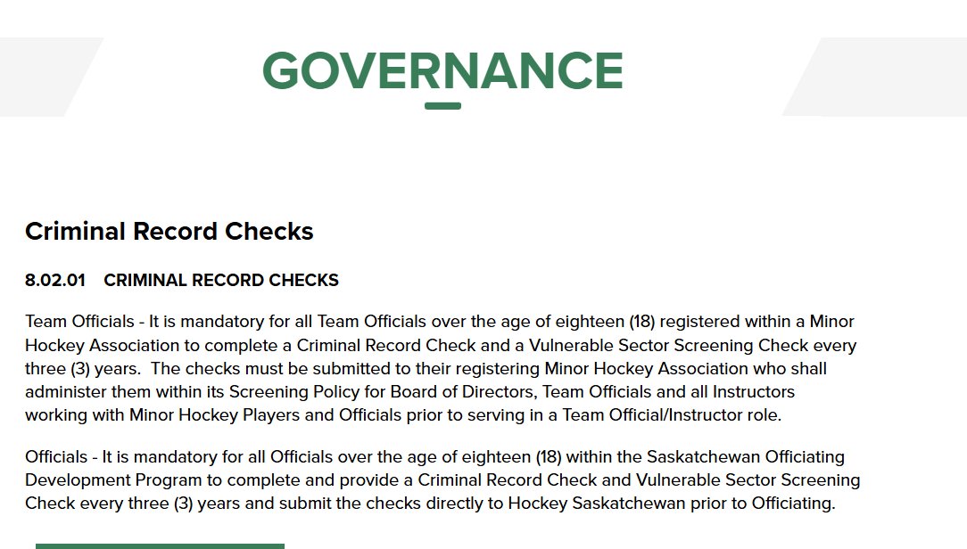
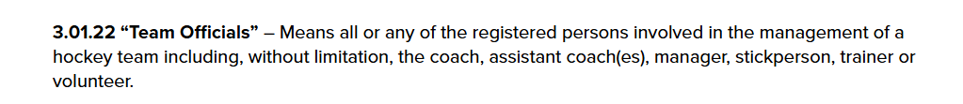
Governance « Hockey Saskatchewan
PSMHA Policy 3.10 states: Hockey Canada and Hockey Sask have updated the CRC requirement to a vulnerable sector check (VSC). In addition, in 2022, VSCs will be required prior to team staff being added to the Hockey Sask roster and PSMHA teams.
Obtaining a Vulnerable Sector Check (VSC): If you live within the White Butte RCMP area, you can visit the White Butte RCMP detachment during their business hours and receive your VSC immediately.
If you have a VSC for another purpose, PSMHA will accept one that has been issued within the last three years (ex. school, ball) with confirmation that you have not been charged or convicted of a crime during that time frame that would be in contravention of PSMHA policy.

A letter of request can be provided at any time.
Please feel free to contact us via email at admin@pshma.ca.

