The 2025 Porter Parent Football Association (PPFA) Newsletter – Preseason
THE LTHS PORTER PARENT FOOTBALL ASSOCIATION IS COMPRISED OF A GROUP OF VOLUNTEER PARENTS WHOSE OBJECTIVE IS TO ENHANCE THE EXPERIENCE OF OUR PLAYER’S PARTICIPATION IN LTHS FOOTBALL. THE GOAL OF THE LOCKPORT PPFA IS TO FOSTER AN ENVIRONMENT THAT CREATES ONE OF THE GREATEST AND MOST MEMORABLE EXPERIENCES OF YOUR PLAYER'S LIFE. WE AS PARENTS, CREATE THIS ENVIRONMENT THROUGH POSITIVE REINFORCEMENT OF THE PLAYERS AND THE EFFORTS OF THE COACHES. IN ADDITION, WE SUPPORT OUR PROGRAM SOLELY THROUGH FUNDRAISING ACTIVITIES. OUR FUNDRAISING EFFORTS GO BACK IN TO THE FOOTBALL PROGRAM TO SUPPORT THE VARIOUS NEEDS OF THE FOOTBALL PROGRAM (AT ALL LEVELS). THESE INCLUDE WEEKLY VARSITY DINNERS, END OF SEASON DINNERS FOR FRESHMEN/SOPHOMORES, VARSITY BANQUET, SCHOLARSHIPS AND COACHES NEEDS (EQUIPMENT, SPONSORSHIPS ETC).
- Twitter @LockportFootba1 - Facebook @ LTHSFootballBoosters  - Lockportfootball.com

News and Notes – Save the Dates
** Several upcoming fundraisers (Nik&Ivy, coupon books and an all-season Spiritwear store) – Stay informed thru our social media sites and 8to18 **
Aug 12th 2025 (6-9 pm) We will be hosting a Meet & Greet Fundraiser at Nik & Ivy. We are in need of a few football and cheer parent volunteers to assist us on that night. We appreciate your support! Volunteers
Aug 16th 2025 After football practice, we will have our 1st checkpoint for coupon books (fundraiser). We will continue our annual Watermelon Day tradition for players and host an informal Parent meeting afterwards. Note - Checkpoints are player opportunities to turn-in sold coupon book money. Volunteers
Aug 19th 2025 (7 pm) Parent Porter Football Association board meeting (LTHS Porter room).
Aug 22nd 2025 (5 pm) Maroon/White game.
Aug 23rd 2025 After football practice, we will have our 2nd/final checkpoint for coupon books.
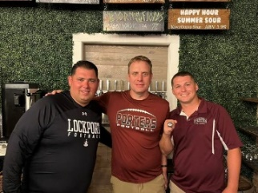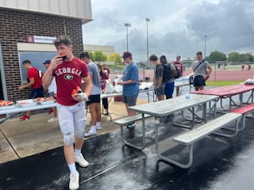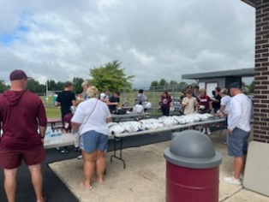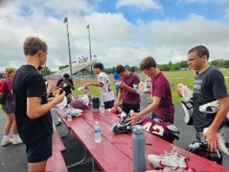
Helpful Links Game Digital Tickets IHSA Football Info 8to18

