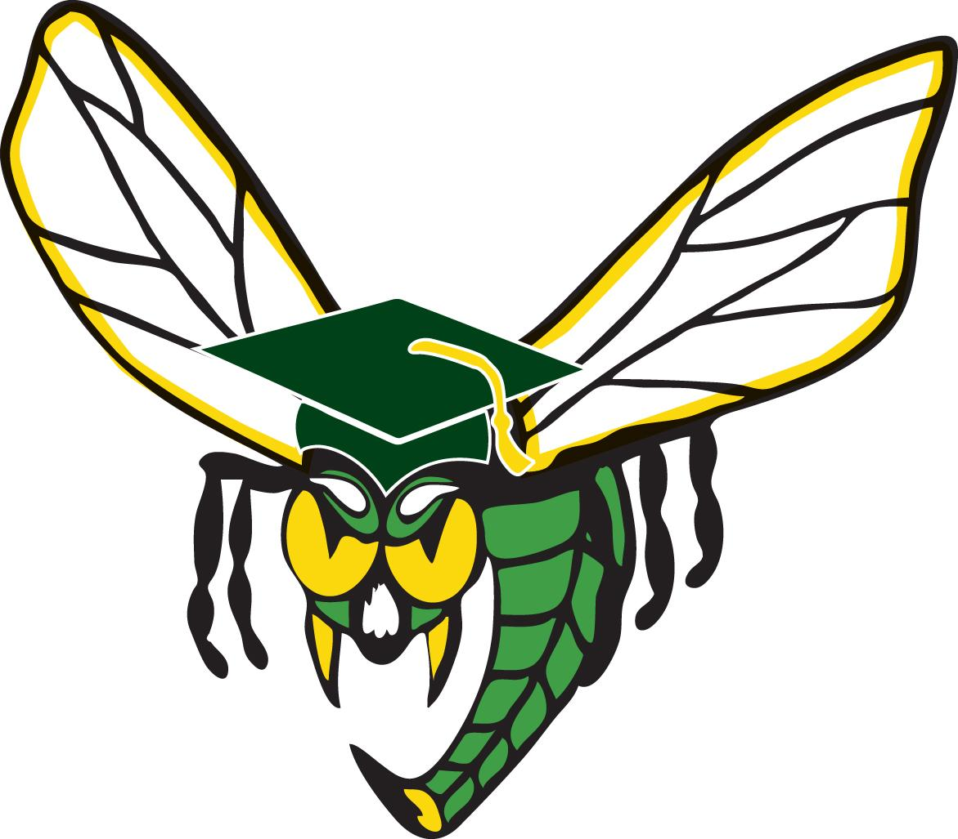

Thank you for your willingness to help celebrate the
Graduating Class of 2020

Purpose:
- Drum up community enthusiasm for Edina High School’s 2020 Graduates
- Create awareness for the Mobile Commencement on May 31st from 9 a.m. to 4 p.m.
- Spread messages of resilience, hope and hornet pride!
- Encourage Instagram posting of bus sightings/celebrations @XXX (thinking EHS Insta)

How:
- We will be posting details on main Facebook sites, Edina Moms page, Edina information station
- Please supplement outreach any way you choose! Talk to your friends, distribute fliers, send emails, make and hang posters, post on Nextdoor, etc.

Ideas:
- When buses come by come out and cheer, bang pots, play instruments, sing the Alma Mater, make NOISE!
- Decorate your yard or neighborhood! Consider Edina green balloons, streamers, ribbons, posters, lights, etc.
- Hold up signs of congratulations for seniors in your neighborhood
- Craft chalk art & messages on sidewalks and streets
- Orchestrate a neighborhood parade: seniors in cars, people in yards
- Wear Edina Gear or Edina Green on May 31

Edina Proud - Green and Loud

