Practice Ideas
- Dynamic Warm-Up & Athletic Development Work - 10 to 15 minutes

“Coach Says…” | Races | Diamond Drill | Fresno Drill
Dribble Tag | Dribble Knock-out

- Teaching Skills and Using Fun Drills to Improve Skills - 25 to 30 minutes

Layups | Pivot 21 Layups | Jump Stop | Shooting Form
Mikan Drill | One Hand Pound | Pair Passing | Zig-Zag Pass
Fight For It | See the Court

- Games to Practice Offense and Defense (Plenty of 2 on 2 & 3 on 3 work to teach skills) - 20 to 25 minutes
No Dribble Keep Away | Defensive Challenge | Reaction Rebounding | Close Out, Box Out
1 Dribble Full Court | 2v2 Box Out | 3-Man LSU

- Scrimmage – 15 to 20 minutes

- Cool Down – 5 minutes

Practice Philosophy
- Layups
- Footwork
- Shooting Form
- Ball Handling
- Basic Passing
- 2v2 and 3v3
- Defense
- Spacing
- Motion Offense

- Dynamic Warm Up & Athletic Development Work - 10 to 15 minutes

- Opening Stretches
- Jog, to opposite baseline and back
- High knees stretch, to half court
- High knees, half court to baseline
- Butt kick stretch, opposite baseline to half court
- Butt kicks, back to starting baseline
- Shoulder stretch (deltoid muscles), to half court
- Arm stretch (triceps muscles), half court to baseline
- Layup skips, back to starting baseline
- Inside/Outside (inside), to half court
- Inside/Outside (outside), half court to baseline
- Toes & Heels (toes), baseline to half court
- Toes & Heels (heels), back to starting baseline
- Lateral lunges, to half court
- Forward lunges, half court to baseline
- Sprint back to starting baseline

- Races From Different Positions - This is great to improve athletic ability and it's a fun way to for the kids to work on first step quickness. On your command whether it's a verbal or a visual cue, the kids race to a spot (3-point line, free throw line). You can alternate starting positions between standing, on your belly, on your back, facing the opposite direction, or anything else you can think of.

- Coach Says - This is a fun game to get the players to practice movements. Coach says a particular movement. Then, the child does what you say. It's kind of like Simon Says. Coach says "Do a push up." You can do this with many different types of movements & directions, such as skips, backward skips, lateral skips, push-ups, partner pulls, crawls, lunge, squat, jump, hop, bound, lateral shuffle, and lateral crossover.

- Diamond Drill - This agility drill will help improve your players' quickness and speed. It's great because it involves the basic movements of basketball with sliding, running, and back pedaling.
- Players will start underneath the hoop.
- On the whistle, the first player will sprint to half-court.
- Once the player gets to half court, the player will slide diagonally where a cone or some sort of marker should be sitting. Make sure that the players are using a proper defensive slide: butt low, head up, hands out, chest out, good balance, and don't bring the feet together when sliding.
- Once the player gets to the cone, (s)he will perform a defensive drop step and slide to his left to where he started.
- When underneath the hoop, the player will turn and backpedal as fast as possible to half court.
- Once at half court, the player will slide to his left as quickly as possible to a cone that should be located on the opposite sideline.
- Once the player reaches the sideline, (s)he does a defensive drop step and slides as quickly possible towards the hoop.
- Repeat the drill as necessary if you want to condition your players.

- Fresno Drill – Defensive slides with drop-step. Follow the coach, drop-stepping with change of direction. Introduce using the voice on defense to help develop “team defense.”

- Dribble Tag – Declare boundaries and who is “it.” All players have a basketball to keep dribbling. Could also alternate days with regular tag.

- Dribble Knock-Out – Declare boundaries and give each player a ball. Players must maintain dribble and stay within boundaries or they are knocked-out. The players attempt to poke the ball away from others to knock them out while maintaining their dribbles. The boundaries shrink as fewer players remain.

- Teaching Skills and Using Fun Drills to Improve Skills - 25 to 30 minutes
- Layups – See Practice Philosophy, #1 Layups.

- Pivot 21 Layups
- The goal of the game is to make 21 layups before the other team
- You'll divide your players into two equal teams. Each team should get in their own line on either side of the basket
- You'll need two chairs positioned just past the three point line. Place a ball on both chairs.
- You'll need two coaches or players to replace balls. Each coach should have a ball. So you'll have a total of four balls for this drill.
- On the coach's command, the first player in each line will sprint to the chair and pick up the ball.
- After picking up the ball, they should pivot, dribble to the basket, and shoot a layup. (Even though it's a race, make sure they use good pivoting footwork and layup form.)
- The coach should replace the ball as it's removed from the chair.
- The next player in line can start running to the chair as soon as the first player shoots their layup.
- After the player shoots the layup, they get their own rebound and immediately pass the ball to their coach.
- After passing the outlet to the coach, the player should get back in line and be ready to go again.
- The goal is to make 21 baskets before the other team. Whoever reaches 21 first, wins! You can reward the winner with Gatorades or just about anything they will enjoy.
- The drill can get chaotic at times, but it's fun!
- When running this drill, you'll want to make sure the kids are using proper pivots and proper form shooting layups. They will want to go as fast as possible, but don't let them make bad pivots.
- You should also specify which pivot they'll use for the drill. (Front pivot with left foot, back pivot with right foot, etc.).
- And you'll want to make sure they dribble with the appropriate hand (use left hand of left side of the basket and vice versa).

- Jump Stop – See Practice Philosophy, #2 Footwork.

- Shooting Form – See Practice Philosophy, #3 Shooting Form.
- Mikan Drill – This is a great drill to work on shooting close to the basket. It's a great warm up drill to start every shooting workout with. Rebounding and quick feet also play a role in this drill.
- Stand to one side of the basket slightly inside of the block facing the baseline. Jump and power the ball up for a layup. Make sure to use the backboard.
- Soon as you land, jump back up and rebound the ball out of the net. Try to rebound the ball as high as possible. When you grab the ball, keep it above your head.
- Your jump should transition you to the other side of the hoop. If you shoot on the right side, your jump should take you to the left side.
- Continue the process side to side working on your left and right hands.
- Continue this pattern back and forth for a set number of repetitions.
- Explode towards the basket on every jump.
- Get the ball up and off the glass. Aim for the top corner of the square

- One Hand Pound – This is an extremely challenging drill for players of all levels (including professionals). However it has a steep learning curve and all players adapt quickly as long as they use proper technique. This drill improves dribbling, passing, hand strength, weak hand, and confidence.
- Players are paired and placed about 8 feet apart. One player has a ball. To start, player puts the left hand behind his back.
- On command, "Pound," player dribbles the ball one time, as hard as he can. Ball should not come above the waist. He also must catch it with the same hand he dribbled with. Repeat several times to create a level of comfort. Give the ball to the other player and repeat.
- Repeat the drill with the left hand with the right hand behind his back.
- Ball goes back to first player. On the command, "Pound," player dribbles one time as hard as he can. On the command, "Pass," player passes with the same hand he caught the ball with. Repeat with other player.
- As drill progresses, you can give multiple, "Pound," commands before calling "Pass" and you can adjust the speed in which you call the actions.
- Remember:
  - Players must maintain an athletic stance so they are able to get their legs into the pass.
  - Only one hand is used to dribble, pass and catch.
  - Recover the dribble in the finger tips.
  - Get your hand behind the ball to pass and follow through to your target.
  - DON'T BE AFRAID TO LOSE THE BALL!
- Pair Passing – Players are paired up and face one another about 8 feet apart. They then pass back and forth, making sure that they step toward their partner to pass and step to the ball to receive. Coach calls the type of pass to be thrown. Gradually, partners move further apart as they are comfortable and accurate.

Using the same setup as above, players shuffle from baseline to baseline, passing the ball back and forth. Speed of their movement and distance of the pass is determined by each player's ability. This is not a race and the objective is for players to learn to pass on the move. The coach can determine which type of pass is used.
- Step to pass.
- Follow through so the backs of your hands are together with the thumbs pointing down.
- Step to catch.
- Catch with your hands extended and guide the ball into your body to secure it into triple threat position.

- Zig-Zag Pass – Players are split up in two rows facing each but staggered to form a zig-zag pattern. Starting on one end, a ball is introduced and must be passed to each player in turn in a zig-zag order. The ball comes back once it reaches the end of the line. A second ball can be introduced at any time. The three keys are:
- Good passing form.
- Being alert and available to receive the pass.
- Only passing when teammate is looking.

- Fight For It – This drill emphasizes the use of proper box out techniques to maintain the inside position for the rebound, as well as the aggressive pursuit of the ball. Do NOT allow diving.
- Divide the team into two groups of five. Give one team jerseys to wear.
- Have one team stand on the center circle, facing the middle. The other team stands behind them.
- Set the ball in the middle of the circle.
- On the whistle, the team on the outside attempts to get into the middle to retrieve the ball.
- The team on the inside must box out the opposing team to keep them from getting to the basketball.

- See the Court – See Practice Philosophy, #8 Spacing.

- Games to Practice Offense and Defense (Plenty of 2 on 2 & 3 on 3 work to teach skills) - 20 to 25 minutes
- No Dribble Keep Away – This drill provides a fun way to teach kids to move without the ball to get open for a pass and provides a context for developing an understanding of effective spacing. For the passer, it provides practice in pivoting and protecting the ball from a defender. Obviously, it helps kids overcome dribble mania and to see the court. Provide defenders with the basics of defending the passing lanes effectively. This is a foundational drill for denial defensive techniques
- The team on offense keeps the ball for two minutes, which is one round. Depending on the age range, you might consider finding a fun piece of music that lasts about two minutes to make the drill more engaging.
- The team with the ball gets one point every time they complete a pass to a teammate.
- There has to be a pass every five seconds. If the team does not pass within the five seconds, they lose a point and the counting starts over. They can get negative points, but this isn't likely (In fact, if this is happening, you should stop the drill and teach the prerequisite cutting skills more thoroughly). The coach will count each five second sequence out loud.
- A steal taking more than five seconds to pass, dribbling, or a pass that goes out of bounds erases a point, but the 'offense' gets the ball back for the remainder of the round.
- After one round, the offense and defense change roles and you play round two.
- Play for two or three complete cycles and provide the kids with positive rewards for their total completed passes. For instance, you could give kids some skittles or the like.
- Feel free to adjust the time parameters to suit the age and abilities of your kids.

- 1 Dribble Full Court – This is a great drill to teach players how to move and get open. Limiting the dribble makes it necessary for receivers to find passing lanes and passers must learn to pivot and find the receiver.
- Players play 3 on 3 full court with 1 Dribble.
- Receivers should go somewhere, plant, and cut back *through the ball*.
- Passes must be crisp, hitting the target hand.
- Receivers must continue to work and move to get open.
- Receivers should continue to their cut *through the ball* until they make the catch.
- Important for the offense to pivot and protect the ball by "ripping it through" or "sweeping it low" to keep it away from the defenders hands.
- If the defense intercepts they try to go the other way and score in the same manner at their basket.
- 1st team to score wins.
- Reaction Rebounding – This rebounding drill has an interesting twist that nicely simulates game situations. This drill will help your players find the opponent and get them blocked out. Make sure you communicate and get everyone blocked out. Stay low when blocking out. Use proper form when blocking out -- find your defender then back pivot into them. Always keep your elbows out after securing the rebound. Make a good outlet pass to the coach.
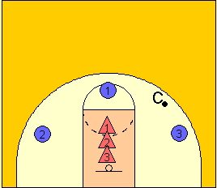
- Position three offensive players as shown in the diagram.
- Position three defensive players in the lane. Assign numbers to each defensive player.
- A coach should have the ball somewhere on the court.
- The coach passes the ball to one of the perimeter players and calls out a number (1, 2, or 3).
- The player in the lane, that had their number called, goes to close out/block out the shooter. The other 2 players have to identify who they block out. This forces the other two to quickly react and get to one of the other perimeter players. They should then get the ball and secure the rebound.
Repeat the drill as necessary and give everyone a chance to rebound several times.
- Close Out, Box Out – This drill provides a competitive situation for practicing boxing out. This drill emphasizes principles of closing on a shooter and maintaining a box out for the defensive players, and it teaches offensive players to follow their shots. It will give players practice in sustaining the intensity required to box out and to beat a box out.
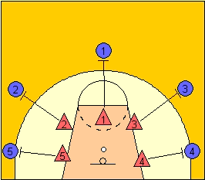
- Position five offensive players just outside the three-point line as shown. Five defenders match up and assume position at the edges of the key as shown. Place a ball on the ground just in front of the hoop.
- On the coach's first whistle, defensive players sprint to close out on the offensive players. The last three or four steps should be wide and choppy with the body leaning slightly back and arms raised to shoulder height.
- One the coach's second whistle, all five offensive players "shoot" a jump shot (none of them will have a ball). Defenders contest the shots by shouting "shot" and by moving close to the shooters with arms fully extended straight up and keeping their feet on the ground.
- As the shooters come down, the defenders turn and box out. The offensive players try to get to the ball near the hoop, and the drill remains live until one does get to the ball. The coach times this starting on the second whistle and ending when an offensive player gets to the ball.
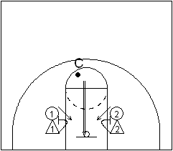
- The coach blows a third whistle to signal that the repetition is over.
- 2v2 Box Out – Teaches boxing out for rebounding.
- Offensive and defensive player on each side of the lane.
- The coach throws up the ball, defense blocks out, offense goes after the rebound.
- If the offense gets rebound, they try to score. If the defense rebounds, they pass the ball out to the coach.

- 3-Man LSU – This drill works on converting a layup in transition, and quickly transitioning to deny defense by face guarding the offensive player.
- Have players form a line behind half court on the far right or left side of the court.
- The first player has the ball and dribbles in for a layup.
- The second player takes the ball out of the net, goes out of bounds, and attempts to inbound to player 3.
- After the layup, the first player faceguards the third player.
- The third player attempts to come to the ball and receive the inbound pass.
- At 4 seconds, the offensive player breaks long.
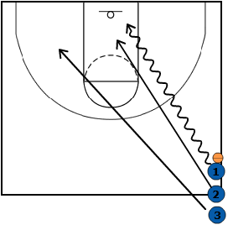
- The defender is playing deny defense by face guarding the offensive player and attempts to make the steal or stop the offensive player from scoring.
- Defensive Challenge – This drill is great because it provides a positive, fun twist to scrimmaging that encourages and rewards defense. It also gets your players in the mentality of, "I want to play defense."
- Perform this drill with 3-on-3, 4-on-4, or 5-on-5 in the half-court or full court.
- Split your players into two teams.
- Only the defense can score points, either by forcing a turnover or securing a rebound.
- If the defense gets a defensive stop, the team stays on defense.
- If the offense gets a basket or the defense fouls a shooter, the offense and defense switch.
- Play to 5 points or whatever you deem necessary.

#1 Layups
- You make lay-ups with your eyes.
- Shooting is about rhythm.
- The power to get the ball to the basket comes from your drive leg. Try to touch your nose with your knee.
- Early in the process, success has to be defined in terms of correct form rather than made baskets.
- Focus on the process, not the results. Younger kids may have problems with balance and strength. Don’t sacrifice form for made baskets.
Without a ball:
- Line up your team in rows.
- On the command, ”Set”, have them stand with their left leg forward and their right leg extended straight back. Knees should be bent and hips low in an athletic posture.
- On the command, “Drive,” have them step forward with their right leg, without taking their left foot off the floor, and drive their right knee in the air. The visualization phrase that I use is "Try to hit your nose with your knee."
- After driving the right knee, talk a little about the feeling they get when they drive the knee. They should feel their whole body lifting.
- Next, on the command “Drive,” combine the knee lift with a jump off the left leg. It might take a few reps to co-ordinate the knee drive with the jump but it will come quickly.
- Next, give the command "Drive," and, at the appropriate time, add the command, "Shoot." Players then go into a right- handed shooting motion. Timing is important, as you want to shoot while the player is in the air. Emphasize holding the follow-through on the shot until after they return to the floor.
- Next, in cadence, call, "Set, Drive, Shoot." Explain that this, when done with proper timing, is the action involved in taking a lay-up.
- When you feel that the shooters are comfortable with the right hand, alter their stance and have them practice a left- handed lay-up motion.
- On the command, ”Set”, have them stand with their left leg forward and their right leg extended straight back. Knees should be bent and hips low in an athletic posture.
- On the command, “Step Back,” players step back with their left foot so it is extended straight back and the right foot is forward.
- On the command, “Step,” players step forward with their left leg. Follow the, “Step,” command with, “Drive,” and, “Shot,” in cadence, to create the rhythm for taking an active lay-up.
- When you feel it is proper, switch to a left handed lay-up.
- On the command, ”Set”, have them stand with their left leg forward and their right leg extended straight back. Knees should be bent and hips low in an athletic posture.
- On the command, “Step Back,” players step back with their left foot so it is extended straight back and the right foot is forward.
- On the command, “Step Back,” players step back with their right foot so it is extended straight back and the left foot is forward.
- On the command, “Step,” step forward with the right foot.
- Add the command, "Dribble." Players will then imagine they are taking one dribble with their right hand. (This is a great opportunity to teach them about the rules concerning when the ball must be dribbled in order to move their pivot foot without traveling.)
- Follow the "Dribble" command with, "Step," "Drive," "Shoot."
- When said in the proper cadence and with proper timing; "Set," "Step Back," "Step Back," "Step," "Dribble," "Step," "Drive," "Shoot," will give players a basic feeling and rhythm for taking lay-ups, with and without a dribble
After they are good at taking lay-ups without a basket, move to a basket; teach them the proper angle to approach the basket; and go through the same sequences shooting right-handed and left-handed.
Add a ball.

#2 Footwork
- Triple threat positioning
- Pivoting on their left and right foot without traveling
- Square to the basket as soon as they catch the ball in a triple threat position.
- Jump stops
- Don't travel!
- Stay low when pivoting. Keep your knees bent and butt down, in a good triple threat stance.
- Don't get out of your triple threat stance until you hear the whistle. You always want to stay low, so you can take off quicker.
• Line your players up on the baseline. If you have more than 10 players or a small court, you'll need to divide them into two groups because they won't have enough space.
• Have each player spread out with about 5 feet between them, so they have enough room for pivoting.
• When you blow the whistle, all players should start running at 3/4 speed.
• At various intervals, blow the whistle and yell out their pivot instructions. Your choices are: front pivot left foot, front pivot right foot, back pivot left foot, back pivot right foot.
When the whistle blows, the sequence for the player consists of: jump stop (both feet should hit the floor at the same time), pause for a second, do a full 180 degree pivot, pause for a second, do a full pivot bask to starting position, and stay in triple threat position until whistle blows again.

• Watch every player to make sure they did the jump stop and pivot properly. If anyone traveled or if they're goofing off, make them start over again, back at the baseline.
• If everyone did it correctly, blow the whistle again. All players should start running.
• At various intervals, blow the whistle and yell out their pivot instructions. Your choices are: front pivot left foot, front pivot right foot, back pivot left foot, back pivot right foot.
• When all players reach the end of the court, start over again. You can blow the whistle anywhere between 1 and 5 times during their trip down the court.
• You should run this drill so players run down the court at least 5 times.

Tip #1 - The motivation aspect of this drill is simple. If they do it wrong, they all have to go back to baseline and start over again.
Tip #2 - It's important to always mix things up and keep your players guessing. You should mix up the number of times and locations that you blow the whistle. You might want to let them run all the way down without blowing the whistle once. And next time blow the whistle 5 times.
Tip #3 - Vary the speed that your players run. Start out with half speed, then progress all the way to full speed. Again, mix things up.
Tip #4 - Add a ball. Generally, you should use a ball for this drill and have them dribble while they are running. However, you might want to start without a ball, especially when first teaching younger players how to run this drill. Or if you don't happen to have enough basketball balls, they will still get benefit without it.
Tip #5 - Make sure ALL players pivot properly. Their butt should be down, knees bent, with feet shoulder width or wider. The pivot should be a full 180 degree turn, and then back again. Some players will have trouble with this at first or just do partial pivots. But keep on them to do it right. It's an important skill to master!
Tip #6 - You might want to use this as a combo warm up drill every day. For me, it worked great as the warm up at the beginning of every practice. This saved time because they worked on important skills and warmed up at the same time.
Tip #7 - You really should run this almost every day, especially if you have players at the high school level or younger. At the minimum, run the drill every other day.

#3 Shooting Form
- Eyes on Target
- Stance and Balance
- Shot Pocket
- Grip
- Balance Hand
- Delivery
- Upforce and Landing
- Follow Through
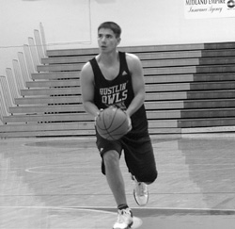
- 1) EYES ON TARGET
To improve accuracy, locate the target (rim) as early as possible.
- Keep your eyes on the target and do not follow the flight of the ball.
- Keeping your target focus is very important!

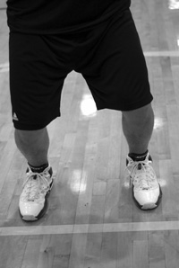
2) STANCE AND BALANCE
Feet are shoulder width apart for good balance.
- Feet should be in a slightly staggered stance that is consistent and comfortable for you. Your shooting foot is slightly ahead of the non-shooting foot in a comfortable position.
- Point your feet in the general direction of the basket, but not necessarily directly at it. We prefer an open stance, but you can also use the closed (squared) stance if that's more comfortable for you. With an open stance, your feet point towards one side of the basket. For example, a right handed shooter will point his or her feet just to the left of the rim for a more natural position and shooting motion.
- Once you develop a comfortable stance, line up your feet the exact same way on every shot. Whatever stance you use, consistency is critical.
- Flex/bend your knees on every shot.

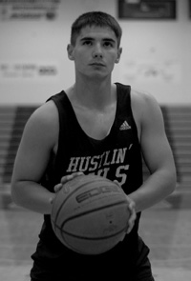
3) SHOT POCKET
As you catch the ball, move it quickly into the shot pocket.
- Line everything up so the ball and your shooting eye form a straight line to the basket. This is VERY important.
- Position the ball several inches above your waist.
- Grip the ball properly and be ready to shoot.
- Position the ball in your shot pocket the SAME way every time you catch it.

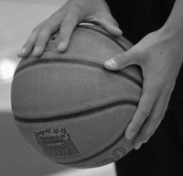
4) GRIP
Place the air hole between the middle and index fingers.
Line up your fingertip pads parallel to the long seams of the ball, so you can monitor the back spin.
Leave space between the ball and the middle of your palm. You should be able to insert a pencil between the ball and your palm area.
Spread your fingers far enough apart to comfortably balance the ball in one hand.
The ball should sit on your finger pads.
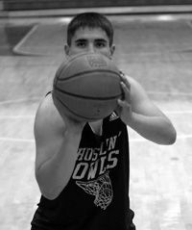
- 5) BALANCE HAND
- Your non-shooting hand should be on the side of the ball.
Your balance hand should not add force or spin to the shot.
Your non-shooting hand should not move on delivery and should ALWAYS come off the ball FIRST.

6) DELIVERY
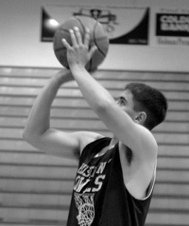
- The ball should start motion directly upwards from the shot pocket (no dipping of the ball).
- Your elbow should be positioned comfortably under the ball.
- The ball stays in front of you and should not go behind your head.
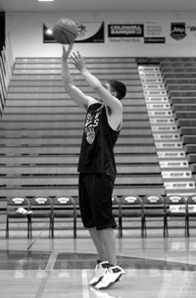
- Uncoil your body with your legs, core, and arm power all coordinated.
- Your elbow and wrist should extend in a straight line to the basket.
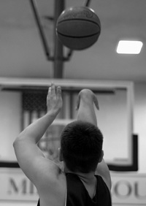
- Your shooting hand should extend in a straight line to the rim.
- Hand position on delivery is very important. The ball should come off the hand with perfect symmetrical backspin.
- As shown in the picture to the right, your guide hand stays to the side and does not influence the flight of the ball.

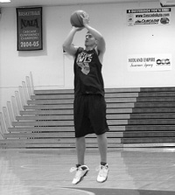
7) UPFORCE AND LANDING
Release the ball on the way up, just before the top of your jump.

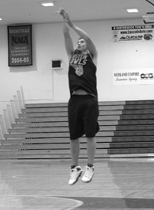
- Use your legs to generate upforce.
- You should land in the same spot that you jumped, which shows that you have good balance on your shot.

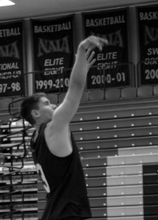
8) FOLLOW-THROUGH
Your wrists should be floppy (relaxed).
- Fingers should be pointed at the target (rim).
- Finish high. You should see your fingers at the top square of the back board.
- Hold your follow through position until the ball hits the rim.

#4 Ball Handling
• Dribble the ball hard. The more time the ball spends in your hand, the more control you have of the ball. The harder you dribble, the quicker it gets back in your hand.
• Head up at all times. Look at the rim or a spot on the wall during all practice.
• Use your finger tips to control the ball, not your palm.
• Use your imagination. Picture when and how you would use each of the dribbles.
• Teach mentality. There is too much dribbling for no reason in our game today. I like to teach that the primary purpose for putting the ball on the floor is to get a lay-up. If you don't have an opportunity, don't put it on the floor.
• Basketball is a game of length. Work on lengthening the dribble. Work to get your opportunities with 1 dribble. You don't beat defenses with your dribble. You beat people with your feet; you SEPARATE from your defense with the dribble.
• Basketball is also a game of angles. Try to move in straight lines. Whenever you make an "East-West" move (something that takes you toward the sideline), re-capture a "North-South" path (direct line to the basket) as quickly as possible.
• Don't do things in 2 dribbles that you can do in 1.

• Practice outside your comfort zone. Experiment; go faster than you are used to, use your imagination. When working on new skills, don't be concerned with losing the ball. Just pick it up and do it again. If you practice only things that are comfortable, then you will never improve.
- Chair Changes –
- Keep your head up.
- Stay low and keep your knees bent when making your change of direction move. (This improves quickness because standing upright will only slow you down when you're ready to explode past the defender.)
- Use your finger tips when dribbling (not your palms).
- Work on lengthening the dribble. Work to get your opportunities with 1 dribble. You don't beat defenses with your dribble. You beat people with your feet; you SEPARATE from your defense with the dribble.
- Place a chair about 21 feet from the basket. It can be on top, on wing, or in the corner.
- Start about 8-10 feet beyond the chair. Dribble straight at chair. At chair, use a change dribble (crossover, inside out, behind back, etc) to go beyond chair and make a lay-up.
- Try to get to the point where you need only one dribble to get to the lay-up. Practice all the changes.
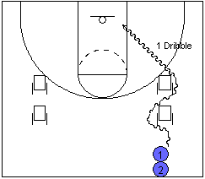
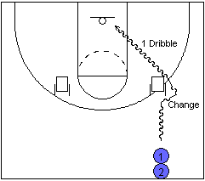
- You can add additional chairs or cones for more of a challenge.
- Two up, Two Back –
- The 2 up dribbles should be hard, attacking dribbles.
- The player should understand that anytime he can get the defense going backwards he has a big advantage.
- Be sure the backup dribbles are protected dribbles. Do not expose the ball to the defense.
- The push dribble should be an explosion in a straight line to the basket. Whatever the outcome of the move, it should be accomplished in 1 dribble.
- Set a chair or cone about 21 feet from the basket.
- Take 2 hard dribbles at the chair.

- When reaching the chair, take 2 backup dribbles.

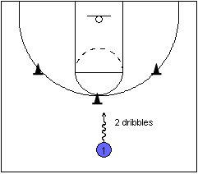  - Use a change of direction dribble (cross over, inside out, etc).  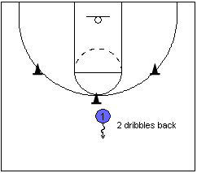  - Push ahead into 1 dribble lay-up or pull-up jumpshot. |  | 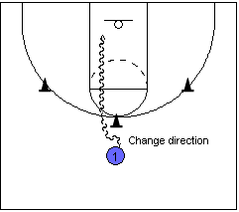

- Dribble Screens –
- Set screen on an angle toward the corner.
- Ball should be brought below the screen. That, in combination with the angle the screen is being set at makes it very difficult for the defense to get over the top.
- Experiment with different change dribbles. Crossover, inside-outs, spins and half spins are all very effective in going over the top or turning it down.
- Ball handler should explode off the screen. His first thought should be to get separation off the screen. He should get as much distance as possible off the screen with his first dribble. This will be a major benefit when teams hedge or trap on your screens. When done properly, separating off the screen will force switches and mis-matches.
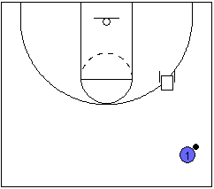
Option 1: Over the Top
Set a chair 20 feet out at the foul line extended.
Player starts with the ball near mid-court.

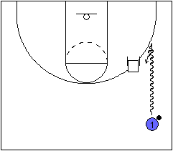
Player dribbles and takes the ball below the chair.
Once below chair, player makes change dribble and comes off the chair, simulating a ball screen.
Player can now finish with a shot or take it to the rim.

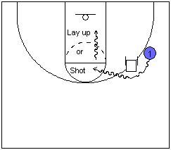
Option 2: Turn Down Option
This simulates what the guard can do if the defense beats the ball over the top of the screen.  Once below the chair, player makes a change dribble to go over the top over the screen.  Player then makes a second change to "turn down" the screen and goes below.  Player finishes either with shot or at the rim. | 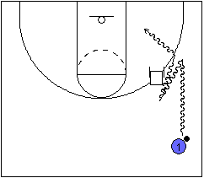

#5 Basic Passing
- A good pass is a pass a teammate can catch
- When passing, step toward your receiver.
- When catching, step toward the pass
- Like shooting, the ball should have a backspin to it. This is accomplished by following through on every pass.
CHEST PASS
The chest pass is named so because the pass originates from the chest. It is thrown by gripping the ball on the sides with the thumbs directly behind the ball. When the pass is thrown, the fingers are rotated behind the ball and the thumbs are turned down. The resulting follow through has the back of the hands facing one another with the thumbs straight down. The ball should have a nice backspin. When throwing a chest pass, the players should strive to throw it to the receiver's chest level. Passes that go low to high or high to low are difficult to catch.
BOUNCE PASS
The bounce pass is thrown with the same motion however it is aimed at the floor. It should be thrown far enough out that the ball bounces waist high to the receiver. Some say try to throw it 3/4 of the way to the receiver, and that may be a good reference point to start, but each player has to experiment how far to throw it so it bounces to the receiver properly. Putting a proper and consistent backspin on the pass will make the distance easier to judge.
OVERHEAD PASS
The overhead pass is often used as an outlet pass. Bring the ball directly above your forehead with both hands on the side of the ball and follow through. Aim for the teammate's chin. Some coaches advise not bring the ball behind your head, because it can get stolen and it takes a split-second longer to throw the pass.
WRAP AROUND PASS
Step around the defense with your non-pivot foot. Pass the ball with one hand (outside hand). It can be used as an air or a bounce pass. You will often see the wrap-around, air pass on the perimeter and the wrap-around, bounce pass to make an entry into the post.

PICK AND ROLL PASS
This is a pass that is used when the defenders double-team or switch on the pick and roll. If dribbling to the right, your left side is facing the target and you bring the ball up from your right side to throw the ball overhead to the screener who has either rolled to the basket or popped to the perimeter. The pass is used to shield the ball from the defender, and many times is thrown in "hook shot" fashion. Advanced players can do this while slightly fading away from the defender.
Tip #1 - Do overload drills to build speed and strength. Using 2-ball passing drills and using drills that force players to use one hand to pass, especially with their weak hand, will build strength and confidence. (It is important to explain to your players that the one-hand passing drills are DRILLS to build specific skills, not techniques to use in games.)
Tip #2 - Teach spacing. This is the most overlooked and possibly the most important aspect of offensive play. Teach your players what is the optimum distance they can effectively pass.
Tip #3 - Teach players to shorten the pass. As an aspect of spacing, taking a dribble toward a receiver will, in certain instances, improve spacing.
Tip #4 - Make the easy pass. There is no need for great passes when ordinary passes will do. Pass to an open teammate, in an area he can catch it, away from the defense. If you cannot do that, don't throw the pass.
Tip #5 - Emphasize the catch. While we would all like every pass to be perfect, we all know that will not be the case. The receiver must go where he needs to go to catch the ball. This may seem unrelated, but, to draw a parallel, baseball players know that a great defensive 1st baseman makes great infielders. He covers up for bad throws and can make a shortstop a star. By emphasizing the catch, passers will become more confident and receivers more aggressive.
Tip #6 - Scrimmage without dribbles. Nothing will teach players more about spacing, passing angles, getting open, and making effective passes than not allowing them to dribble. Be prepared for some initial frustration.

#7 Defense
- Stay between man and the ball
- Always stop the ball if it is in front of you
- Fronts of the Feet - Most of your weight should be on the fronts or balls of your feet and the majority of the weight should be on the big toes. Heel should still be in contact with the ground.  - Wide Base & Feet Turned Slightly In - Your feet should be pointing straight ahead or slightly turned in (pigeon-toed). This creates an angle that allows you to provide more force against the ground. In the picture to the right, the feet are bowed out which is improper form.  Your feet should also be slightly wider than shoulder width apart.  - Hips Back & Knees Bent - Butt should be behind the heels and your knees should be pointing forward, but not past the toes.  - Knees Inside of Feet - This helps create better push-off power.  - Butt Down - Staying low helps maintain balance.  - Shoulders Over Knees - Your shoulders should be over your knees with your chest out and back straight or slightly arched.  - Hands up - Depending on the tactic (Hands out or hand up to defend shot/dribble).  - Eyes focused on the player's waist or chest  - You should be able to draw a vertical line from the front of your forehead thru the front of your knees thru the front of your toes.  - All of this should create GREAT BALANCE. | - 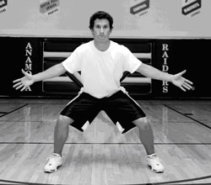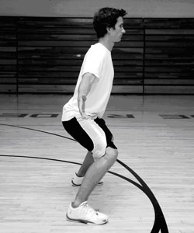

#8 Spacing
- Players at the three-point arc need to be at least ten feet away from other players.
- Catch the ball in triple threat.
- Jump to the ball.
- Be ready to move.
- The fast-break prevent spot at the top of the key should never remain vacant.
- Praise players for making passes that show great court vision.
- Encourage players to make crisp, accurate passes.
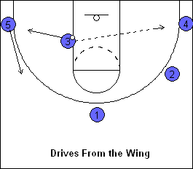
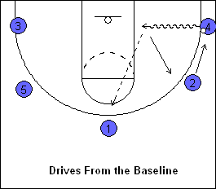
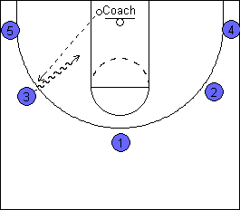
Instructions
- The drill begins with the coach passing to any of the players on the three-point line.
- Whoever catches it immediately drives toward the hoop as if for a lay-in.

- The driver then passes to any of the players on the three-point line.
- Rule: The player who passes the ball needs to fill a vacated spot along the perimeter. He needs to be 10 to 12 feet away from the person closest to them. This helps the players understand the spacing concept.

- Next, the player who caught the ball drives to the basket. The driver then passes the ball to another player on the perimeter.
- This action continues until the coach yells "Shot" to signal the driver to continue in for a lay-in instead of passing.
If two players go the same area, you should stop the drill and point out to the players that they are bunching together. Explain to them that they need to communicate to each other who is going to fill the spot. Make sure that they understand when they get close together, it makes it much easier for the defense to guard them.
On every catch, the players need to jump to the ball and catch in a triple threat position. By jumping to the ball, it teaches them to beat the defender to the ball. By getting in a triple threat position as quick as possible, it teaches them to be ready to shoot or drive if they see an opportunity to dribble penetrate.
Progressions:
- Pass until the coach yells, “shot.”
- Alternate hands on every other drive. First time, drive to the right with the right hand. Second time, drive left with the left hand or vice-versa.
- Tell the players to pass the ball a certain number of times and take a shot. This progression would be continuous WITHOUT the coach yelling, “shot.” For example, pass the ball 3 times, and a take a shot. If you want to ensure that everybody takes a shot, you could say that each player needs to take a shot before one player takes a second shot.
- Coach sets a time parameter as well. For example, see how many layups they can make in 2 minutes. They can shoot a layup after 4 passes. Each player has to take a shot before any player can take their second shot. Each player must take their second shot before any player takes their third shot and so on.
- Instead of shooting layups, shoot jump shots.

#9 Motion Offense

A motion offense is a free form offense that has no pre-planned cuts or passes. Rather it has rules and options. Motion offenses are often called "Read and React" offenses. A motion offense gives players a choice of what to do depending on what the player sees the defense do. No two motion offenses are alike. Pass and screen, pass and cut, curl and pop, inside-out, flare and cut -- this is the language of the motion offense.
- There are 8 spots on the floor. When cutting, fill one of them and try to free a teammate on the way.
- Make the next open pass.
- After passing, player has 2 options: Basket cut or screen away (slash cut).
- When basket cutting, come out opposite the ball. Other players adjust to the open spot.
- Look opposite the pass you receive for your next pass.
- Fill a post spot for a maximum of 2 passes.
- 5 passes before a perimeter shot. No perimeter shots before the ball touches the post once.
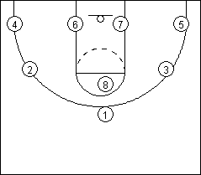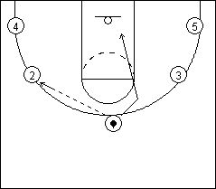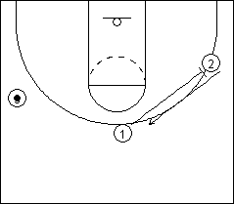
Slash Cut
8 Spots
Basket Cut
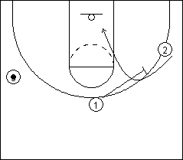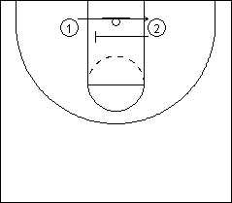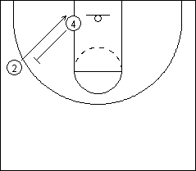
Screen Across
Curl Cut
Screen Down
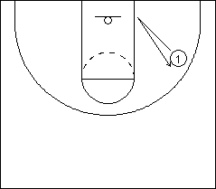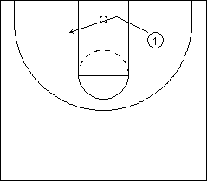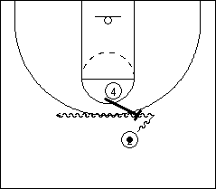
High Ball Screen
V-Cut
Flash Post
Brookline Basketball Club Culture
- Beat the ball down the floor in transition and conversion.
- Rebound position every shot – back, space, pinch on free throw.
- Play defensive in a stance.
- Help and then recover.
- Help the helper.
- Close out with hands above shoulders.
- Dive on loose balls.
- Protect the ball when you have it.
- Rip through on pivots – strong with the basketball.
- Chin rebounds.
- Meet every pass.
- Change in direction and speed on cuts.
- Take a charge.
- Steal passes that are thrown too far.
- Sprint from spot to spot in practice.
- Contest every shot.
- Ball fakes.
- Deflect passes.

1. Catch the ball – Move to the ball, what will you do with it when you get it – think ahead
– Be in a athletic position, hands out, see the court
– Triple Threat - don’t immediately dribble, when you do, keep your dribble
2. Eyes – HEAD-UP at all times - everyone, even when cutting so you can see the ball
– Help Offense: see the court, see when to set screens, keep your head up
– Help Defense: see your man -> see the ball, call out screens, deny lay-ups, call out shot
3. Bounce Passes - Hard passes, no over the top passes especially cross court
– Any pass below the key should be a bounce pass, fake high pass and bounce pass
4. Fakes - fake a pass then pass to the other side, fake a shot then pass
• V-cut – cut before you move to open spots, on offense move without the ball
• Jab step – lose your man, cut to the basket or jab step and shoot (creates spacing)
5. BOX OUT – face your man – fore arm, turn when the ball starts coming down
• Stay low and stay in contact, own the spot
• On offense - in the paint, step in front of defender & box out to receive a pass

