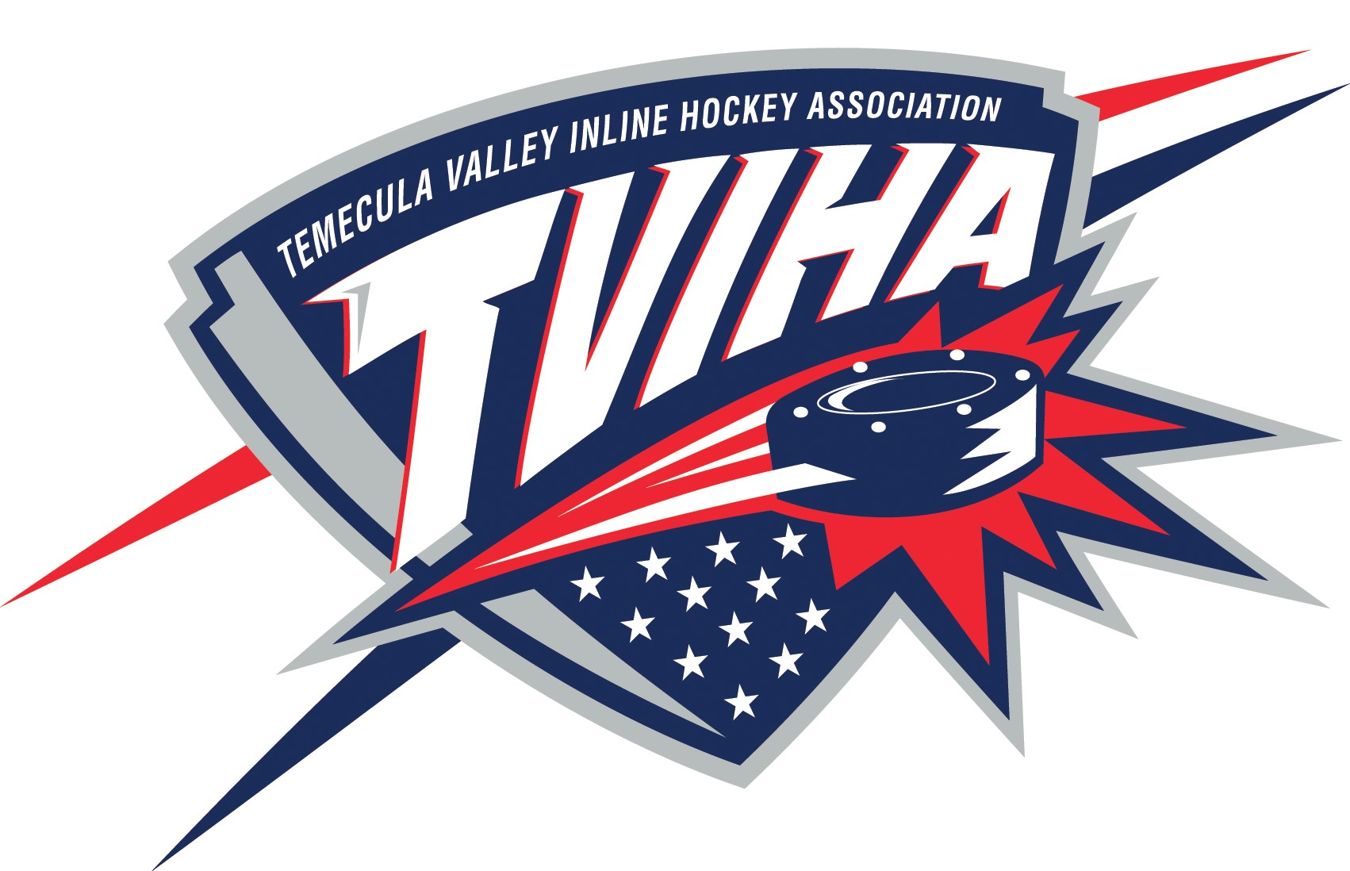

Temecula Valley Inline Hockey Association
Regular Meeting Minutes
October 17, 2017

- Call to Order & Establish Quorum:
- President, Tom Bilek, called meeting to order at 6:39pm.
- The following people were present: Alysha Stichter, Gina Downey, David Bowman,
Bobbie Platek, Tom Bilek, Craig Charyak, Sonja Johnson, Katie Worley, Destiny Parker

- Reading and Approval of Minutes
- September minutes were reviewed and approved.

- Treasurer’s Report: Alysha Stichter
- September Checks #3947-3969 were reviewed and approved.

- Fall 2017 Recreation League
- The season is generally going very well in all divisions.
- The Teams are relatively even strength and games are usually very competitive.
- There have been a few fair play concerns by some coaches that were noted.
- Due to low attendance of 17U games we should consider closing the snack bar.
- The 17U Division has had some disciplinary issues.
  - One 17U player was ejected and given a 1 game suspension per the rule book. Disciplinary committee reviewed and decided not to add further punishment.
  - Later in the season the same 17U player with 3 infractions on one play was immediately ejected. This escalated into a verbal incident between parent and BMOD Mike Betsch. Parents were not happy that a game official had to touch and remove their son from the rink. Upon review it was determined our referee was not aggressive toward the offending player and acted appropriately. The player was suspended for 6 games by our Disciplinary Committee due to prior history, comments from game officials and witnesses and after reviewing video of the incident. All BMOD staff and referees were reminded that calm reactions to upset parents and professionally diffusing situations is necessary. Tom believes this player will leave the league.
- Craig has noted that there is a noticeable decrease in the amount of people that attending the 17U games and would like to consider various ways to “energize” the spectators such as raising music volume between plays or possibly creating a cheer section. Many parents simply drop off the older players.

- Referees:
- Some referees have requested increase in the per game fee. Tom agrees that an increase in referee compensation should be considered. The Board of Directors will review.
- Pay scale is higher for the school league

- Warriors:
- The Warriors manual needs to be updated.

- TVIHA/Reign Night at RRSP:
- Further discussion should continue when Justin is present regarding our TVIHA/Reign night.
- Time Changes for Reign players at our rink.
  - 8 & 10U – 7-8PM
  - 12 & 14U – 8-9PM

- Reign Game Night November 4th:
- Friday is the deadline to purchase tickets. Tom will coordinate as possible to keep families together.
- Tickets will be distributed on October 30th at RRSP 5-8PM.

- School League Discussions:
- Turnout has bee better than expected with 60 or more for Middle School however there are some Goalie issues due to low turnout for Murrieta.
- The Rule Book has been reviewed and Tom, Mike & Bobbie will make sure it is completed and approved prior to the start of the season. (Jersey requirement)
- Online registration needs to be set up.

- Chairperson and Board Member Updates:
- *

- Adjournment:
- Meeting adjourned at 7:58pm.

