Buffalo Youth Hockey Association

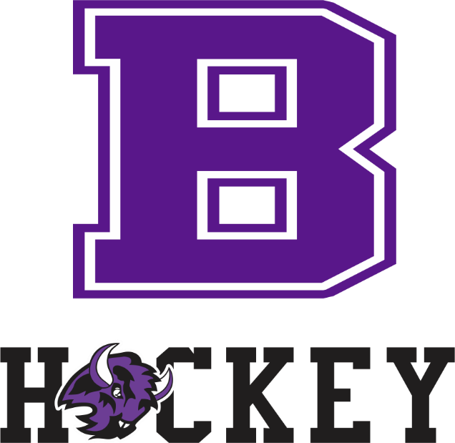

Coach Meeting

Mini Mite/Mite/8U
2022-2023 Season

Mini Mite/Mite/8U Coaches

- Goal – Move as many players, with the appropriate skill levels, to the Squirt/U10 programs
  - Kids have fun
  - Parents are content
  - Coaches teach the skills

- Group Numbers:
  - Mites - Skaters
    - Girls U8
    - Mites Black
    - Mites Grey
  - Mini-Mites -Boy & Girl Skaters
    - Mini Mites Purple
    - Mini Mites White

- Final Group Numbers, Coach Numbers & Players per Team - TBD after evaluations
  - We will have a lot of player movement from our initial starting group especially at the Mini-Mite/6U level.

- Evaluations: 1st week in November
  - Consistency!
  - Please skate with every kid if you choose to skate with them during evals
  - Encourage every kids to do their best and beat their previous time

- Coach Registration: visit website

- Coach Certification: BYHA Coach Application; USA Hockey Number; USA Hockey CEP – Level 1; USA Hockey Age-Specific Module Online; BYHA Coach Registration; SafeSport; Background Screening; Coaching Ethics Agreement; Concussion Protocol

- Coach Expectations: Communicate, develop players, involved with association/parents, face of the program
  - All coaches MUST wear helmets on the ice!

- Types of Coaches: Lead, Head, Assistant
  - Lead Coach – Plan practice, communicate/assign practice plan, skating skills at beginning of practice, divide to stations, game at end of practice, coach coaches in group
  - Head Coach – Game management, parent communication, team development, ambassador of fun
  - Assistant Coach – Same as head coach

- Standard Practice:
  - Lead coach circulates practice plan via e-mail or text beforehand – station assignments included
  - First few minutes on ice is skate-around (great opportunity for fun)
  - Lead coach calls skaters into center at beginning of practice
  - Lead coach takes skaters through group skating drills (optional); head and assistant coaches help skaters w/ technique
    - Or Cross-ice ‘Zone Skating’ – More individual/small-group instruction
      - Separate by ability/experience
  - All coaches set up stations and take skaters through each station; lead coach signals station changes
  - After last station, lead coach organizes game for skaters; head and assistant coaches pick up stations and play in game
  - Lead coach calls group in for group cheer; all coaches help skaters off the ice

- Standard Game:
  - Before the game, find parent to run clock
  - All coaches arrange pads/boards at beginning of ice time
  - Set clock for appropriate game and shift length
  - All coaches help direct skaters on ice and on pads/in bench
  - Shake hands at end of each game before rotation
  - Rotate and repeat
  - All coaches put away pads/boards at end of ice time

- Skill Development

 | Mini Mite White | Mini Mite Purple | Mite Grey/8U | Mite Black/8U
Skating
 | Ready position | Ready position | Ready position | Ready position
 | Edge control | Edge control | Edge control | Edge control
 | Forward start | Forward start | Forward start | Forward start
 | Forward stride | Forward stride | Forward stride | Forward stride
 | Controlled stop  - 2 foot and snowplow | Controlled stop  - 2 foot and snowplow | Controlled stop  - 2 foot and snowplow | Controlled stop  - 2 foot and snowplow
 | Controlled turn | Controlled turn | Controlled turn | Controlled turn
 |  | Forward crossover | Forward crossover | Forward crossover
 | Backward skating | Backward skating | Backward skating | Backward skating
 |  | Backward stop | Backward stop | Backward stop
Puck Control
 | Lateral stickhandling | Lateral stickhandling | Lateral stickhandling | Lateral stickhandling
 |  | Front-to-back stickhandling | Front-to-back stickhandling | Front-to-back stickhandling
 |  | Diagonal stickhandling | Diagonal stickhandling | Diagonal stickhandling
 |  |  | Attacking the triangle | Attacking the triangle
Passing
 | Forehand pass | Forehand pass | Forehand pass | Forehand pass
 | Backhand pass | Backhand pass | Backhand pass | Backhand pass
 | Receiving pass | Receiving pass | Receiving pass | Receiving pass
Shooting
 | Wrist shot | Wrist shot | Wrist shot | Wrist shot
 |  | Backhand | Backhand | Backhand
Body Contact
 |  |  | Stick on puck | Stick on puck
 |  |  | Stick lift | Stick lift

