
Easton Girls Softball
Minors Division
2024 Coaches Packet

Practice Format
Feel free to follow the following practice format:
- Practice 1 – Practice 3: 75 minutes of practice and drills – general outline below
  - 6:00 Introductions/Team Name selection/Team Chant
  - 6:10 Stretching/Show them the field, positions, etc
  - 6:20 How to hold the ball correctly, have each girl partner up to throw
  - 6:35 Running the bases/learning what the bases are and what they mean
  - 6:45 Fielding ground balls
  - 6:55 Catching fly balls in the outfield
  - 7:05 Introduction to Batting/Show them how to hold the bat, swing etc./ have each girl take a few swings off the T
  - 7:15 End with everyone running around the bases / Team Chant

- Practice 4 – Practice 7: 30 minutes of practice / 45 minutes game
- Practice 8 – Practice 12: 15 minutes warmup / 60 minutes game
Drills and Practice Tips
- Teach the girls how to stretch; have them form a circle. Each week you can have a new girl lead team stretching.

- For the first couple practices, have them sit in a circle and introduce themselves to their teammates/break the ice (name, age, favorite sport or activity, etc.). I have always had the girls come up with a team name and a cheer that they all do at the end of practice.

- Teach them the parts of the field and terminology (Infield, Outfield, positions, what are Outs, what are Runs, etc.). I usually walk them around the field and teach them.

- Teach them how to hold the ball across the seams (see below)
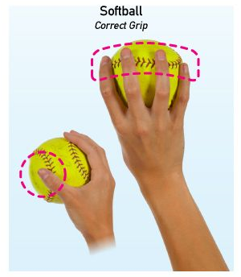
- Teach them how to throw the ball (I can show this to you on the first day)
  - We will teach the girls the Cradle, “L”, Jack Knife technique
  - First, the girl who is throwing points their shoulder to the target
  - Next, the girl who is throwing cradles the ball in their glove
  - Next, the girl who is throwing make a capital letter “L” shape with their hands
  - Then, the thrower yells jack knife and throws and follows through with the throw
  - You can also try having the girls throwing from their knees (whatever hand they throw with, that knee is on the ground, the other leg the knee will be raised)

- How to catch the ball
  - The catcher will form the letter “W” with your hands (see picture below)
  - Tell the girls to always watch the ball
  - When the ball gets thrown to the, they need to move quickly and get behind the ball
  - The following video explains some great tips for catching: https://www.youtube.com/watch?v=uOwC9wmhd0Y
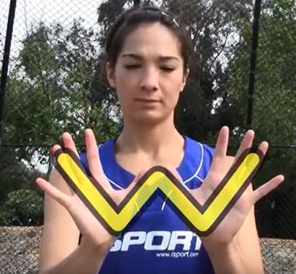
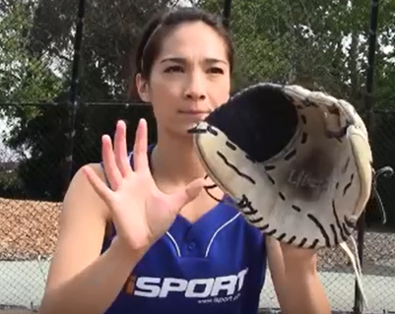
- How to hit a softball
  - Line up feet and knuckles on bat
  - Bring hands back and up to ear level
  - We can use the Load, Pull the String, Swing method (you can see it in the video link below) https://www.youtube.com/watch?v=_F2ldM4zFLo

- How to field groundballs
  - Tell the girls that they should always be in an athletic position
  - They will form a triangle with their glove and feet (you can see this in the first minute of the following video, and I have attached a picture below – it is a little advance for young girls, but gives you the general idea) https://www.youtube.com/watch?v=ccta-HWnXis

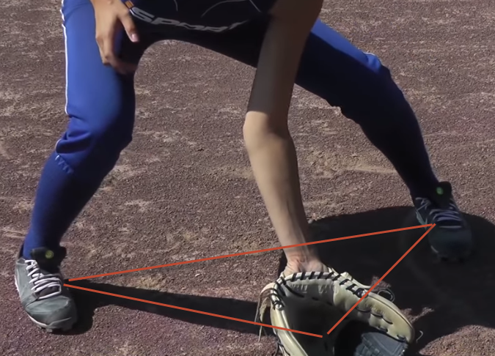
  - You can also teach the girls that once the ball reaches their glove, they can use their other hand and cover the ball like an alligator chomp.
  - We will then teach the girls to have quick feet and once they field the ball, they can quickly jump onto their skateboard and get ready to throw.

- Teach them how to run the bases
  - Have them start at home plate, explain what home base is, and then make them run to first base. When they all complete first base, explain what first base is and then have them do the same drill from first base to second base, then second base to third base, and third base to home plate, etc.
Miscellaneous
Topics ideas of things you can do while in the outfield
Walk to each position: teach them about left field, center field, right field
Do pop up drills on the grass
Do ground ball drills on the grass
Teach them how to swing a bat
Topics ideas of things you can do while in the outfield
Walk to each position: teach them about left field, center field, right field
Cover the different bases to run to
Cover the different positions in the infield
Practice hitting drills
Do pop up drills on the dirt
Do ground ball drills on the dirt
Teach them how to swing a bat

