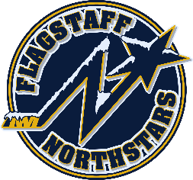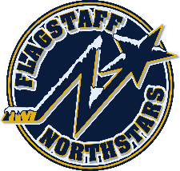
Flagstaff Youth Hockey Association
BOARD OF DIRECTOR’S MONTHLY MEETING MINUTES
December 20, 2023

A motion to cancel the December 20, 2023 meeting was made by Kristi Kolek. Second by Gina Nabours. All board of directors voted in favor. The meeting was cancelled.

BOD Role Call:
☐ Travis Joralmon | ☐ Paul Barton
☐ Brad Mihalik | ☐ Kristi Kolek
☐ Gina Nabours | ☐ Chris Whitney | ☐ Travis Johanson

Coaches:
☐ 6U/8UH- Carrick
☐ 8U Humphreys- M Palmer
☐ 8U Agassiz- Graham
☐ 10UH/14U- Johanson
☐ 10U Agassiz- Hansen
☐ 10/12/14H- Lauritzen
☐ 12U- Walsh
☐ 16U – K. Palmer
Managers:
☐ 8U Humphreys- Kolek
☐ 8U Agassiz- Van Wyck
☐ 10U Humphreys- Joralmon
☐ 10U Agassiz- Darby
☐ 12U- Keck/Robinson
☐ 14U- Johanson
☐ 16U- Welker

Next board meeting scheduled for January 17, 2024 at 6pm.

