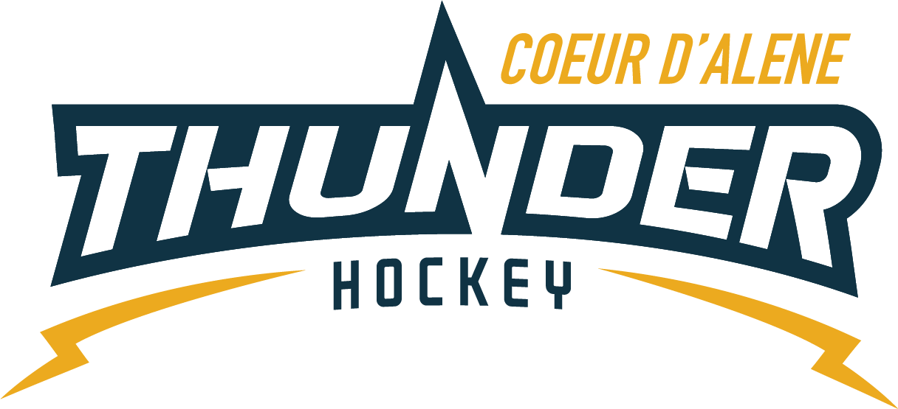

CDAHA

Meeting minutes
Location: Frontier Date: June 23 2021
Attendees: Bob Nelson, Meghan Smith, Matt Creighton, Katie Lovitt, Will Higgins, Joe White, Jackie P, Bart Barrett,
Absent - Josh Leppert, Jarrod Hansen, Matt Fisher
Time: 6:43PM
- Call to order
Matt Creighton, President called meeting to order 6/23/21 6:43PM
- Roll call
As stated above -
- Approval of minutes from last meeting
Minutes approved motioned by Bob second by Will passed unanimously
- New Items
  - TRESURER UPDATE / Finance Committee
    - Current $80,949.24
    - See treasurer report for details on all items discussed –
    - No outstanding checks – one invoice for 2326 for RG and Girls
    - Received 2390.10
    - Received 420 from IAHA – reimbursements
    - Received a grant from Umpqua bank 2000 matt will research and confirm
  - Finance committee Update
    - Meeting to schedule to review season and CPA plan to report expenses and income
    - Need to investigate the CPA cost 40 dollars an hour
    - Discuss with Wes Veech look at options
  - Coaching Committee Update
    - Coaches notified and asked to fill out application for interest
    - John Babcock is back and in on the plan for the season with support from Dan and Josh rolling up through CIC for any additional needs and support t
    - Matt will redo website for mites to stream line
    - Train a new mite parent for succession planning
    - Coaches committee will sit down with the next few weeks with CIC to discuss the frontier history and plan for the future
    - Joe White CIC will like to have the older kids to help the younger kids
    - Community involvement outside the rink
    - Bantam dates August 2nd skills and August 4^{th scrimmage} try outs for travel – to try to reduce the loss of kids to Academy and other try outs let them know what is happening here so they are engaged throughout the year 2007 2008 2009 -Requesting 2 1.15 hours – 250 dollars x2 $50.00 elliot – motions to pay the ice and build registration for try outs. Bob seconds
    - Midget try outs to be scheduled separately later in the year in September 2 weeks before
  - Gear Committee Update
    - Cleaned out closet
    - 22 small sets , 14 med sets . 14 large sets, 4 goalie sets (mites)
    - 4 helmets to sell – check to see how much it has grown in the last 2 years to see if we need more gear – Jackie will check the growth over the last 2 years – net new players -to decide how much more we need to order – will email bob and Emily and bob and Emily will advise the fundraiser committee what is needed.
    - Would like to have 30 small – 20 med – 20 large – matt would like to do 30 of each potentially ordering 20 sets more approximately 125 dollars per set
    - 1 gear check out for summer skate only and check in on last day plus one week later and then cashing checks.
    - Key log
Elliot, Bob, Megan, Emily, Josh, Jakie P, Bart, Katie , mark A,
Email out to collect keys – prob 10-14
If we cant get responses then re key -
    - Lease gear is as supplies last….please include that in all communications
    - Discipline Committee -No report
      - Looking for a new committee chair potentially
  - Safesport Committee update – No report
  - Scheduler update – No report
  - Welcome letter
    - Megan created it will send it out and will be edited and reviewed
    - Pucks motion passed unanimously –
  - Banners - Check with CW on wraps for boards – and see what they can do – Vice would like a Banner to hang up there reprint a banner for KCSO – and a CDAHA banner
  - Summer Skate
    - 45 summer skate kids signed up – blast again for everyone and put on facebook – megan and jakie will do this and contact April
    - Don’t waste ice
  - INGHF /CDAHA – bring a friend
    - 30 plus new kids – from kindergarten to 9th grade
Girls Program Update
- U14 wghl team offered spots registration built and going
- Very successful turn out
Registration Information
    - April has everything
    - Send her the information for mites and more
- Adjournment
Motion to Adjourn Bob second by Megan 8:04
Minutes submitted by: Elliot Taub
Minutes approved by: BOD
- Next Meeting
  - WED July 7 2021 6:30PM
  - Frontier ICE Arena and potential zoom due to vacations TBD

