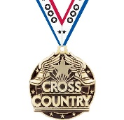
Top 25 All Class – Top 15 AA – Top 12 A – Top 9 B
At the State Cross Country Meet

Has been recognized as an ALL-STATE Performer
By the South Dakota Cross Country Track and Field Coaches association
For
Cross Country

On This Date:
Attested by:
Name
IN ACKNOWLEDGEMENT THAT
Certificate of Achievement

