**For Stillwater Scrimmages – Saturday 8/17**

* Locker room will be open at 6:30am
* Bus departs Rogers HS at 7:30am
* Wear Black shirt, white shorts, white socks
* Games located at Stillwater HS, 5701 Stillwater Blvd, on the athletic fields (walk through large arch/gates)
* One bus will leave Stillwater at 12:30pm and the other at 1:50pm.

**Schedule for Stillwater:**

* Players will know what team they will be playing with for their first game on Friday. There will be players who play on multiple teams Saturday.
* Field 1 is the first field to the EAST of the stadium. Field 2 is the second field to the EAST of the stadium.

**A light snack and water will be available for players as they board the bus, it is recommended they bring additional food and drink, as no concessions are available.**

**Parents are welcome to come watch!**

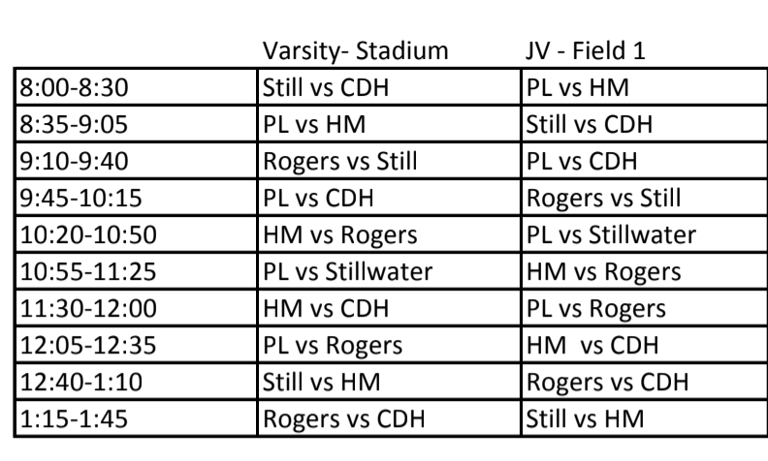

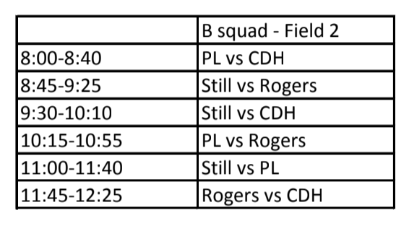

* RHS Community Night 9/15 @ MN United - **Tickets Still Available** – players can bring order form Saturday a.m. before boarding bus to Stillwater or mail by 8/23 to address listed in form - [Link](https://cdn2.sportngin.com/attachments/document/31bd-1942048/Lady_Royals___MN_United_2019.docx?_ga=2.117975881.1706382503.1565655524-936514943.1548383492)