DISTRICT DIRECTOR SIGNOFF SHEET

Association: ____________________ Team Name: ___________________
Classification: ______________ Category: __________ Division: ______

Reviewer’s name (please print): _______________________ Date: _______

TEAM CREDENTIALS FORM
Verify presented
Make sure the CATEGORY, DIVISION, CLASSIFICATION is correct [see charts 1/2]
Make sure the entire top half is completely filled out and legible
Including two different people as contacts
Initial the box to denote verification of the 1-T roster
Compete the box for TOTAL GAMES, AS OF box from the game log
Do not include T5 games in the total; note those on the side
Sign CREDENTIALS VERIFIED BY and DATE
Include any follow up notes; include any items missing or incomplete
Include in the notes any exceptions approved by the SPOC

CREDENTIALS VERIFICATION SHEET (CVS)
Verify presented and filled out properly
Verify that the team has played the minimum number of games required [see charts 1/2]
Verify that each player has played the minimum number of games required [see charts 1/2]
Complete the column CONSENT TO TREAT for those teams required (National bound); form presented
Complete the column OUT OF DISTRICT PLAYER for those players OOD [see chart 3]
[may or may not be in the notes portion of the 1-T roster form]
Verify the SLIDING SCALE column for Youth Tier 3 teams Sliding Scale eliminated for ’24-25
Verify coach CEP level expiration date/completion; strike out those not compliant
Verify coach Module completed; strike out those not compliant
Verify coach SafeSport completed and current; strike out those not compliant
Verify coach Screening completed; strike out those not compliant
Verify 10U and above players have their position and jersey number shown
Verify at least one (1) LRM (Locker Room Monitor) identified
Verify Head Coach identified
Verify Manager identified
Sign VERIFIED BY and fill in the DATE

TEAM ROSTER FORM (1-T)
Verify presented
Check the roster date: ORIGINAL APPROVAL, LAST UPDATED; look for any anomalies
Confirm the DOB VERIFICATION column shows a ‘V’
Confirm the TRANSFER column is filled out
Confirm the printout has City/State for players [used to confirm OOD]

TEAM HISTORY REPORT
Verify presented
Verify no games played prior to the team being rostered
Look for dates of any late player add
Look for any anomalies

PLAYER TRANSFERS
No action needed as these are verified at the time of rostering by the District Registrar.

CONSENT TO TREAT
Verify forms presented for national bound teams
Cross check to make sure a form for each player, coach, and manager [record on CVS]
Verify each form completed properly

MAHA GAME LOG
Verify present and filed out properly
Confirm a score sheet for each game listed
Verify 30% rule
“Teams rostered under this age, division, and category shall not play more than 30% of their
games against Tier 1 opponents.”
“To remain eligible for Districts and States Playoffs, teams may not play more than 30% of their games against teams in a higher category and/or age classification.”
Verify 50% rule
“Teams shall only be eligible in the age classification, category, and division in which they
play the majority of their games prior to Districts or States.”

SCORE SHEETS
Review each score sheet for any missed game misconduct/match penalties not served
Player 4+ (2/10 is 2 penalties)
Team 12+
Score sheets must show a referees signature
If transferred from GameSheet from a paper copy, the original signed scoresheet must be presented
Game misconducts not shown on the score sheet are deemed to be not served

HIGH SCHOOL JV
Verify Division 1 or 2 and record on the “Team Credentials Form”
Division 1: all players from the same school. No out of district restriction.
Division 2: no restriction on school.
Division 2 teams may not have more than six (6) players who reside outside the MAHA District
in which the team is registered. If the player is out of district but is within the school district
from which the majority of the team's players come from that player is not considered out of
district.
Verify a student ID with picture for each player
Non-Varsity High School Division teams may roster up to 25 players between September 1
and November 14 each season. After November 15, those teams with 20 or more players on
their roster would not be able to add any additional players. Any team that falls below 20
could add additional players to bring their team up to 20 players.

CHART 1

CHART 2

CHART 3: OUT OF DISTRICT/ OUT OF STATE

CLARIFICATION FOR TIER III TEAMS
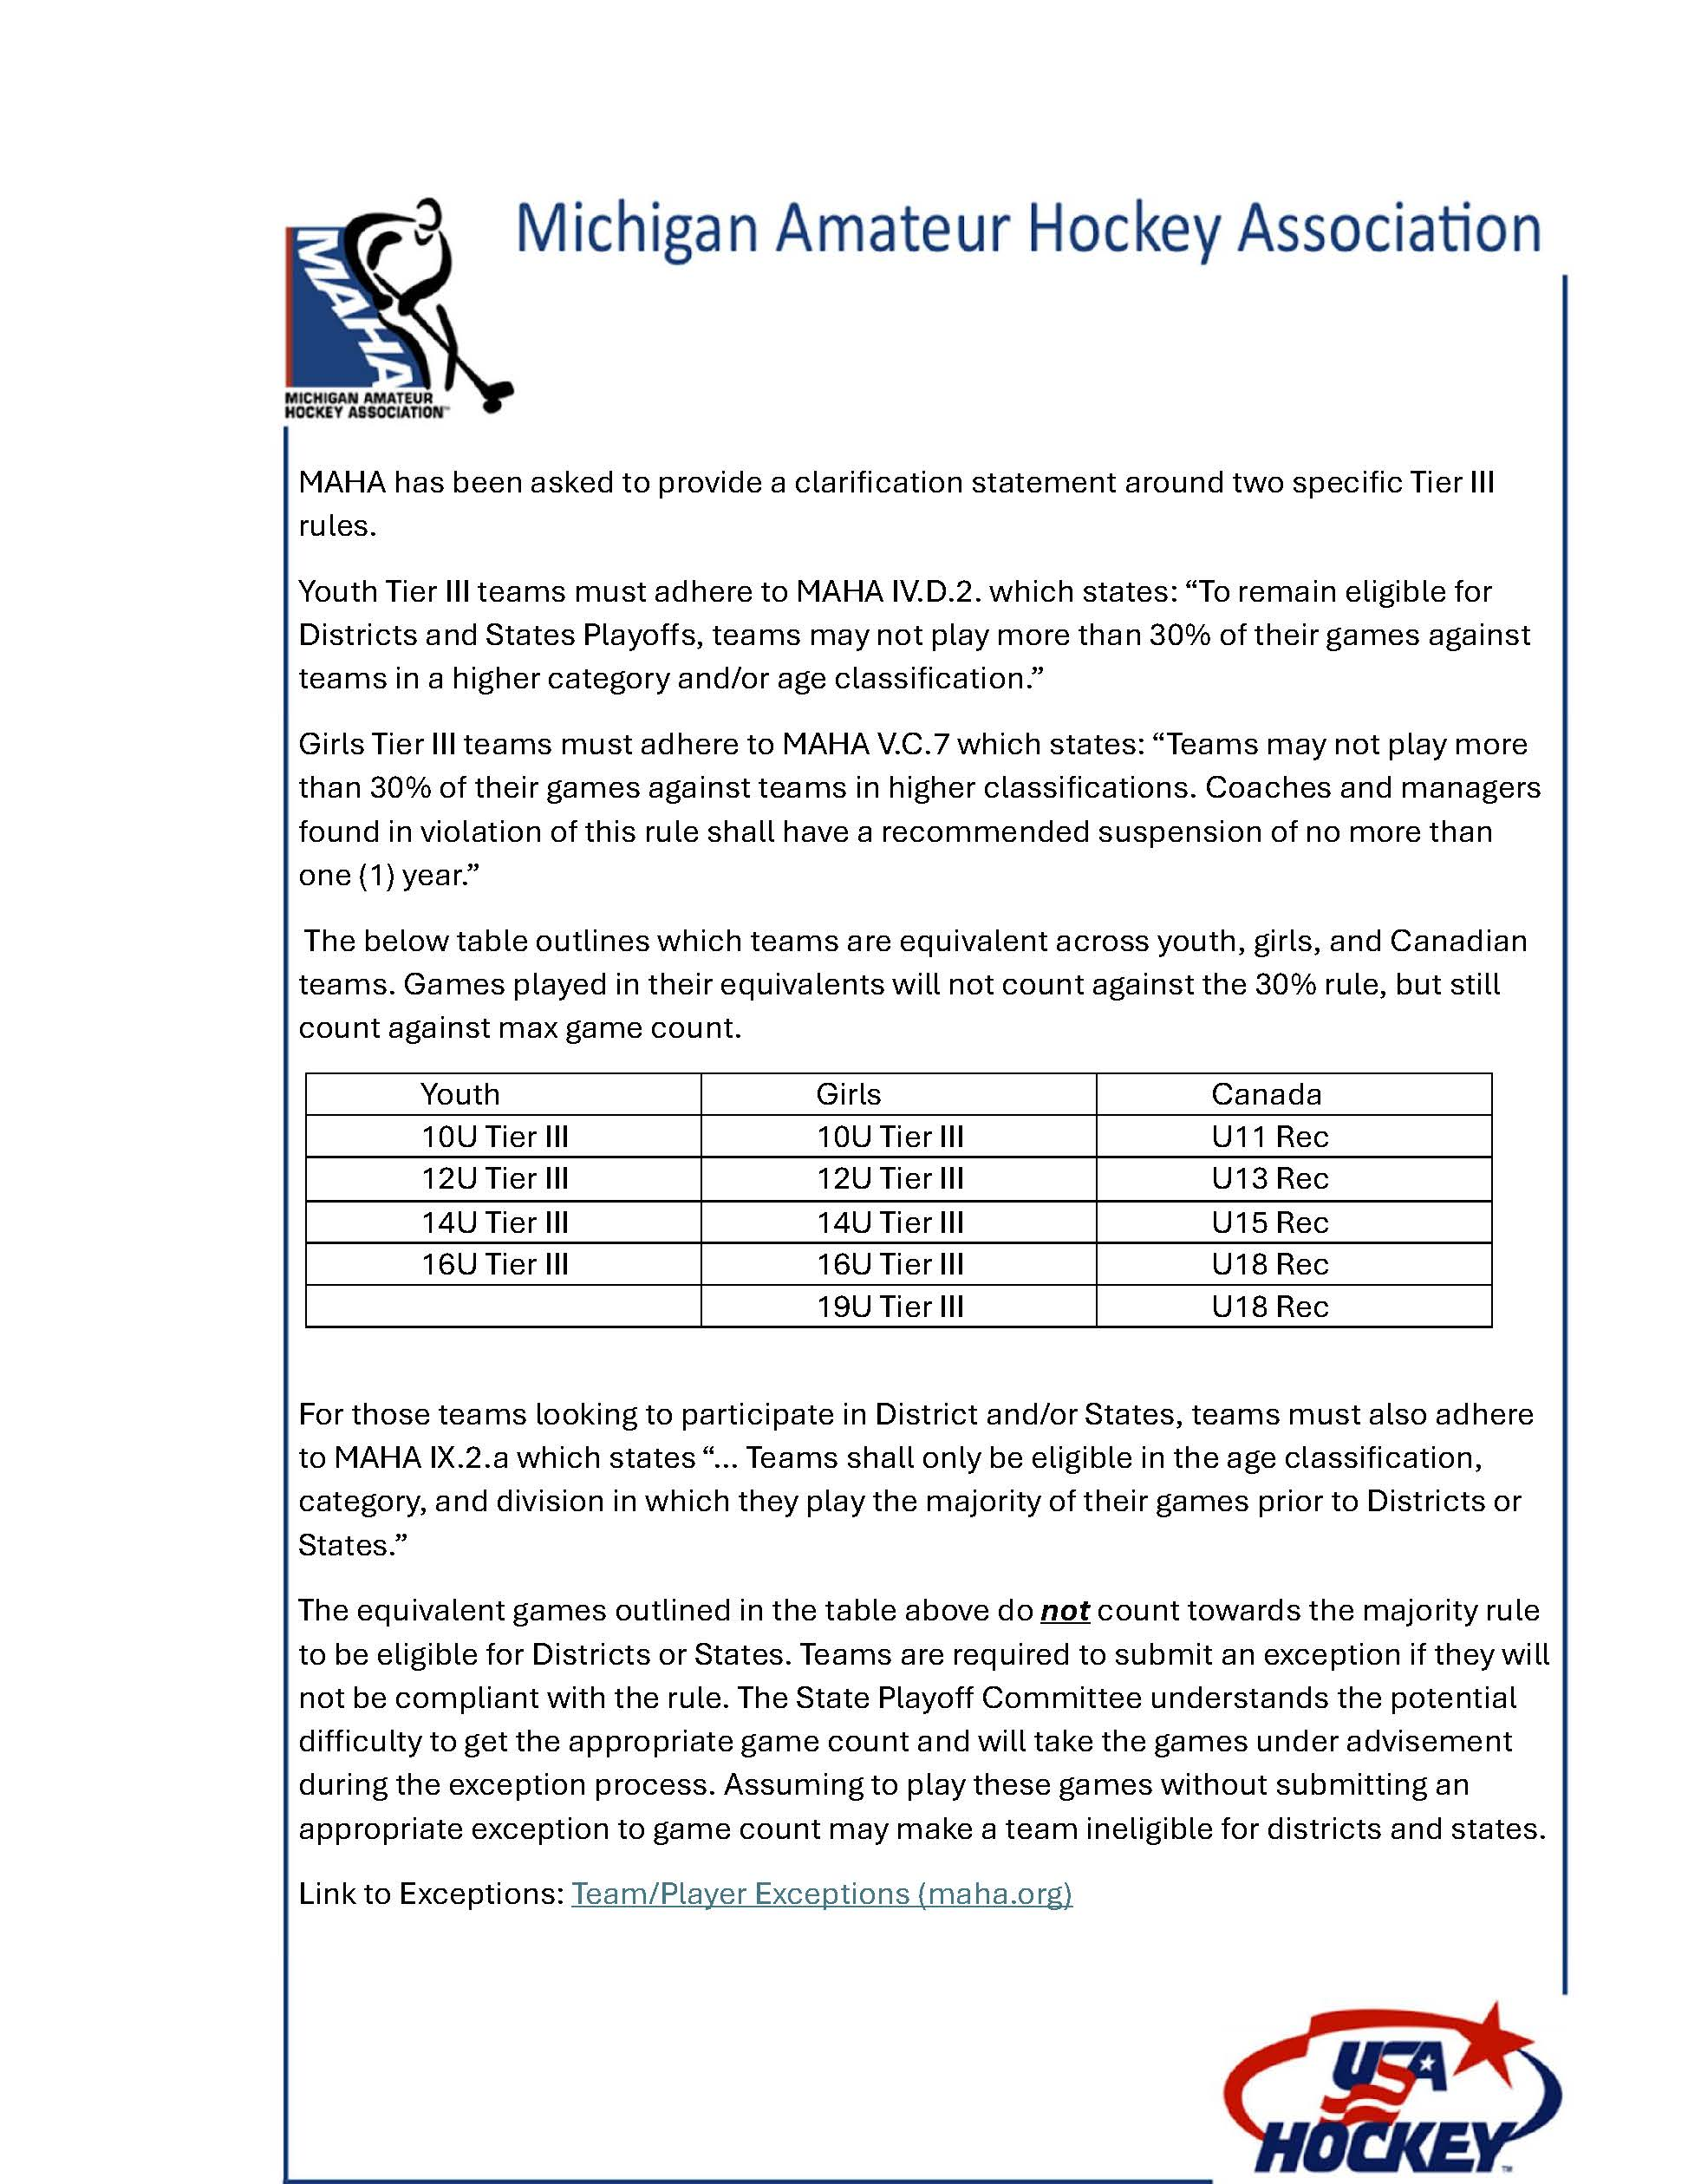

YOUTH AND GIRLS 10U/12U/14U TIER III GAME COUNT PILOT

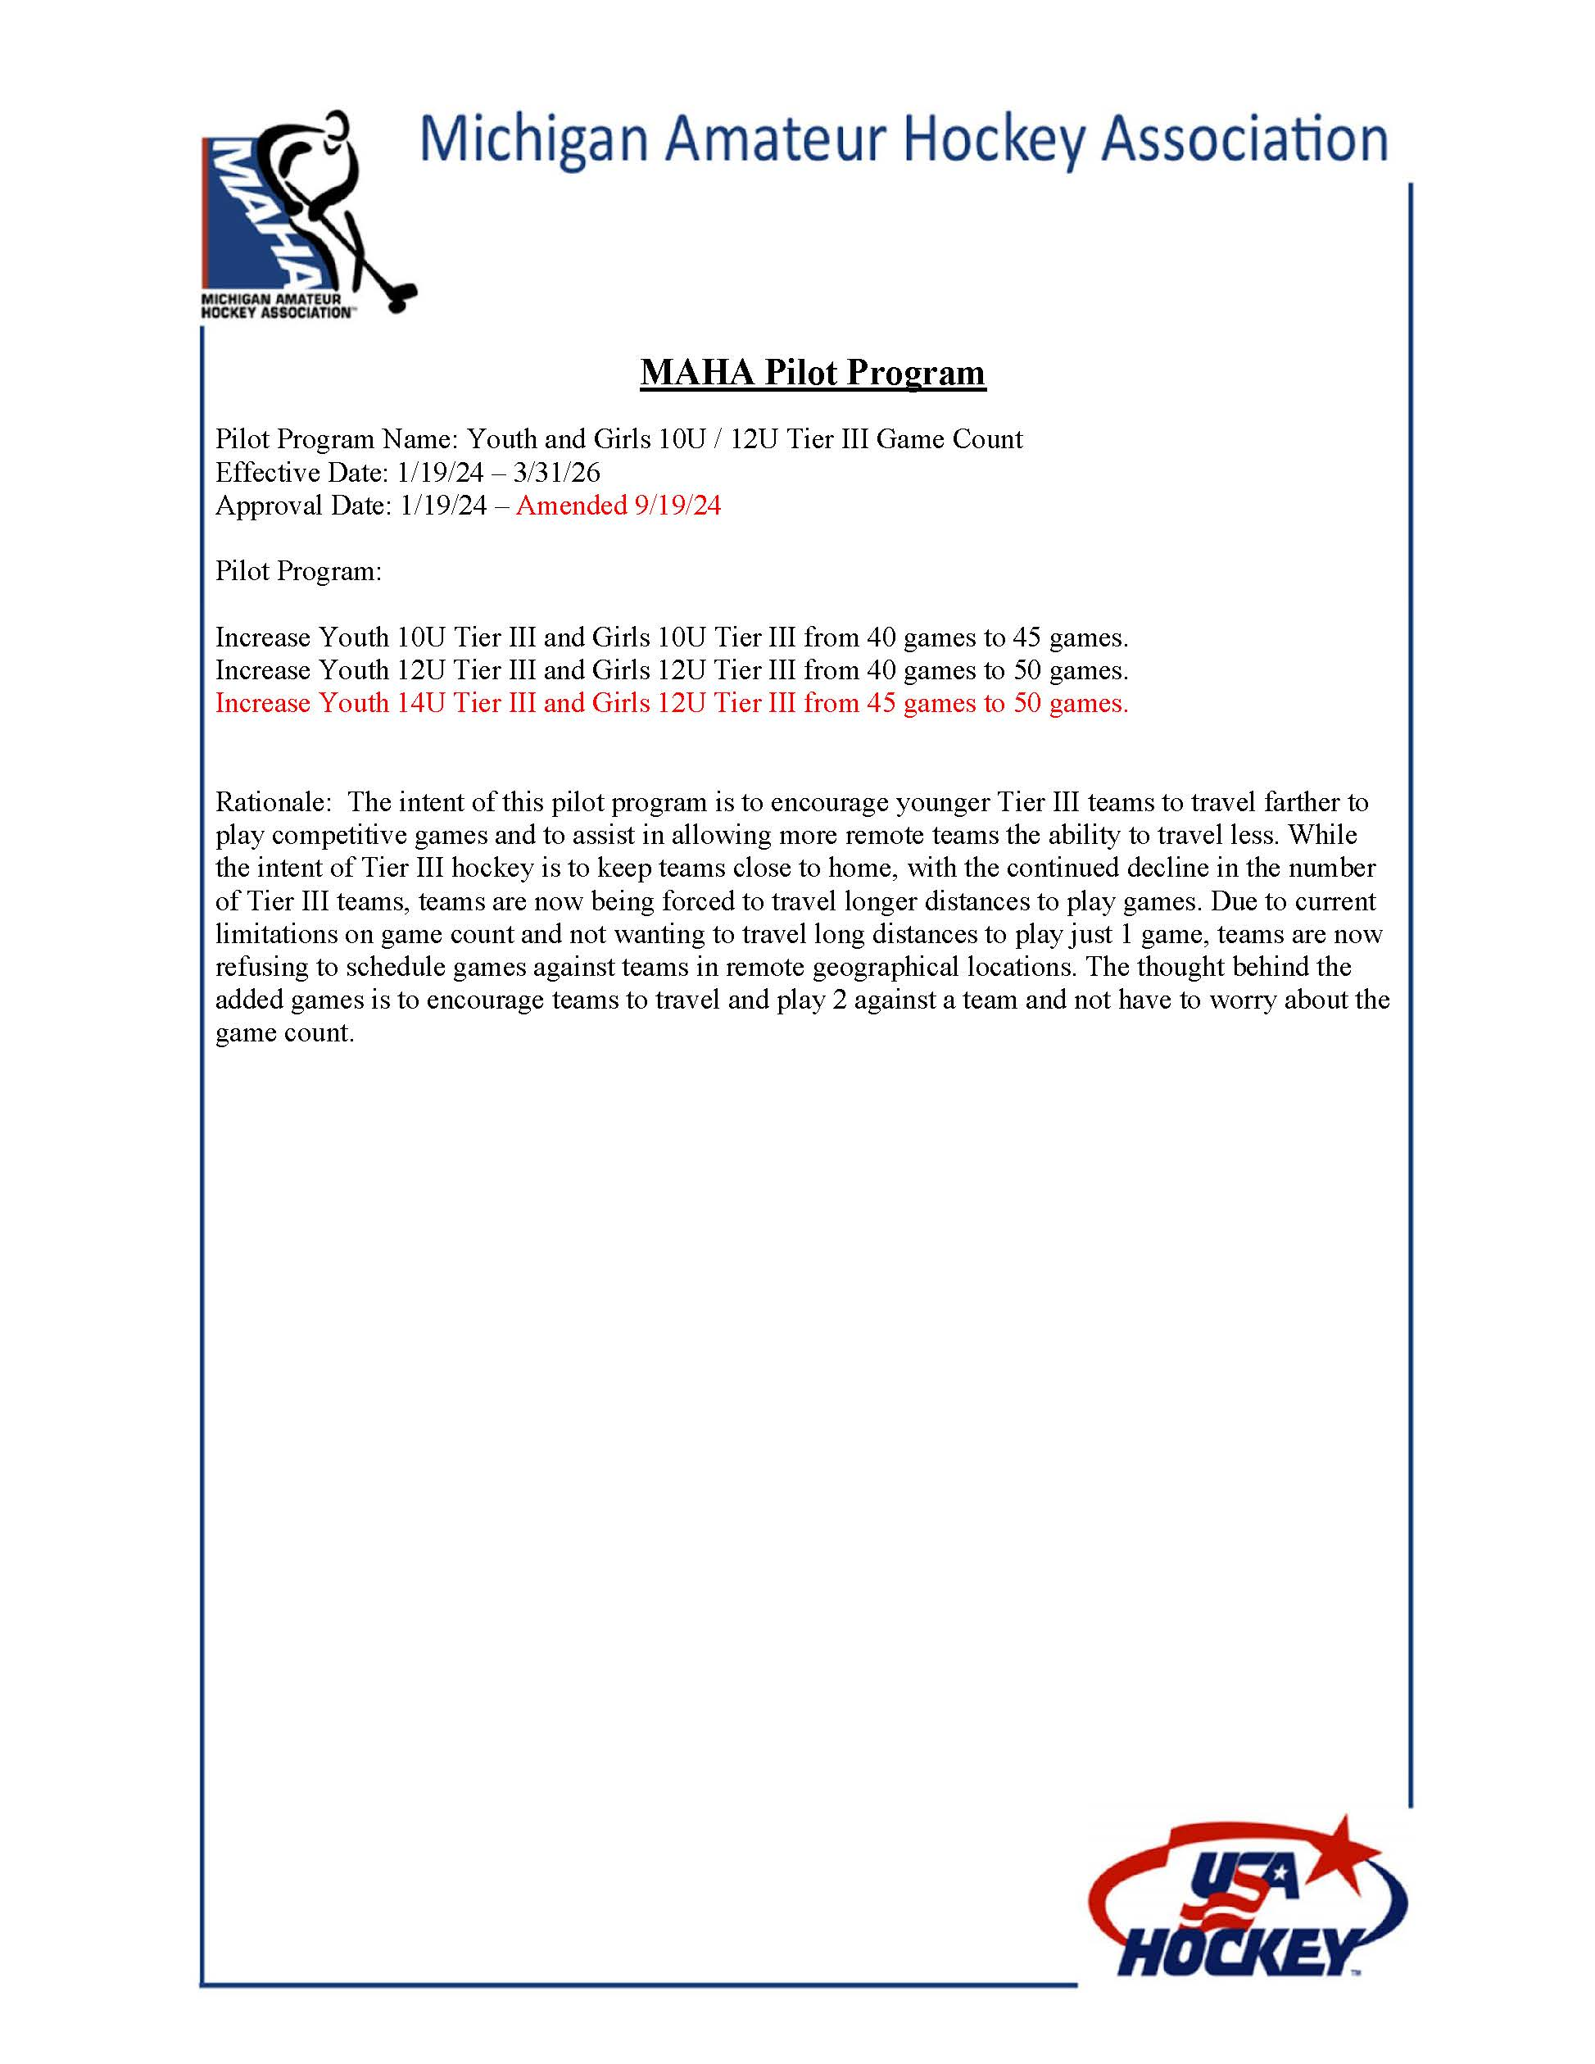

STANDARDIZED PENALTIES FOR 2024-25

PENALTY FOR A PLAYER NOT SITTING A GAME
Sit the next scheduled game(s).
Look at the schedule- say next game and note the date in the notes or if a district game have the team confirm the date with you prior to leaving and so note.

PENALTY TO A HEAD COACH FOR A PLAYER NOT SITTING A GAME
Same as above for the player. Coach can request a hearing.

PENALTY FOR COACH NOT SITTING A GAME
Sit the next scheduled game(s).
Look at the schedule- say next game and note the date in the notes or if a district game have the team confirm the date with you prior to leaving and so note.

PENALTY FOR PLAYING A PLAYER / GAME BEFORE ROSTERED
No penalty to the player.
Coach sits the next 3 games; can request a hearing.

