November 14, 2024 | SYA Meeting

Attendance: Jen Boandl, Tiffany Krasley, Michelle Taylor, Rebecca Jones, Constance Turner, Juan Turner, Jake Williams, Brittney Williams, Lauren Wellbank, Jenn Blaukovitch, Jim Blaukovitch, Bryon Cramsey, Annie Greaves, Adam Segall, Rebecca Jones (Volunteers: Alanah Kemmerer, Lucia Dredge, Jaylene).

Call to Order: Meeting is called to order by Jim at 7:06pm

- Motion to Approve December Minutes: Motion to approve October’s meeting minutes made by Tiffany K and Michelle, none opposed.

- Officer’s Reports:
  - Secretary:
    - Reminder from Sarah Oswald: when requesting the use of STSD indoor space, please be aware that nothing will be approved if it takes place during a holiday or school breaks. If there is something already scheduled and approved but there is inclement weather, it will be automatically cancelled.
    - There will be a sign-up genius sent out for our special December potluck meeting.
  - Treasurer:
i)
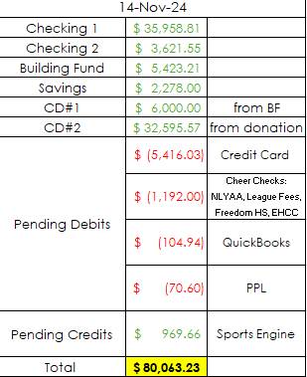
SYA Treasurer’s Report is Approved: Motion made by Annie, seconded by Juan, none opposed.
ii) SYA’s Zelle Account is up and running, attached directly to the SYA Bank Account. We are now able to send and receive money this way, as opposed to Venmo, Cash App, PayPal, etc. Brittney will send out Zelle QR code to all via email.
iii) Wrestling and Basketball budgets are due. Send to Brittney when completed or reach out to her for assistance.
  - President’s Report: Board nominations will be made at today’s meeting (see section 6 of these minutes).
  - Vice President:
    - Budgets and coach’s clearances are due. Submit to Bryon.
    - SYA needs the Child Abuse and Background check - fingerprinting is only necessary if the volunteer has not lived in PA for the last 10 years (as per SYA website below)
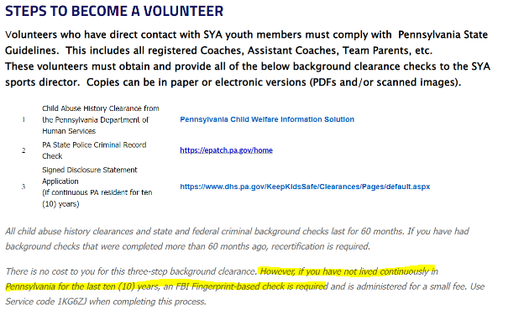
    - Working with Shaun on Swag budget for 2025.
  - Chief Administrative Officer:
  - Communications Officer:

- Old Business:
  - Takeaways from Sarah Oswald meeting (email was sent out):
    - Sarah is a very nice person who wants to do a great job and increase youth's interest in sports so all of our numbers can grow.
    - She would like to build relationships between the district's coaches and SYA.
    - She will work with us in whatever way we prefer, provided we are patient with her. She now has a list of all our Board members' names, titles and email addresses and is fine working directly with individual directors as they submit requests through FMX.
    - She will post events for us when we ask but asks that we be patient with her about that as well.
    - She is even willing to share with us her cell phone number, in case someone needs to get ahold of her emergency.
  - Directors are interested in a coaching clinic: we need to take Sarah up on this.

- New Business:
    - Fundraiser for SES Gym Mats – we will split the cost with SES PTO. There will be a coin toss at the next PTO meeting (with Principal Brem present) for name placement. Should we use “SYA” or “Salisbury Youth Association” for the mats? The consensus is that “Salisbury Youth Association” instead of “SYA” should be printed on the mats, we could add SYA if we want to, as in “Salisbury Youth Association (SYA)”.
    - Salisbury Angel’s Fundraiser – Lauren Wellbank has reached out to the SES social worker regarding the STSD letter asking for parents to contact them if they need help over holidays, as there are no school lunches or breakfasts available. Lauren learned that the most useful thing for families is usually Giant gift cards, small amounts are fine, to help buy groceries. She will set up some collection times during basketball and wrestling practices to accept these gift card donations. She will deliver what we get to the district.

- Directors Updates:
  - Fundraising Director (Shaun):
    - Red Robin November 18, Spirit Night @Skyzone December 20th, Chipotle 1/7 & Community Day May 4th
    - BJ/s Fundraiser raised $352!
    - Working on other Fundraisers to help raise money, TBA
    - Committee for Community Day (will be discussed more at the December meeting)
    - “Night at Laubach” maybe December 11th. We can sell Hot Chocolate and apple cider at the concession stand and have a toy drop off. Other suggestions include inviting the Marching band to perform, as they were planning to perform at the Franko tree lighting which was cancelled.
    - Community Day Money can go towards paying for mats for SES – although they may need the money before hand, we can still allocate those funds for the gym mats.
  - Concessions Director (Jen): Everything is cleaned out and ready for Winter
  - In-house baseball (Kenny):
  - Travel Baseball (Bill):
  - Softball (Michelle): Softball is beginning to plan for the spring season. Registration will open after the holidays. Expect to close registration by mid-February and begin workouts etc. that month as well.
  - Soccer (Lauren and Lauren):
    - Our soccer season will come to a close this weekend, and we'll share the final budget at the next meeting after all of the individual team parties have been held and receipts have been submitted.
    - The Wawa hoagies seemed to work well this season but we'll likely alternate between this and Thompsons (or something else) so we aren't doing the same fundraiser back-to-back. Additionally, setting up the credit card holds at registration was a much easier way to collect and track the fundraising buyout fee. The only hiccup was that there were seven cards declined on Nov. 1st when payments were processed. Now, each of those seven charges are subject to new processing fees which either need to be passed onto families or that soccer needs to eat (in this case it's a total of around $20, but on a larger scale that can really add up). If anyone else opts to go this route in the future we'd suggest adding a little disclosure in the registration screen explaining that the processing fees for these transactions will be passed onto the families if their cards are declined.
    - Everyone had lots of fun at Parents vs Kids games this past week.
  - Football (Juan): Intermural Spring Football is being planned; Details need to be worked out. Adam can help with setting up registrations when the time comes. The Colonial League is not an option for SYA because we would need Varsity, JV and Flag teams and a Plan of Action to prove that we will be able to field a team. It will take a long time to get SYA back into a league, any league. Jim will reach out to Kevin, the SHS football coach, and he and Juan and Bryon will meet with him. Flag needs field space for practices in the Spring – maybe Franko since Laubach is very booked with the baseball/softball/t-ball needs.
  - Cheerleading (Rebecca): the big Tournament is coming up on 11/24; Setting up from 5-7 Friday night, Saturday is the competition. More volunteers are needed to run the event, especially an MC. There will be great prizes to be raffled off as well.
  - Basketball (Josh): Gym times were extremely minimal this week. Next week will be better. I’ve been trying to avoid scheduling practices on weekends to minimize the cost of paying overtime. But it may be unavoidable to be able to give everyone 2 practices per week.
    - Rising Stars League meeting this Sunday with rosters due. Grades 3-6 are starting their regular season weekend of Dec. 7.
    - Jerseys ordered from Phil Snyder.
    - Grades 7/8/HS will formally begin their practices next week.
    - In-house co-ed will start 2nd week in December.
  - Wrestling (Liz):
    - Season has started. We are in week 2 of practice.
    - Ordered our sweatshirts/coaches shirts. SYA will be invoiced from Phil Snyder at some point within the next 3 weeks hopefully..
    - Got 39 kids registered! Woot! That’s a post-COVID high apparently.
    - Our dates for the home matches have been approved for 12/8/2024/ and 1/5/2025.
    - We were triple informed we have to pay OT for the custodians, and we were informed that 2/3 rolling bulletin boards are no longer in good condition. We only have one rolling white board that can be provided.” Wrestling may need two additional rolling / bulletin boards or white boards for tournaments. ***There is a free standing bulletin board in the SES boiler room that the PTO uses sometimes, FYI.

- Discussion:
    - NOMINATIONS for BOARD for 2025:
Jim Nominated Bryon for President
Annie nominated Brittney for Treasurer
Lauren nominates Byron Masi for Administrative Officer
Annie nominated Jim B for VP
Jen nominated Adam for keymaster/ webmaster
No nominations were challenged, there will not need to be elections in December.
    - SYA owns the lights a Laubach and usually asks the fire company to change the light bulbs. It is up to SYA to maintain the light bulbs in Laubach’s field lights.
    - Lauren reported that Jim L presented the Laubach plans at a Commissioner’s meeting last month; an engineer presenting it said the project won’t even get started until 2028; there are many plans / permits / and money to get in place. The township is short several million dollars.
    - Regarding Kenny’s initiative to follow the Santa Clause Firetruck with a trailer to collect toy donations, since the East and West side firemen are doing their Santa runs on the same day, we will focus on the West side for this toy donation collection effort and the East side will have the “Night at Laubach”

- Motion to Adjourn: Motion to adjourn made at 8:30 by Adam and seconded by Michelle.

Next Meeting: December 19, 2024, SHS Cafeteria – Holiday Party

