HOW TO UPDATE STATS/GAME UPDATES ON WEBSITE
**Must be in EDIT mode

Step 1 – Select Game Schedule

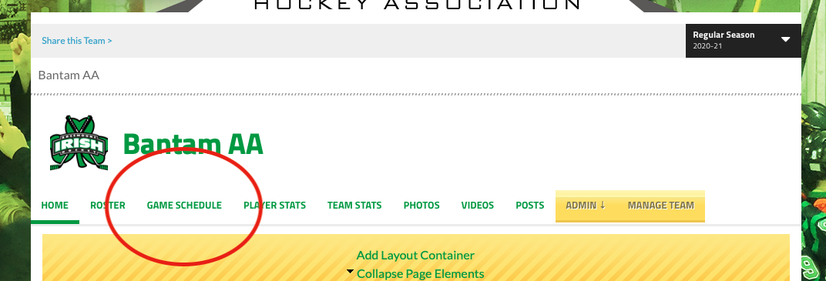

Step 2 – Select Game to Update (Or Skip to Step 4 to use “QS”)

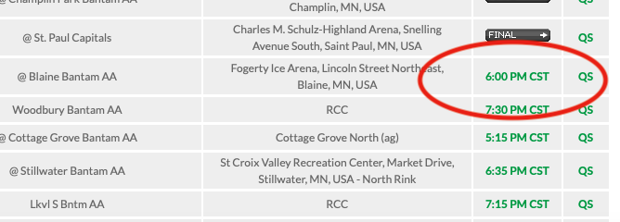

Step 3 – Can choose to score live, update yourself with “Quick Score” or Edit Stats after game.

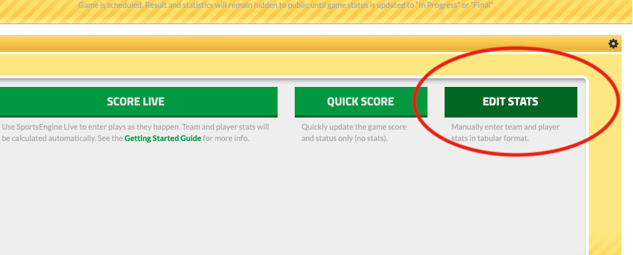

Step 4 - QUICK SAVE

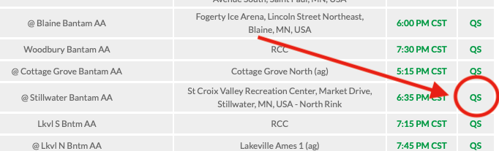

Step 5 –

