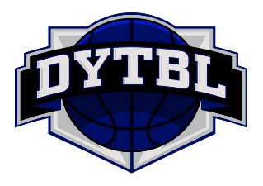
Official Team Roster & Waiver
Team Name _______________________________________________
Head Coach Name: _________________________________ Cell Phone # ______________________________
Assistant Coach Name: ______________________________ Cell Phone # ______________________________
Please read this form carefully and be aware that in signing up and participating in the DuPage Youth Travel Basketball League (DYTBL), you will be expressly assuming the risk and legal liability and waiving and releasing all claims for injuries, damages or loss which you or your minor child/ward might sustain as a result of participating in any and all activities connected with and associated with this league (including transportation services and vehicle operations, when provided).
I recognize and acknowledge that there are certain risks of physical injury to participants in this DYTBL league and I voluntarily agree to assume the full risk of any and all injuries, damages or loss, regardless of severity, that my minor child/ward or I may sustain as a result of said participation. I further agree to waive and relinquish all claims my minor child/ward or I may have (or accrue to me or my child/ward) as a result of participating in this league against the DYTBL or participating teams, including its officials, league coordinators, coaches, agents, volunteers, practice and game facilities.
I have read and fully understand the above important information, warning of risk, assumption of risk and waiver and release of all claims. If registering via fax, my facsimile signature shall substitute for and have the same legal effect as an original form signature.
Jersey# | First Name | Last Name | Birth Date | Age | Grade | Parent Signature
Signed rosters are due prior to or at the team’s first game. Roster changes must be approved by the league commissioner.

