Table of Contents
Purpose and Scope | p. 2
Philosophy of Athletic Programs | p. 2
General Program Considerations | p. 3
Recommendations | p. 3
Questions and Answers | p. 3
Conclusion(s) | p. 7
Appendices | p. 8

PURPOSE AND SCOPE
This document is created to provide key stakeholders with guidance for implementing a Return to Play (‘RTP’) framework within the Mount Si High School during the COVID-19 pandemic. This plan is premised on protecting the health and wellness of high school student-athletes, officials, coaches, staff, and families (“Participants”).

These guidelines are intended to assist athletic directors and coaches as they plan for return to play for student athletes beginning with the fall activities period.

Return to play in-person activity plans must be formulated and implemented utilizing the most up-to-date guidance from the Governor, Superintendent of Office of Public Instruction (OSPI), the Department of Health (‘DOH’), the National Federation of High Schools (‘NFHS’), the Washington Interscholastic Activities Association (‘WIAA’), the WIAA’s Sports Medicine Advisory Committee (‘SMAC’) and the Snoqualmie Valley School District (‘District’) and must be adjusted as new guidance are released.

A supplement will accompany this guidance. The supplement will include Sport Specific Considerations for Return to Play. The information included in the supplement is based on the NFHS and WIAA guidelines, which applied guidance from the governor and was released during the spring of 2020.

It is essential for all athletic personnel to understand that Return to Play cannot begin while King County is in phase one. The information included in this document and the supplement includes steps anticipated for Return to Play for programs during Washington state’s Phase 2, Phase 3, and Phase 4. Please remember that any date included is approximate and this information will be updated as necessary.

PHILOSOPHY OF DISTRICT ATHLETIC PROGRAMS
It is our intention to provide complete athletic programs. District programs do not focus purely on wins and losses or level of competition but recognize the importance of high school athletics in developing self-esteem and worth in today’s students. The staff at each school focuses their efforts on creating opportunities for all athletes who join a program to develop as people, students, and athletes. Coaches work to help students grow into responsible adults who understand how hard work and dedication to themselves and others can translate into success in all aspects of their lives.

During the fall of 2020, coaches have an essential task to provide an environment where all athletes can reconnect with their peers and other members of their community while re-establishing roles within a program, with a constant focus on gradual improvement of individual skills within a program’s structure.

This fall, plans need to be flexible as the district works to deep clean and attend to facilities to create the greatest flexibility for the future availability of facilities.

During the fall season:
- Athletes should be active even if they cannot gather as groups.
- Coaches must consider injury and progressive return while planning Return to Play activities.
- Any at-home/virtual workouts must be simple, low impact and low risk.
- An emphasis on movement quality rather than quantity of exercise is vital; proper movement is key to mitigating injury.
- Coaches must avoid rushing deconditioned athletes to full participation as most injuries occur early in a season
- Coaches should increase activities (workload) by 10% each week once Return to Play has been implemented.
- Coaches should focus on a healthy environment, quality experience, progressive training, and safety.
- Coaches will help athletes to engage in a daily activity, allowing all athletes to maximize personal potential.
- Coaches will communicate with each other, parent(s)/guardian(s), and athletes.
- Coaches will continue to emphasize positives each day, while finding new ways to challenge all athletes.
- Coaches will emphasize appropriate attendance at activities focusing on motivating athletes.

GENERAL PROGRAM CONSIDERATIONS
All Return to Play activity must comply with local, state, and federal standards for physical distancing and safety within facilities. It will take collaboration to create safe plans for facility use that will be compliant with public health directives. The following are general recommendations and questions to be considered and included in any Return to Play plans by all athletic programs.

RECOMMENDATIONS
- Athletic and Activities Coaches and Advisors will remain in contact with their building athletic/activities director.
- The Activities/Activities Director will stay up to date on how community and state recommendations will impact athletic and activity programs at the building level and communicate any changes to current guidance.
- Eliminate use of low ventilated spaces and spaces that prevent physical distancing (e.g. locker rooms).
- Create visible markers on fields and floors (using appropriate materials to prevent damage) to indicate appropriate spacing in gyms, classrooms, entrances to the school, etc.
- Model what you expect of your athletes.
- Be clear and consistent about expectations and enforce these expectations.
- Move activities outside where possible.
- Utilize a staff member to help athletes move from one area of the facility to another.

QUESTIONS AND ANSWERS
Q: What is the current Snoqualmie Valley School District facility guidance?
A: As stated, District facilities are closed and there is no set date for them opening for District programs.

Q: Who will make the decision about access to our facilities?
A: The decision to provide access to facilities will be made by District personnel and will then be communicated with the high school.

Q: For a facility of our size, what is the capacity for accessed spaces to fit current guidelines?
A: The building athletic/activity director and coaches will need to communicate specific Return to Play plans at the school level to ensure the facility has the capacity to handle the physical spacing and other requirements that are necessary to implement to offer athletic or activity programs.

Q: How will you manage/sanitize bathroom use?
A: The Mount Si High School custodial staff will be able to provide support by sanitizing a chosen bathroom during scheduled activities.

Q: What is our plan/checklist for cleaning and disinfecting surfaces, including athletic or other equipment?
A: The school will be provided with cleaning supplies to utilize during fall activity. The Athletic and Activity Department will work with Mount Si High School custodial staff to provide these supplies.

Program plans should include:
- Students should limit brining non-essential items to an activity. Any student bag/equipment should be laid out in spaces with 6 feet between and not on team benches or bleachers.
- Adequate cleaning schedules.
- A requirement that individuals wash their hands for a minimum of 20 seconds with warm water and soap before touching any surfaces or participating in workouts.
- Hand sanitizer is a sufficient replacement for hand washing and will be provided for programs to make available to individuals during activities.
- Appropriate clothing and shoes must always be worn. One set of athletic shoes should be dedicated to this activity only and not worn outside the venue if possible.
- Students must be encouraged to shower and wash their workout clothing immediately upon returning home.

It is essential that equipment is cleaned after use. Coaches will need to oversee equipment cleaning. Additional information will be provided by athletic department personnel prior to Return to Play plans being implemented.

Athletic programs should limit the amount/type of equipment distributed through each phase of re-opening.

- Phase 2: Programs should focus on general conditioning and individual skill development and avoid the use of shared equipment (towels, clothing, sport specific equipment). Individual drills requiring the use of athletic equipment are permissible, but the equipment should be cleaned prior to use by the next individual. A pod will use the same balls through an activity and may not be shared with another pod. Balls must be sanitized if the pod rotates to a different coach, if a second athlete touches a ball, after each session and/or following the completion of the practice.
- Phase 3: Phase 2 guidance continues.
- Phase 4: Phase 3 guidance, plus programs may begin using weight rooms, while following all physical distancing and safety guidelines.

Q: How will you control access/egress of the facility?
A: It is essential that there is a controlled flow into and out of athletic facilities. The athletic director will need to identify the entry and exit points from fields (and/or gyms) and communicate this to coaches and athletes. Additionally, the athletic director will work to identify staff whose role will be to assist with the access/egress points in each facility. The identified staff will also assist with daily athlete health screening.

Each program facilitating an activity will work with their athletics/activities office to ensure their athletes are up to date with all registration. If athletes are not fully registered, they will not be allowed to participate until they are registered in full.

Q: How will you limit contact points in the facility (e.g., open doors, water bottles, equipment, etc.)?
A: Student athletes will be required to bring their own water bottle(s) and other equipment and the sharing of personal equipment is prohibited. There is no sharing of clothing (towels, shoes, or other specific equipment). Doors and other contact points in the facility must remain locked and have adequate signage communicating the open areas of the campus and the protocols for accessing those areas.

Q: What is your plan should a coach, athlete, etc. become sick? How will programs ensure activities can continue or will it be necessary to suspend activities?
A: Each program must ensure there is a back-up plan of critical functions in the event a coach becomes sick and/or is not able to come to the workplace. Use the strategy of “3 deep” if possible, meaning there are two levels of back up for each critical function. No athlete and/or coach are to be present and/or participate if sick and/or exhibiting any of the signs related to COVID-19 (fever, cough, loss of taste, etc.)

Q: What will be the structure of your activity?
A: It will be essential for programs to work with the athletic director to secure the facility. Programs will need to engage in cooperative dialogue to ensure all programs are able to schedule adequate time and space for athletes. Questions to answer while planning include:
- If conducting multiple sessions in a day, what will be the time between sessions?
- How many sessions per week will you conduct for each group?
- How will you clean between sessions?

Q: How will you maintain spacing in your facility or field during activities?
A: In order to provide adequate space for teams, the athletic director will need to identify the number of ‘zones’ available to athletic programs on each campus. Programs should be assigned a zone(s) to utilize for their scheduled activity. In the area provided, coaches will need to use advanced planning to maximize the space and time available, so athletes receive the maximum benefit of a scheduled activity. Use of staggered drills, opposite ends of a zone, or communicating a strict limit to the number of athletes a program will allow in a zone are a few ideas that may be utilized by coaches.

It is recommended that there is 30 feet between pods.

Once a coach has planned a scheduled activity, it will be essential to include in the plan how the activity and the spacing requirements will be communicated with athletes. Use of a pre-activity email along with a white board to clearly illustrate where multiple stations are located while adding visible markers for start and stop points, (e.g., visible spacing marks throughout a facility) is one idea coaches can use to begin their planning.

Spacing will require staffing. Programs must include in their planning adequate staff to be present during activities to monitor spacing.

Q: What is your plan for protective measures?
A: Masks (personal protective equipment or PPE) and gloves will be provided for coaches by each school. PPE will be required of coaches until further notice. Gloves and masks are to be utilized while cleaning equipment. Spacing remains an essential part of program’s plans for coaches’ protective measures.

Athletes and coaches must wear a face covering when not actively engaged in the physical exercise (coming to and from practice, engaging in a team meeting, etc.).

Discussions with the WIAA include the use of cloth face masks for athletes during all Phase 2 and Phase 3 activities and during Phase 4 when not engaging in rigorous activity. As WIAA guidance is released this will be clarified for all coaches. Athletes are responsible for providing their own masks.

When disposing of a used mask, each mask should be placed in an individual plastic bag.

Q: What is your plan for participants with health vulnerabilities?
A: When a coach is in a high-risk category, it will be important for the building athletic director to work with that program to determine how the impacted coach may remain actively involved with the program. For example, a coach in a high-risk category could continue remote participation, zoom team meetings, writing practice plans, etc.

Athletes who fall into a vulnerable category should not participate in any in-person Phase 2 activity.

Q: Should there be written plans and coordinated scheduling for all programs?
A: Programs must create a written plan in order to effectively work together with other head coaches and the athletic director to effectively utilize the facility during the fall season.

Each program should include detailed plans for implementing good hygiene and physical distancing, including:
  - Frequent hand washing
  - Avoid touching your face including eyes, nose, and mouth
  - Frequently use hand sanitizer
  - Remain at least 6 feet apart from others.

Q: What is your communication plan for parent(s)/guardian(s)?
A: A clear and comprehensive Return to Play plan will be an essential element of parent communication. This plan must include practice health and safety expectations, drop- off and pick-up patterns, activity groupings, etc. It will also be necessary to establish the means of communication from coach to parent(s)/guardian(s) and athletes. Communication cannot be left to a ‘team parent’ or volunteer.

Without clear and honest communication from athletes to coaches and from coaches to athletes, a program will face challenge and frustration.

The most important element of program communication as Return to Play is implemented is the health of athletes and coaches. All participants must understand and commit to complete honesty related to their health and any potential symptoms they may feel. Athletes must see a physician and be cleared for training after being diagnosed with or having accessed a medical practitioner with symptoms associated with COVID-19. Head Coaches and the athletic director must make it clear that there is no penalty for missing activities and that if a participant, or any member of their family, does not feel well, they should stay home. Guidance from OSPI states that if students (athletes), staff (coaches, volunteers, etc.), or parent(s)/guardian(s) are showing symptoms of COVID-19, have been in close contact with someone who has confirmed or suspected COVID-19 in the last 14 days, they are not allowed on-site.

Per WIAA Rule 17.11.4 an athlete must present to the school officials (athletic director and athletic trainer) a written release from a medical authority. For a suspected case of COVID-19, this written release must come from a medical doctor, without exception.

Q: Will participants need to be screened before activities?
A: Symptoms of COVID-19 may appear 2-14 days after exposure to the virus. Therefore, if a coach/advisor/student participant is not feeling well and/or has exhibited symptoms (including but not limited to the following list) the individual should stay at home and notify the head coach (for athletes and assistants) and the head coach will notify the athletic director, school nurse and site coordinator:

Covid Symptoms
- Fever or chills
- Cough
- Shortness of breath or difficulty breathing
- Fatigue
- Muscle or body aches
- Headache
- New loss of taste or smell
- Sore throat
- Congestion or runny nose
- Nausea or vomiting
- Diarrhea

OSPI guidance states that a fever of 100.4°F or higher or a sense of having a fever is reason to send a participant home. The directive to screen before in-person activities will remain in place until further notice.

Each program facilitating an activity during the fall will work with their athletic director to identify the individual(s) who will be responsible for taking and recording attendance at the beginning of each scheduled session.
- If an athlete attends an activity and is found to have any symptom, the athlete will be sent home and the parent/guardian, athletic director, school nurse, site coordinator and athletic trainer will be contacted.
- If a coach/advisor attends an activity and is found to have any symptom, the coach/advisor will be sent home and the athletic director, school nurse, athletic trainer and site coordinator will be contacted.

If someone in the coach/advisor’s family or someone the coach/advisor has been in close contact with an individual who is showing signs of COVID-19 (including but not limited to the symptoms above), please notify the head coach and your athletic director.
  - If an athlete has been exposed to individuals with symptoms, the athlete is required to stay home, and the athletic director, school nurse, site coordinator and athletic trainer will be contacted.
  - If a coach/advisor has been exposed to individuals with symptoms, the coach/advisor is required to stay home, and the athletic director school nurse, site coordinator and athletic trainer will be contacted.

These reporting protocols will remain in place until further notice.

Q: What do I have to ensure happens DURING an activity?
A: During each activity participants must:
- Follow directions for spacing and stay at least six feet apart from others.
- Not make physical contact with others, such as shaking hands or giving a high five.
- Avoid touching your face.
- Avoid sharing items, such as food, drinks, or towels.
- Maintain appropriate physical distancing from other athletes when taking a break.
- Wear gear to and from any athletic activity.
- Wear face coverings when not engaged in physical activity.

Q: What do I have to ensure happens DURING an activity?
A: After each activity participants must:
- Leave the facility immediately after any activity.
- Wash hands thoroughly or use a hand sanitizer when leaving practice.
- Locker rooms are not available for changing. Instead, wear athletic gear to and from any athletic activity.
- Refrain from extra-curricular or social activity, meaning no coaches or athletes may congregate before or after after the activity.

CONCLUSION(S)

While the opportunity to offer a Return to Play to athletes is exciting, the return will only be successful if all participants continue to practice good hygiene and people who feel sick stay home.

Together we can provide meaningful experiences for all participants. For a program to develop a complete plan, coaches will need to apply sport specific guidance in the Sport Specific Considerations for Return to Play. Included in the supplement are specific details related to the numbers of participants who can be present at an activity, how facilities may be accessed during each phase, and additional considerations for offering meaningful in-person activities. As plans are finalized, please contact the Athletics and Activities Department with questions or for assistance.

Appendix A: Governor’s 4 phases to re-open

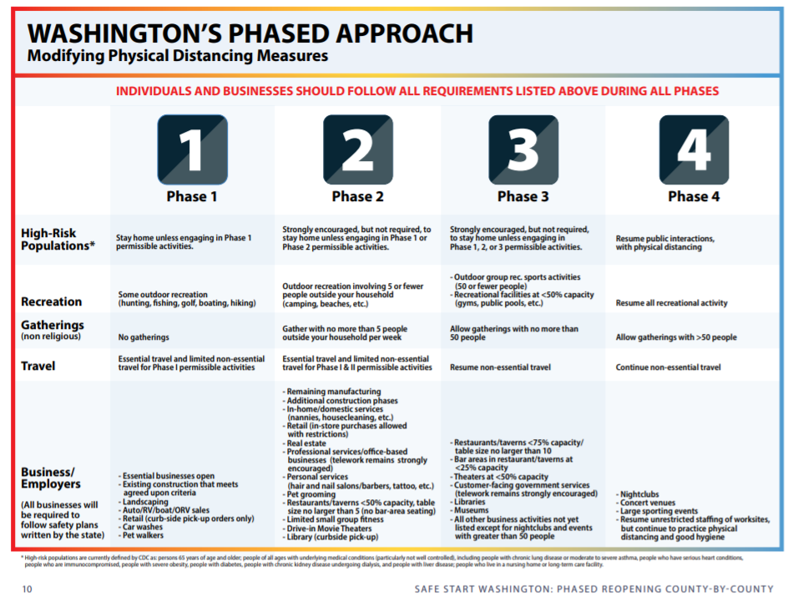

Appendix B: Medical Resources

Athletes who need to complete a physical examination may contact any of the following clinics to make an appointment. The District is working on a partnership to provide physicals for District athletes. More information about this partnership will be available later in the summer.

Snoqualmie Valley Clinic
38700 SE River St. #400
Snoqualmie, WA 98065
(425) 888-2299

Swedish Primary Care
37624 SE Fury St.
Snoqualmie, WA 98065
(425) 888-2016

Snoqualmie Ridge Medical Center
35020 SE Kinsey St.
Snoqualmie, WA 98065
(425) 888-4452

Snoqualmie Valley Hospital
9801 Frontier Ave. SE
Snoqualmie, WA 98065
(425) 831-2300

Meadowbrook Urgent Care
209 Main Ave. S #115
North Bend, WA 98045
(425) 831-0777

