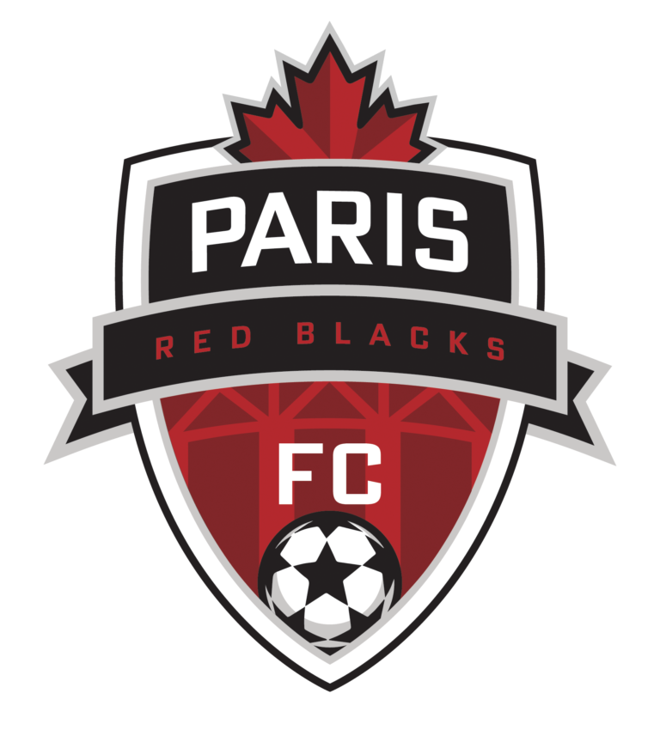
What is “Academy Grassroots” Soccer?
You may notice that we have a couple of teams at different age groups labelled as “Academy Grassroots” teams – and are wondering what that means.

Our Academy teams are run by coaches from Ulysse Soccer Training, and have an extra level of commitment, both time and cost, for those families and players who are interested in a more immersive soccer experience at the grassroots level (U8 to U12). We only have a couple of teams offering this at this time (for the 2025 season – U9 Boys and U11 Boys), but the program may expand in future.

All of our grassroots teams (both Academy and regular) compete in the same Hamilton District league. The district team is still “rep” or “travel” soccer, with regular practices, winter training, league play, and festivals in the summer.

The Academy program adds additional practice time, different festivals/tournaments, and classroom time to the mix.

For our discovery sessions, please attend the sessions for the team(s) you are interested in – you can attend both if you wish.

Please contact us at info@parisfc.ca if you have any questions about either program, and we will forward interested parties to the Academy coaches.

Thanks,

