Samantha Burns
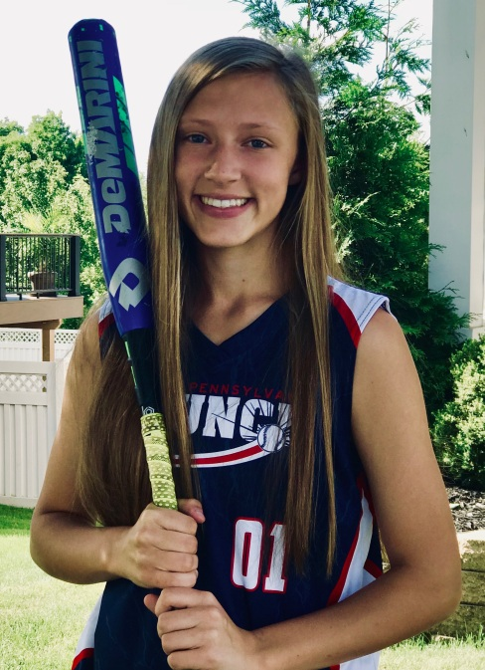 | Sport: Softball Position: SS/CF Jersey #: 01 (High School and Travel)  Bats: Right - Lefty Slapper Throws: Right  Time to First Base: 3.06  Birth Date: 04/28/2002 Gender: Female Ht.: 5'5" Wt: 115lbs  Grad Year: 2020 Weighted GPA: 4.2 Planned Major: Undecided  Honors/AP Classes:  Honors Biology, Honors Chemistry, Honors Algebra 2, AP Government  City: Harrisburg State: PA Zip: 17112  Cell Phone: 0 Email Address: sburnsie01@gmail.com  Parent: Tracey Burns Cell Phone:  Email Address: chapman.tracey1@gmail.com  Parent: Mark Seavey Cell Phone: 315-404-2673  Email Address: mseavey18@yahoo.com

High School: Central Dauphin High School
City: Harrisburg State: PA Zip: 17112
School Phone: 717-703-5360
High School Coach: Ken William Cell Phone: 717-215-1724
Email Address: kenneth7173@comcast.net
Awards: Varsity Letter Award Freshman Year (earned starting position), 2017-2018 6-A 1st place District Medal

Additional Sports Played:
Basketball
Travel Softball: Central PA Krunch, Harrisburg PA - 2015 to present
Email: www.centralpakrunchsoftball.org
Travel Coach: Naul Walter Cell Phone: 484-241-9454
Email Address: nwalter@wearebg.com
Lead Off Batter for Central PA Krunch

2017 Krunch Stats: BA: .465 OBP: .492 AB: 185 Hits: 86 BB: 10 RBI: 21 Runs: 67 (lead Team) SB: 17 (lead team)
Krunch Awards: 2015-2016 - 1 Game MVP Medal, 2016-2017 – 5 Game MVP Medals, 2017-2018 - 1 MVP Medal

Upcoming Tournaments:
6-16-2018 Summer Jam NIT, Sterling VA
6-22-2018 USA States, York PA
7-6-2018 Pegasus College Showcase, Collegeville PA
7-14-2018 Diamond Queen’s Showcase, Leesport PA
7-21-2018 USA Diamond Fever, Palmyra PA
7-26-2018 New England’s Finest, Plainville MA

