North Mecklenburg High School
Head Coach: Eric Morman
Email: ericr.morman@cms.k12.nc.us

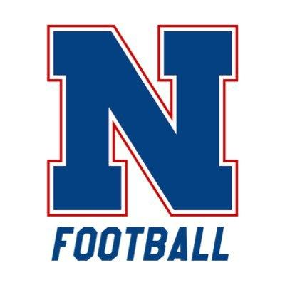

I want to take this opportunity to WELCOME YOU to North Mecklenburg High School football! You are about to embark on a great four years! Some say that your high school years are the best years of your life and here you are, getting ready to begin!

I don’t know if you have any experience playing football but we would love to have you come on out and give it a try! I am writing this letter to encourage every freshman planning to attend North Mecklenburg to play football next year for the VIKINGS. Our football program will only get stronger and stronger with each one of you that decide to play. Every freshman class is different! What will your freshman class be like?

We want you to be a part of this amazing opportunity. Our football program prides itself on faith, family, education and football. So, if you are up for a challenge and if you are up for building a bond with a great group of guys, you will make a great football player! Whether you have 7 years playing experience in Pop Warner Football or no experience ever playing, we want you to play!

We look forward to meeting you on June 12th at 5pm for your first day of workouts with the North Mecklenburg Viking Football Program.

More Summer information and the workout calendar can be found on our CMS athletics website!

GO VIKINGS! #BeUncommon

