2026 PRYFC Guardian Cap Sponsorship
FROM MARCH 1st THROUGH JUNE 1st 2026
Paso Robles Youth Football & Cheer  PO Box 2678  Paso Robles, CA 93447  www.pryfc.com  Tax ID 20-4559108 |  | Custom Amount
 |  | Please specify an amount that you would like to donate $___________
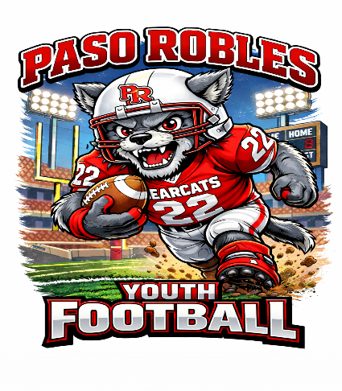
PRYFC would like to Purchase Guardian Caps for All Youth Football
Players. We are reaching out in hopes of getting a few sponsors to help
us with this purchase. PRYFC will match dollar for dollar on Sponsorship’s.
the GOAL is to get approximately $6,000 in Sponsorship’s and PRYFC
Match that with $6,000. That’s a total of $12,000 enough to get around
200 Guardian Cap’s.
Here are a few quick benefits of Guardian Caps:
- REDUCES IMPACT - Reduces impact of daily blows
- ONE SIZE FITS ALL - Fits all football helmets youth and Adult
- REDUCES RADIANT HEAT- Up to 20 degrees
- PRESERVES HELMET - Less wear and tear on helmet paint, decals, & flex panels
- LIGHTWEIGHT - All versions weigh less than a pound
- QUIET - Dampens sound waves and vibrations, removing loud “crack” of the helmet
- 50% reduction in concussions among players wearing the Guardian Cap
Sponsorship includes website/social media recognition.
Larger sponsors will also have their logo on a banner to be displayed at home games.
If you have Questions, please contact PRYFC President at President@PRYFC.com or Text Him at 805-674-2903
Company Name:

Address:

Telephone:

Contact Person:

Email Address:

Website:

Please email completed form to Treasurer@pryfc.com. Checks payable to Paso Robles Youth Football and Cheer (PRYFC).
Please email a highest resolution picture of your company logo to President@PRYFC.com or a standard font will be used for your company name.
PRYFC is a 501 c3 non-profit organization (Use this completed form as your receipt for donation!)
Authorized Signature ____________________________________________________Date__________________________________________

