Team Leader Report Junior Duals 2023

Team: 2023 Team Indiana Junior Duals
Team Leaders & ISWA Title: Pat Parham
Coaches: Mike Weimer, Mitch Sliga, Elijah Bailey
Volunteers & Others You'd Like to Thank: Thomas Pompei, Tom Hall, Pat Culp, and Keith Davison – all these people mentored me and/or helped me prepare for the trip. Theresa Rankin was also a great team leader counterpart to work with.
Team Results: Freestyle, 2-7, 8th in the Red/Blue pool
Greco, 3-5, 4th in the Green pool
Record/Roster:
First Name Last Name Weight Class Greco Freestyle Notes
Brady Byrd 100 7-1 8-1
Nathan Rioux 106 7-1 9-0 All Tournament Team - Freestyle
Jaden Farr 113 0-8 2-7
Luke Rioux 120 6-2 5-4
Tanner Tishner 126 5-3 7-2
Tye Linser 132 4-3 1-6
Lucas Clement 138/145 3-3 2-7
Jacob Weaver 145 1-1 4-3
Branson Weaver 152 4-4 4-5
Nayl Sbay 160 0-0 2-5
Ethan Smith 160 5-3 1-3
Chase Leech 170 2-1 2-0
Brenton Russell 170 2-4 0-4
Anthony Cashman 182 3-5 0-0
Noah Weaver 182 0-0 5-4
Luke Penola 195 3-4 5-4
Benjamin Land 285 5-3 4-5
Overview:
Team Indiana traveled to Tulsa, Oklahoma for the Junior National Duals Championship. The team competed well and wrestled hard against our country’s best during the four days of grueling competition. Several individuals had standout performances including Brady Byrd (7-1 Greco, 8-1 Freestyle), Nathan Rioux (7-1 Greco, 9-0 Freestyle All-Tournament Team), Luke Rioux (6-2 Greco), Tanner Tishner (7-2, Freestyle), and Chase Leech (2-0, Freestyle). Forfeiting multiple weight classes was the difference in most of the duals in which our team came up short. The team battled hard and represented Indiana with class once again proving the best wrestlers in Indiana are some of the best in the country.

Special Awards: Nathan Rioux All-Tournament Team
Photo(s) & Captions:
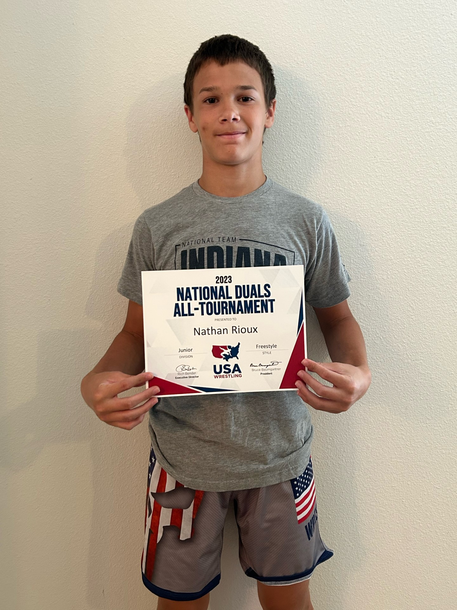

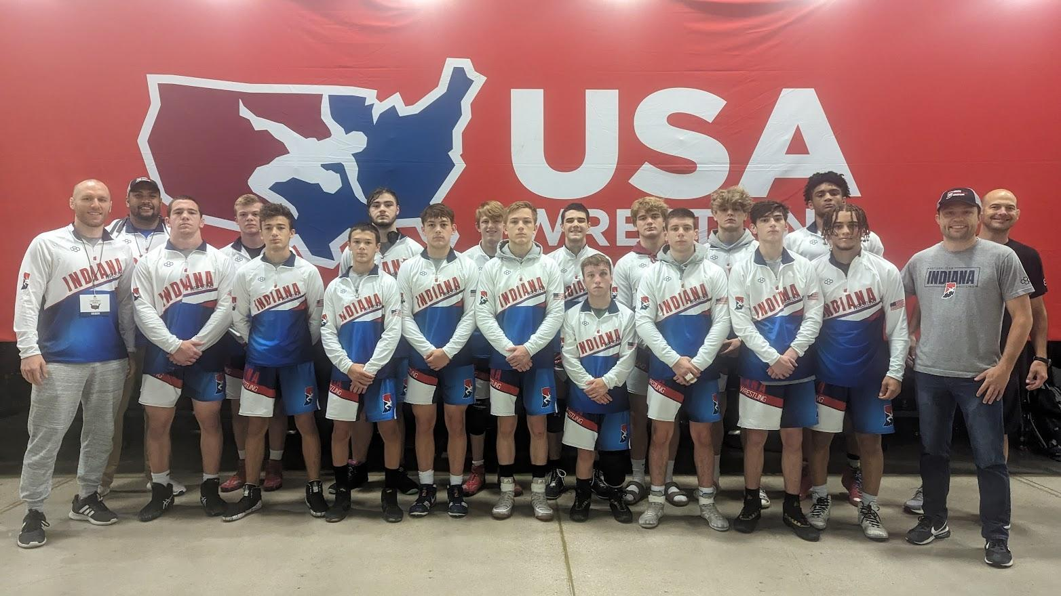
Freestyle Team Photo: Back Row: (L to R) Coach Elijah Bailey, Noah Weaver, Benjamin Land, Jacob Weaver, Lucas Clement, Chase Leech, Ethan Smith, Brenton Russell, Coach Mike Weimer
-Front Row: Coach Mitch Sliga, Luke Penola, Luke Rioux, Nathan Rioux, Branson Weaver, Tye Linser, Brady Byrd, Tanner Tishner, Jaden Farr, Nayl Sbay, Coach Pat Parham
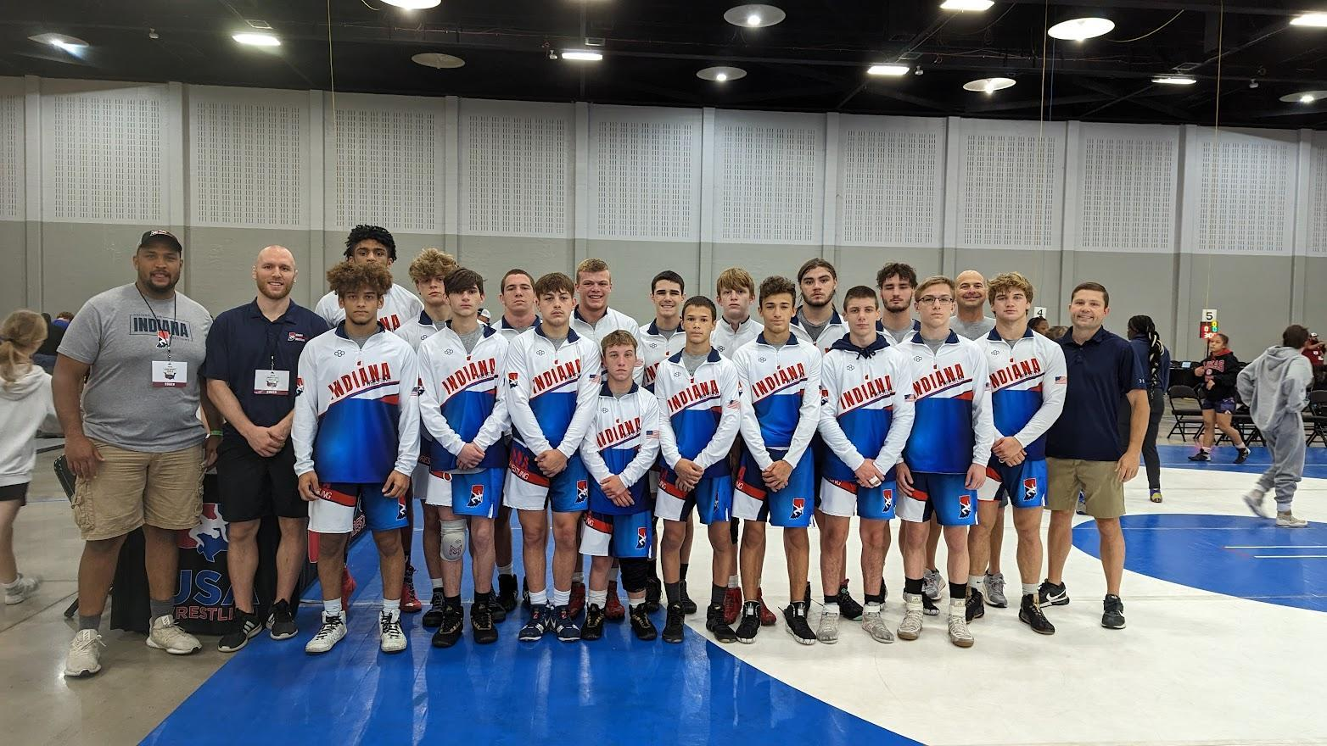
Greco Team Photo: Back Row: (L to R) Coach Elijah Bailey, Coach Mitch Sliga, Brenton Russell, Ethan Smith, Luke Penola, Noah Weaver, Lucas Clement, Jacob Weaver, Benjamin Land, Anthony Cashman, Coach Mike Weimer, Coach Pat Parham
-Front Row: Nayl Sbay, Jaden Farr, Branson Weaver, Brady Byrd, Nathan Rioux, Luke Rioux, Tanner Tishner, Tye Linser, Chase Leech

