Tomorrow kicks off our first dynamics sessions! We are thrilled to be able to continue with our 2020/2021 hockey season. Under our current COVID-19 situation, there are certain steps that we must implement in order to play this year.

**For dynamics at the MAC:** Prior to your skater arriving at each dynamic session (and no fewer than 2 hours prior to arriving), they must complete the SCYHA COVID-19 Questionnaire. If the questionnaire is not completed for your skater (whether a parent completes it, or the skater), they will not be allowed on the ice. We understand that this is not ideal, but a step we need to take to allow us all to enjoy the sport we love and to keep everyone safe. We appreciate your understanding and cooperation.

This questionnaire can be accessed at this link (it’s a google form): <https://forms.gle/C3zvv4m3ecrW4ML37>

Also, here is a QR Code for easy access:

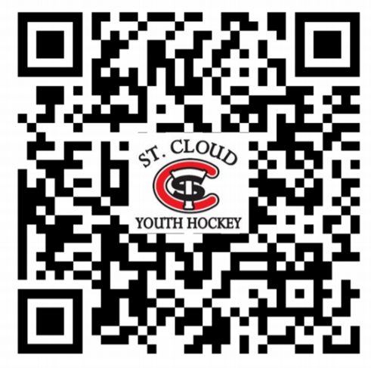

You can access this form either on a computer or on your smart phone.

A tip to make this easy: once you access the site the first time, save it to your favorites or bookmark it on your phone or computer. This way you don’t have to remember the website every time.

**For dynamics at the National Hockey Center (NHC**): You will need to complete the COVID-19 Self-Assessment for SCSU prior to coming into the facility. This is also referenced to as the ‘Green Screen’. Your skater will be checked in by an employee of the NHC as you enter the building.

The link to the NHC COVID Self-Assessment: <https://mnscu.co1.qualtrics.com/jfe/form/SV_1HAgGHJbBzcyDCl>

If you have any questions about this form or anything related to COVID-19, please contact Jenna Binsfeld at 320-492-4446 or [jbinsfeld@parkindustries.com](mailto:jbinsfeld@parkindustries.com).

Thank you and we are looking forward to a fun and healthy hockey season!