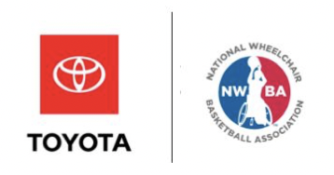

NWBA x Toyota
Third Quarterly Social Recap
July 3 – September 30

NWBA social pages
Facebook: @NWBA70
Twitter: @NWBA
Instagram: @NWBA

Total number of posts (including Toyota posts)
Facebook: 165
Instagram: 118
Twitter: 126 - 6 are retweets

Total number of posts for/with Toyota
Facebook: 36 (22% of all NWBA FB posts)
Instagram: 27 (23% of all NWBA Instagram posts)
Twitter: 30 – 4 are retweets (24% of all NWBA twitter posts)

Engagement/Impressions
Facebook
Overall reach: 634,835
Avg reach per post: 3,847
Overall impressions: 916,487
Avg impressions per post: 5,554
Overall engagements: 51,656
Avg engagement per post: 313
Reach on Toyota posts: 87,728
Avg reach per Toyota post: 2,437
Impressions on Toyota posts: 131, 656
Avg impressions per Toyota post: 3,657
Engagements on Toyota posts: 6,932
Avg engagement per Toyota post: 193

Highest performing Toyota posts:
- “Congratulations to Wichita, Kansas! The city will be hosting the 2020 Toyota National Championship Series.” https://www.facebook.com/NWBA70/photos/a.372087186370/10155948030311371/?type=3&av=372048056370&eav=AfYvhlM4bYaF_nhwfJldS83Mr5b4tnNwV5UxghLGbJ_dvrGFNtm6v4OO9a6QxLLFhJg&theater
- 14,983 reach
- 24,462 impressions
- 1,145 engagement
- “Who needs roadside assistance when you have the Toyota USA Women’s National Team?” #RollWithUS” https://www.facebook.com/NWBA70/photos/pcb.10155962323306371/10155962323156371/?type=3&theater
- 8, 358 reach
- 12,472 impressions
- 1,187 engagement

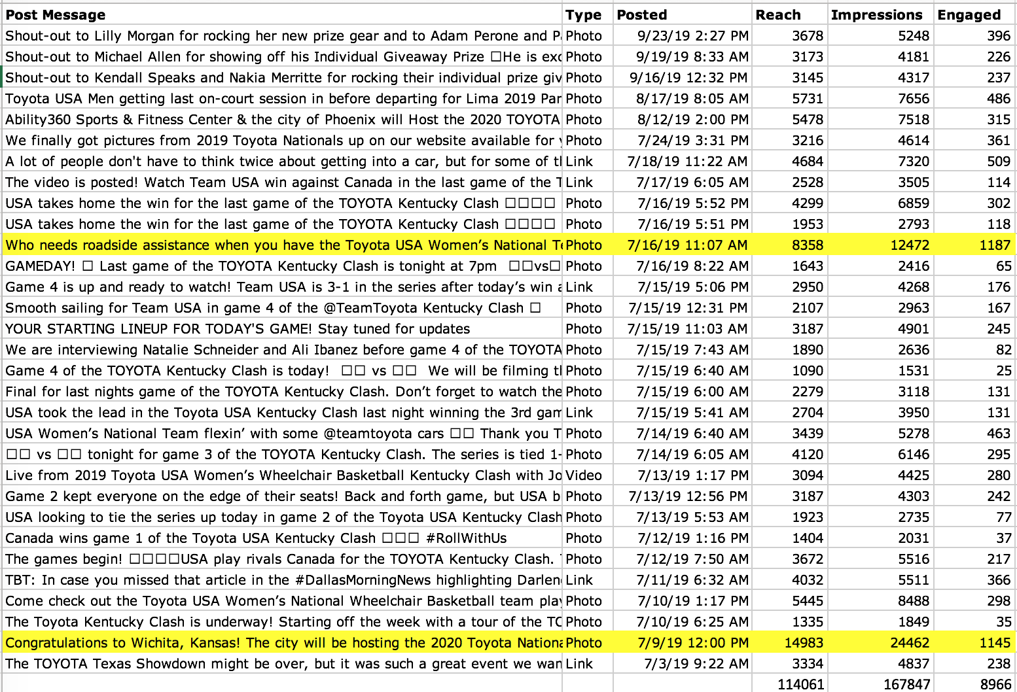
Breakdown of each FB Toyota post:

Instagram

Total likes on Toyota posts: 3,685
Avg likes per Toyota post: 136
Total comments on Toyota posts: 48
Avg comments per Toyota post: 1.78
Total shares on Toyota posts: 65
Avg shares per Toyota post: 2.4
Total saves on Toyota posts: 24
Avg saves on Toyota posts: .89
Total reach on Toyota posts: 41,679
Avg reach on Toyota posts: 1,544
Total impressions on Toyota posts: 65,786
Avg impressions on Toyota posts: 2,437

Highest performing Toyota posts:
- “Who needs roadside assistance when you have the Women’s National Team? 💪😎 #RollWithUS”
https://www.instagram.com/p/Bz_CnPgJACu/
- 301 likes
- 6 comments
- 8 shares
- 4 saves
- 1,897 reach
- 3,534 impressions
- “Toyota Team USA Men getting last on-court session in before departing for 2019 ParaPan American Games in Lima, Peru. One last ‘push’ after months of training to defend their gold medal🥇from 2015 and earn their ticket to 2020 TokyoParalympics. #RollWithUS #Lima2019 #SquadGoals #EarnOurTicket #DefendIt”
https://www.instagram.com/p/B1RP1JppT-7/
- 236 likes
- 5 comments
- 3 shares
- 0 saves
- 2,538 reach
- 3,484 impressions

Breakdown of each Instagram Toyota Post:
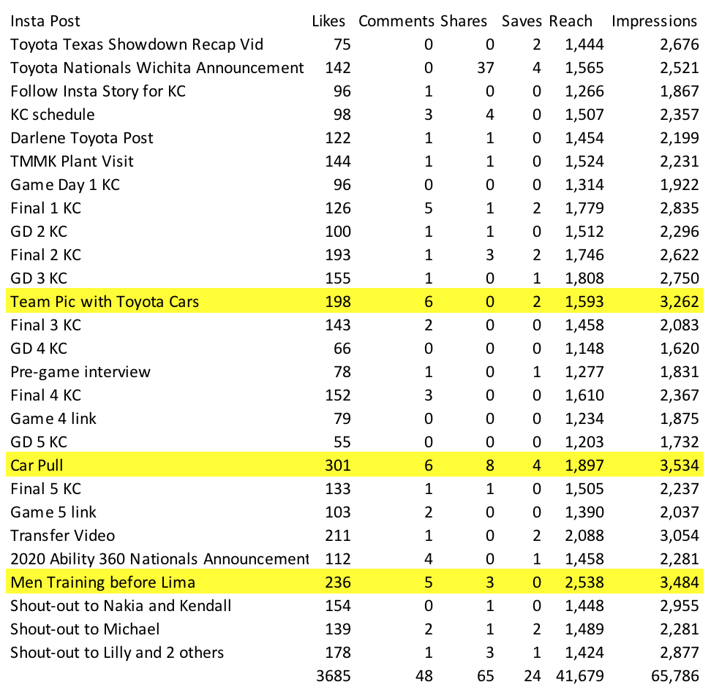

Twitter
Overall likes on Toyota posts:173
Avg likes per Toyota post: 6.65
Overall comments on Toyota posts: 2
Avg comments per Toyota post: .08
Overall engagement on Toyota posts: 1,174
Avg engagement per Toyota post: 45
Overall impressions on Toyota posts: 26,543
Avg impressions per Toyota post: 1,021
Overall retweets on Toyota posts: 52
Avg retweets on Toyota posts: 2
Highest performing Toyota posts:
- “Congratulations to Wichita, Kansas! The city will be hosting the 2020 Toyota National Championship Series. @TeamToyota” https://twitter.com/NWBA/status/1148668224839585792
- 39 likes
- 0 comments
- 17 retweets
- 4,905 impressions
- 516 engagement
- Final score of game 5 in the Kentucky Clash
https://twitter.com/NWBA/status/1151293278349864962/photo/1
- 13 likes
- 0 comments
- 5 retweets
- 2, 871 impressions
- 56 engagement

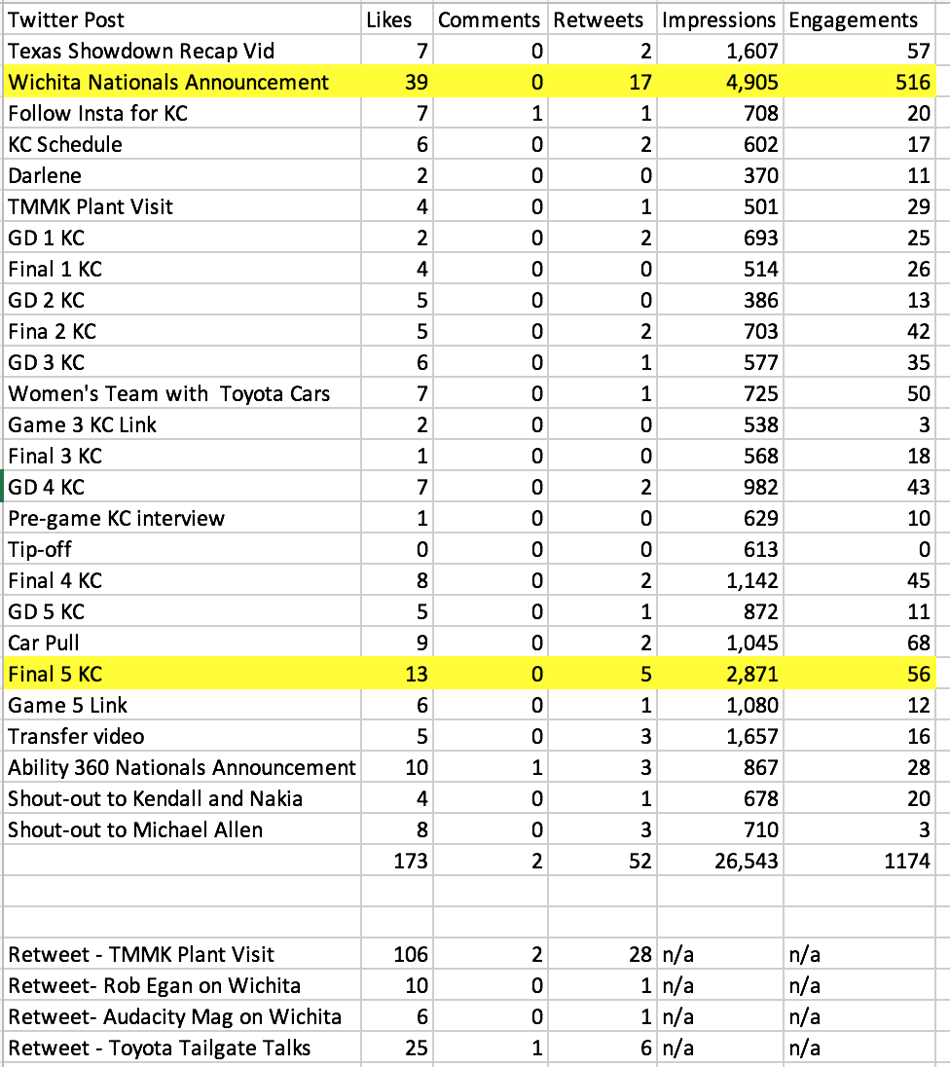
Breakdown of each Twitter Toyota Post:

Standout Engagements:

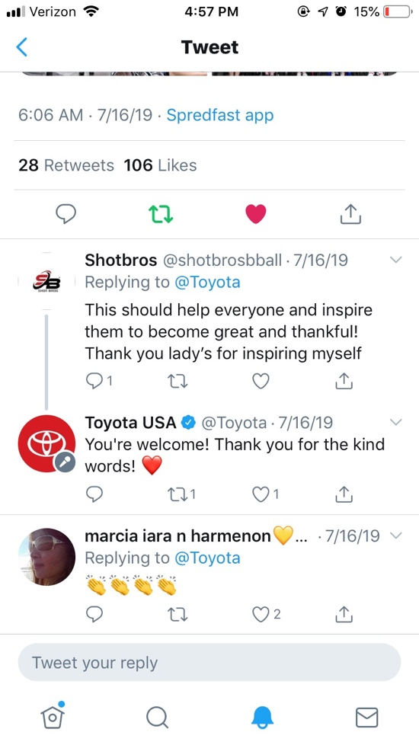
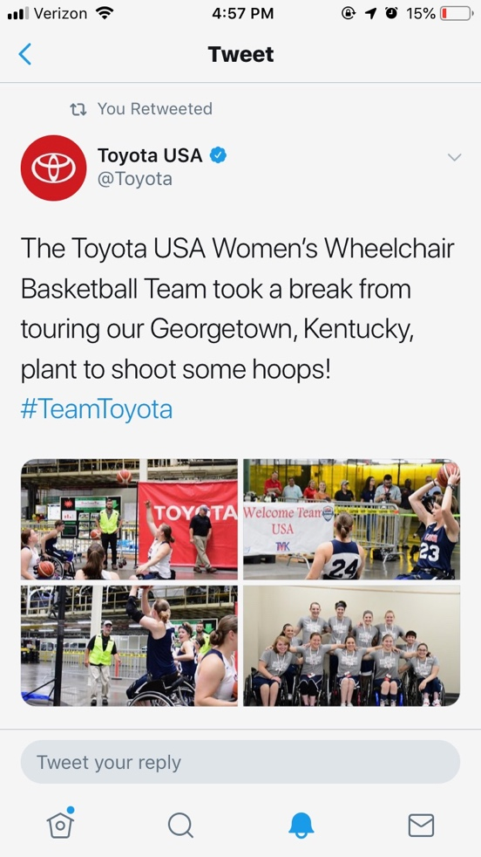
TMMK Plant Visit and we shared the Texas Showdown Video Recap that got 324 views

Any content created for Toyota (graphics, etc)

- All references to Toyota USA Men’s and Women’s National teams in graphics, previews, recaps
- All Toyota Training camp graphics, previews, recaps
- All 2019 Toyota Women’s Wheelchair Basketball Kentucky Clash graphics, previews, recaps, live-streams, and pre and post game FB live interviews
- TMMK PLANT VISIT
- All game live-streams included Toyota logo and Toyota commercials (at least 1 per quarter)
- Toyota National Championship Series Announcements
- Uses combined NWBA and Toyota logo for ALL Toyota content

Some (not all) Athlete Posts:

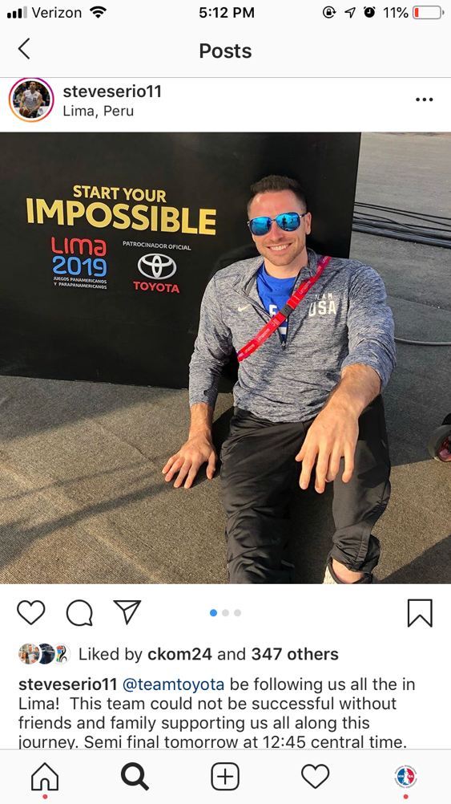
Steve Serio:
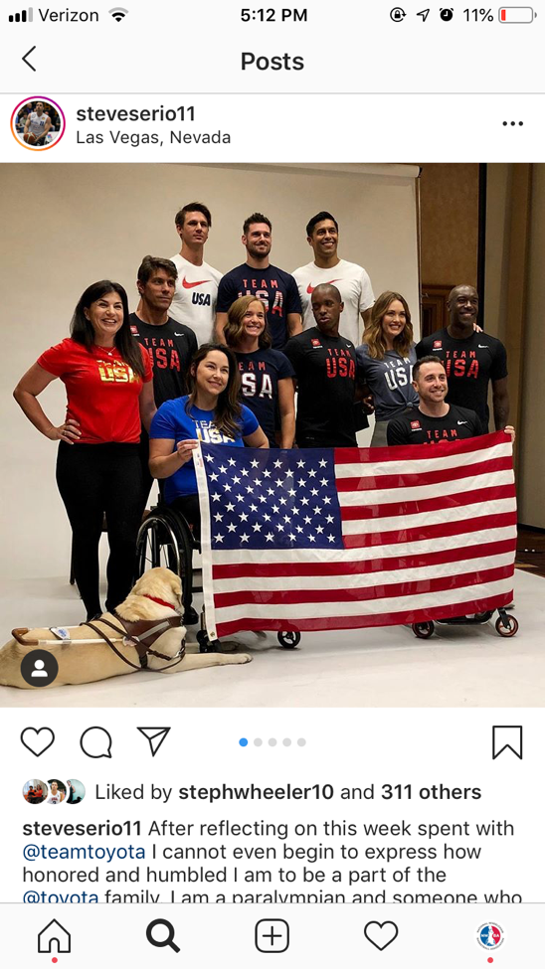
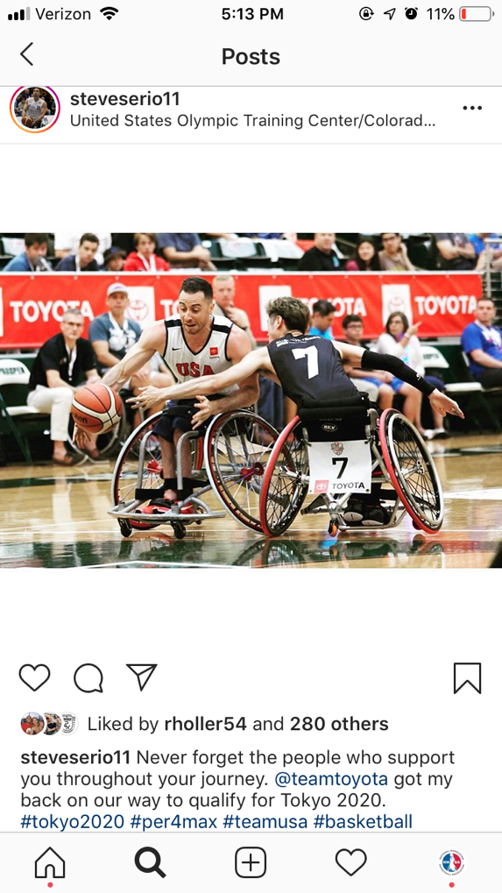
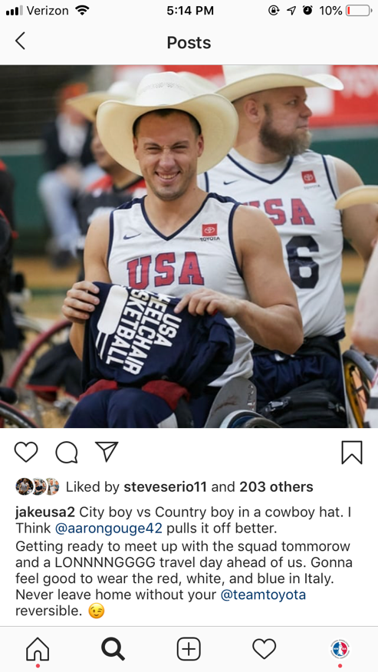
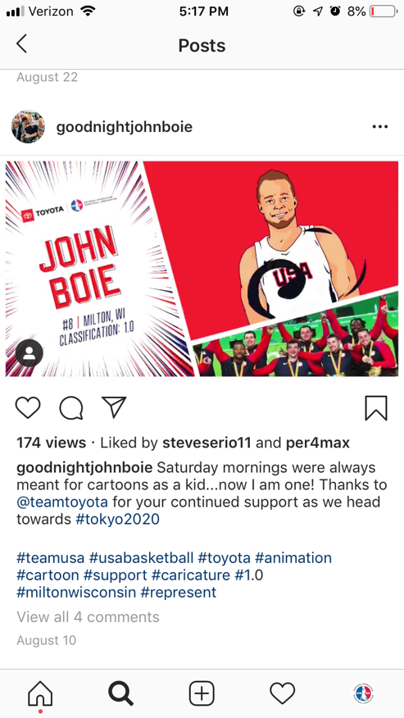
Jake Williams, Jorge Sanchez, and John Boie:
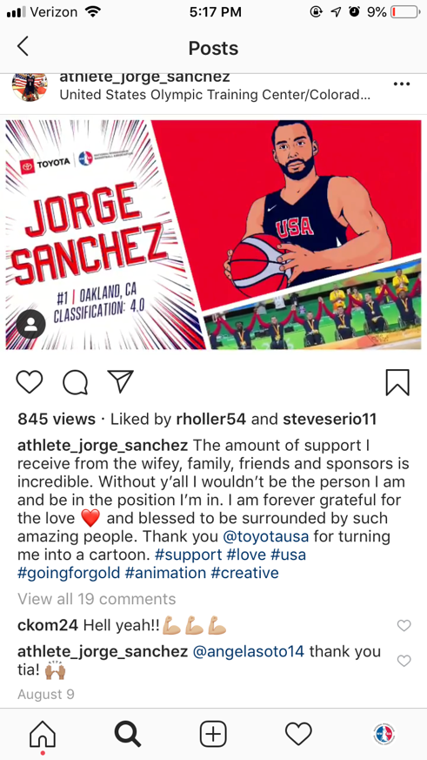

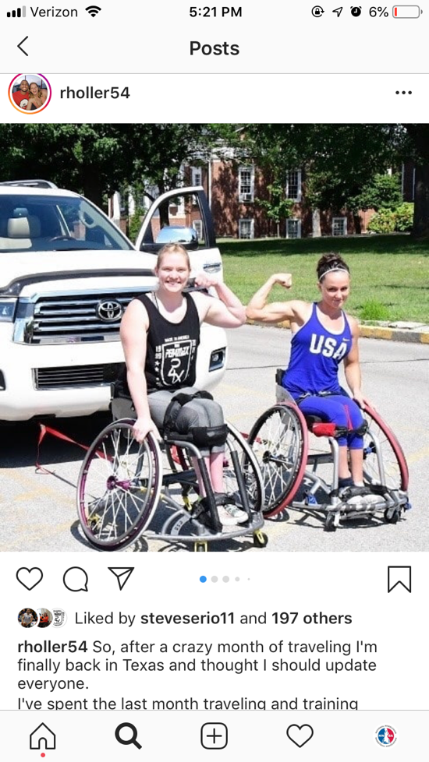
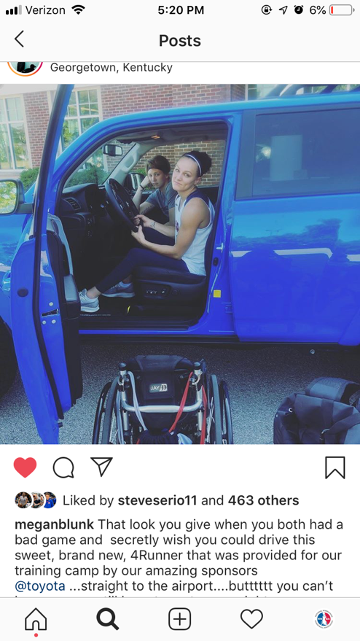
Rose Hollermann and Megan Blunk
